**Project System Requirements**

# **VERSION HISTORY**

|  |  |  |  |
| --- | --- | --- | --- |
| **Date** | **Version No.** | **Author** | **Details / Changes** |
| 25/11/2019 | 1.0 | Mark Jackson | Initial Draft |
| 22/01/2020 | 1.1 | Author 2 | Section 3 Distribution List added |
| 24/01/2020 | 1.2 | Mark Jackson | Updated following completion of Business Requirements |
| 04/02/2020 | 1.3 | Author 2 | Distribution List updated to match Business Requirements |
| 12/03/2020 | 1.4 | Mark Jackson | Updated with additional changes agreed following original sign-off |

# **SIGN OFF**

|  |  |  |  |
| --- | --- | --- | --- |
| **Name** | **Job Title** | **Signature** | **Date** |
| Name | Position |  |  |
| Name | Position |  |  |
| Name | Position |  |  |
| Name | Position |  |  |
| Name | Position |  |  |
| Name | Position |  |  |
| Name | Position |  |  |

# **DISTRIBUTION LIST**

|  |  |
| --- | --- |
| **Name** | **Job Title** |
| Name | Position |
| Name | Position |
| Name | Position |
| Name | Position |
| Name | Position |
| Name | Position |
| Name | Position |
| Name | Position |
| Name | Position |
| Name | Position |
| Name | Position |
| Name | Position |
| Name | Position |

# **TABLE OF CONTENTS**

**Contents**

**1.** **VERSION HISTORY** 2

**2.** **SIGN OFF** 3

**3.** **DISTRIBUTION LIST** 3

**4.** **TABLE OF CONTENTS** 4

**5.** **INTRODUCTION** 6

**5.1** **Audience** 6

**5.2** **Project Summary** 6

**5.2.1** **Background** 6

**5.2.2** **Objectives** 7

**5.2.3** **Business Drivers** 7

**5.3** **Project Scope** 7

**5.3.1** **In-Scope Functionality** 7

**5.3.2** **Out of Scope Functionality** 14

**5.4** **Document References** 14

**6.** **BUSINESS REQUIREMENTS** 14

**7.** **SYSTEM REQUIREMENTS** 15

**7.1** **Context** 15

**7.2** **Users** 15

**7.3** **Process Flow** 17

**7.3.1** **Permissions** 17

**7.3.2** **IBAR Design** 20

**7.3.3** **IBAR Production** 21

**7.3.4** **Pallet Note** 21

**7.3.5** **Time Logging** 22

**7.3.6** **Site Works** 25

**7.3.7** **Test Certificates** 26

**7.3.8** **iControl** 27

**7.3.9** **Vision Reports** 30

**7.4** **Functional Requirements** 32

**7.4.1** **Vision** 32

**7.4.2** **Engineer App** 48

**7.4.3** **IBAR Importer** 95

**7.4.4** **Zebra Labels** 98

**7.4.5** **Pallet Note** 103

**7.4.6** **Test Certificates** 109

**7.4.7** **iControl Web** 115

**7.4.8** **iControl Client App** 118

**7.4.9** **Vision Reports** 121

**7.5** **Non-Functional Requirements** 129

**7.5.1** **Performance Requirements** 129

**7.5.2** **Safety Requirements** 129

**7.5.3** **Security Requirements** 129

**7.6** **Requirements Priority** 129

**7.7** **Requirements List** 129

**8.** **APPENDICES** 137

**8.1** **Glossary** 137

# **INTRODUCTION**

## **Audience**

This document is intended to be used by:

* Key business stakeholders
* Senior software development team members
* Software testers

## **Project Summary**

### **Background**

The project is to manufacture and supply product for the XXXX project. This includes:

* 70 units runs in total
* Each unit approximately 100m in length
* 6 runs manufactured per week
* Includes delivery and installation

The installation work will be subcontracted out (Site Engineers), however the company is responsible that each Subcontractor meets strict working regulations. These include:

* A full history of working hours produced within one hour of request (otherwise the Site Engineer will be excluded from site)
* Tax Code when working on-site (whether meetings or installation work)
* A limit of 183 days in a year before they pay TAX (183 whole days including the day of arrival within the country)
* A limit of a 40-hour working week
* Limit on overtime for the construction industry
  + 138 hours in any four-month period
  + A maximum of 250 hours in a 12-month period
* Working hours include lunch breaks & breaks

Site Engineers will need to record installation work (including testing) and capture client sign off.

### **Objectives**

* Capture working hours within the Engineer App
* Able to monitor hours logged and ensure employees do not hit the limits set within the Works Order
* Additional On-Site Tests to be added to the Engineer App / Vision
* Allow Client installation tests sign off, within the Engineer App
* Export the data in the client’s desired format also Sage format to allow the payment of wages
* Report all employee & subcontractor working time
* Automated reporting via schedules via email

### **Business Drivers**

* **Project Managers**: Will be able to keep track of each contractor’s hours logged, and if required to allocate resources appropriately.
* **Human Resources (HR)**: With logged hours captured for each contractor, HR will be able to calculate wages rather than their current manual process that is mainly manual.
* **Site Engineers:** Will be able to log when they arrive in the country, hours on-site using the Engineer app, rather than the need to complete manual paperwork and sent to HR (this applies to both employed staff and subcontractors)

## **Project Scope**

### **In-Scope Functionality**

#### **Time Logging (Engineer App)**

* User will be able to log when they entered the site of a Works Order [SR-1]
* User will be able to log when they leave the site of a Works Order [SR-2]
* User will be able to log when they are working on components to track the hours worked per run [SR-3]
* User will be able to log when they have finished working on components [SR-4]
* User will be able to log date & time and country of arrival:
  + Based on GPRS of the device [SR-5]
  + User able to confirm or amend the Country returned (based on the GPRS of the device) [SR-6]
* User will be able to log date & time and country when leaving based on GPRS of the device [SR-7]
* Able to track the working hours and overtime based on the employee’s working time per day [SR-8]
* Users log onto the Engineer App by entering their Vision credentials
  + Display a warning when a user has exceeded the **Daily Working Hours Warning Limit** when logging a new time log entry [SR-9]
* Each user able to log project time for:
  + Travel time [SR-10]
  + Paid rest day [SR-11]
  + Paid hours for no work [SR-12]
  + Site Subs (UK) [SR-13]
  + Site Subs (Outside UK) [SR-14]
  + Site Closed [SR-15]
* Each user able to log non-project time for:
  + Public holidays for country [SR-16]
  + Days of training [SR-17]
  + College [SR-18]
  + Annual leave [SR-19]
  + Sickness [SR-20]
  + Standby [SR-21]
* Time displayed within the Engineer app is the local time [SR-22]

#### **Engineer App**

* Fully iOS 13 compatible [SR-23]
* Access allowed for authorised Employees [SR-24]
* Access allowed for authorised Subcontractor [SR-25]
* Users log onto the Engineer App by entering their Vision credentials, with an additional security layer of PIN number specific to the user and device [SR-26]
* Able to operate outside premises and sync to Vision via a manual push/pull request [SR-27]
* User access will be controlled by permission groups managed within Vision to specific Works Orders [SR-28]
* Users will be presented with text based on their preferred language, which will be limited to:
  + English [SR-29]
  + Bulgarian [SR-30]
* User able to component has been installed on its pre-assigned run [SR-31].
  + Note: Components are assigned to a run as soon as they are created in the design stage.
* Able to log the area on-site where they have tested by scanning the Service Tag label which is linked to the equipment / the run of the Works Order [SR-32]
* Scanning the Master label on the end of each run will display:
  + A summary of all components of the equipment (the run) [SR-33]
  + The completion percentage progress of the run defined by the number of components which are fitted to the run via scanning or a toggle of the list of components [SR-34]
  + Tests results recorded for each component of the run [SR-35]
* The Engineer App will be used to capture test results [SR-36]
* Ductor Testing - Users will scan the run and complete an IBAR Installation Test Certificate, to which they can then add any number of IBAR Ductor & Torque documents (a new single combined Test Document type) as required to capture this information for all joints along the bar [SR-37]
* Torque Testing - Users will scan the run and complete an IBAR Installation Test Certificate, to which they can then add any number of IBAR Ductor & Torque documents (a new single combined Test Document type) as required to capture this information for all joints along the bar [SR-39]
* Investigate the concept of importing results from a BlueTooth test device [SR-38] (desirable requirement)
  + Following discussions with Test Team lead, it was agreed this could be investigated at a later date, but would require a significant amount of time from the Software Development Team, the Test Team, and the R&D department; unfortunately the timescales required would not be viable for the initial go-live of the system changes

#### **iControl App**

* The app which will be able to scan a component or the equipment / the run and view:
* all components installed on the run (equipment) [SR-40]
* all test results (including Ductor & Torque tests) [SR-41]

#### **Vision**

* Additional Subcontractor users to be added to Vision
  + allow them to access the Engineer App only [SR-42]
  + have them defined under their Organisation, which would distinguish them from Company employees [SR-43]
* Permissions groups by Works Order with assignable users [SR-44]
  + New screen to select authorised works orders for any users with the Subcontractor Organisation set [SR-45]
  + Users with the Subcontractor Organisation set will only be permitted access to Engineer App; logging into the Vision web interface will be prevented [SR-46]
* Able to hold data captured from time logging which is stored in UTC (however will be displayed in the local time of the country the work log was entered in):
  + Date & time of arrival in a country [SR-47]
  + Date & time when leaves country [SR-48]
  + Date & time of arrival on site [SR-49]
  + Date & time when starting work on a component / run [SR-50]
  + Date & time when finished work on a component / run [SR-51]
  + Date & time when they left the site [SR-52]
* Able to set a **Country’s Working hours Warning Limit** [SR-53]
* Able to set a **Country’s Working hours Maximum Limit** [SR-54]
* Default working hour limits will be derived from the country of the Works Order with the values being editable [SR-55]
* Able to set the **Daily Working Hours Warning Limit** per Works Order within Vision per user [SR-56]
  + If a user exceeds the warning limit an email is sent to distribution group and Works Order Project Manager [SR-57]
  + If a user exceeds the warning limit the user is notified through the Engineer App when logging a new time log entry [SR-58]
* Able to set the **Daily Working Hours Maximum Limit** per Works Order within Vision [SR-59]
  + If a user exceeds limit an email is sent to configured users (HR & Project Manager) [SR-60]
* New Site Time Logs administration screen
  + HR personnel can view all time log entries entered by employee, log type (all project and non-project time logs, enter/leave site entries, and enter/leave country entries), and/or works order [SR-156]
  + HR personnel can edit all Time log entries (all project and non-project time logs, enter/leave site entries, and enter/leave country entries) [SR-157]
  + HR personnel can delete Time log entries (all project and non-project time logs, enter/leave site entries, and enter/leave country entries) [SR-158]
* Existing Employee Time Logs Vision menu item to be renamed to Production Time Logs to distinguish from the new menu item for Site Time Logs [SR-160]
* Able to hold On-Site Location for Equipment [SR-64]
* Works Order updated to include new free text field ‘Held To Order Text’, containing information to display in corresponding new field on Pallet Note [SR-65]

#### **Pallet Note**

* Pallet Note updated to include the following [SR-66]
  + New report parameters
    - Show Vesting Information (Yes/No): Choose whether or not to display the new information on the report; defaults to ‘No’ [SR-67]
    - Vesting Month/Vesting Year: Allows the Vesting month and year to be set; defaults to the current month and year [SR-68]
    - Location Held: Allows the Company site to be selected where the equipment is being held; defaults to N/A [SR-69]
  + New graphics and figures for Value and Length (m) displayed on front sheet [SR-70]
    - Only display if ‘Show Vesting Information’ has been selected [SR-71]
    - The graphic for Value, and the figure itself, will display the actual local currency for the works order [SR-72]
    - The Value will be pro rata by length, based on the proportion of the QMF value for the total bar length vs QMF overall length (for bar components) [SR-73]
    - The value will be the straightforward item value (for e.g. tap off boxes/non-components) [SR-74]
    - Values will be after discount in all cases [SR-75]
    - The Length will be the lengths of components only (not e.g. tap-off boxes) [SR-76]
  + New columns for Value and Length (m) displayed on the detail sheets [SR-77]
    - The Value will display in the actual local currency for the works order [SR-78]
    - The Value will be pro rata by length, based on the proportion of the QMF value for the total bar length vs QMF overall length (for bar components) [SR-79]
    - The value will be the straightforward item value (for e.g. tap off boxes/non-components) [SR-80]
    - Values will be after discount in all cases [SR-81]
  + A new Vesting Details sheet included at the end of the pallet note [SR-82]
    - Only display if ‘Show Vesting Information’ has been selected [SR-83]
    - Includes the following fields, all in large text
      * Held To Order - data pulled from the new Held To Order Text field on the works order [SR-84]
      * Project - data pulled from the WO Number and WO Project Name from Vision [SR-85]
      * Location Held - data pulled from the selected ‘Location Held’ parameter [SR-86]
      * Listed Item Reference - data pulled from the Production Schedule Description, M0, and total component lengths [SR-87]
      * Pallet No - data pulled from the selected Pallet parameter [SR-88]
      * Vesting Month - data pulled from the selected ‘Vesting Month’ and ‘Year’ parameters [SR-89]
* When the delivery date is updated for a delivery batch on the In Production screen, the Delivery Date on the production schedule to **not** be automatically updated for Project XXXX lines (as is currently the default behaviour for all works orders) [SR-90]

#### **IBAR Importer**

* IBAR importer to set the parent run’s Client Reference [SR-61]
* IBAR importer to email error when attempting to import components without run reference in filename, for XXXX works order only [SR-62]
* Capture the total quantity of components from the Import document within Vision for a run [SR-155]

#### **Zebra Labels**

* Client Reference to be added to the IBAR Zebra labels for components [SR-63]

#### **Test Certificates**

* Client Reference to be added to the IBAR Test Certs [SR-91]
* Client Reference to be added to the Ductor and Torque Test Certificates [SR-92]
* Torque Test Certificate to be available as a full Test Session type, rather than as an ‘additional document’ added by users to other types of Test Session [SR-93]
* Ductor and Torque Testing - Changes required as follows
  + Logo updated to Company logo [SR-95]

#### **Vision Reports**

##### **Site Timesheet Report**

A fortnightly report generated for each user using a date range from and to (of site’s local date and time) [SR-97]. This will show:

**For Weeks 1 and 2**:

* + **Week Commencing** – 1st day of the Week (Saturday) [SR-98]
  + **Normal Hours** – Display ‘**On Site’** Time logged Monday to Friday 6am to 4pm (local time) [SR-99]
  + **No Work / Office** – This will include hours logged for
    - **Paid Hours for No Work** (Monday to Friday local time) [SR-100]
    - **Days of Training** (Monday to Friday local time) [SR-101]
    - **Paid Rest Days** (Any Day)[SR-102]
    - **College** (Any Day) [SR-103]
  + **Basic** – This will include a total of all hours under Normal Hours & No Work / Office [SR-104]
  + **Breaks** – Any time logged Monday to Friday then 0.5 hours per day is added here [SR-105]
  + **Basic Total** – Basic hours minus Breaks hours [SR-106]
  + **O/T at 1.33** – This will include hours logged if Basic Total time & Travel Time for a day is over 9.5 hours and logged Mon-Friday between 4pm and 12am (local time) for:
    - **On Site** [SR-107]
    - **Days of Training** [SR-108]
  + **O/T at 1.50** – This will include hours logged on Saturday’s between 6am to midnight (local time) for:
    - **On Site** [SR-109]
    - **Paid Hours for Now Work** [SR-110]
    - **Days of Training** [SR-111]
  + **O/T at 2.00** – This will include hours logged on Sunday (local time) for:
    - On Site [SR-112]
    - Paid Hours for No Work [SR-113]
    - Days of Training [SR-114]

And will also include hours logged any day of the week between 12am to 6am (local time) for:

* + - On Site [SR-115]
    - Paid Hours for No Work [SR-116]
    - Days of Training [SR-117]
  + **Travel** – This will include hours logged as **Travel Time** logged Monday to Friday (local time) [SR-118]
  + **Travel x1.5** - This will include hours logged as **Travel Time** logged on Saturday (local time) [SR-119]
  + **Travel x2** - This will include hours logged as **Travel Time** logged on Sunday (local time) [SR-120]
  + **Holiday Pay** - This will include hours logged as **Annual Leave** logged [SR-121]
  + **Site Subs** - This will include hours logged as **Site Subs (UK)** [SR-122]
  + **Site Subs (Abroad)** - This will include hours logged as **Site Subs (Outside UK)** [SR-123]
  + **Standby** - This will include hours logged as **Standby** [SR-124]
  + **Site Closed** - This will include hours logged as **Site Closed** [SR-125]
  + **Fortnightly Totals –** Shows 1st and 2nd Week total hours [SR-126]
  + **Employee No:** Displays the employee number [SR-127]
  + **Payment Ref:** Displays the Sage payment reference [SR-128]
  + The report is exportable to Excel [SR-129]

##### **Component Progress Report**

A report generated for a Works Order [SR-130] which will display for each run:

* + Each Run [SR-131]
  + The Run’s planned total components count [SR-132]
    - This data is pulled from the latest BOM QTY column, via the IBAR Imported (See 4.2.1.6)
  + The Run’s planned total length [SR-133]
    - This data is pulled from the run’s parent QMF line within Vision
  + The Run’s components installed count to date [SR-134]
  + The Run’s components installed total length to date [SR-135]
  + The Run’s percentage complete to date [SR-136]
  + The Run’s total site hours recorded to date [SR-137]

##### **Hours Worked Per Country Report**

A report generated for all users with a selectable date range (of site’s local date and time) [SR-138] will display:

* + Country of Work [SR-139]
  + User’s name [SR-140]
  + Hours worked in the country [SR-141]
  + Highlight those user’s that have hit the Vision set warning limit for the country [SR-142]
  + Highlight those user’s that have hit the Vision set maximum limit for the country [SR-143]

##### **Hours Worked Per Works Order Report**

A report generated for all users with a selectable date range (of site’s local date and time) [SR-144] will display:

* + Works Order [SR-145]
  + User’s name [SR-146]
  + Hours worked on Works Order [SR-147]
  + Highlight those user’s nearing the Vision set maximum limit for the Works Order [SR-148]
  + Highlight those user’s that have hit the Vision set maximum limit for the Works Order [SR-149]

##### **Site Time Log Exceptions Report**

A report generated for a selected date range will display:

* + Highlight any Leave Country entry, where there is no matching Enter Country entry [SR-150]
  + Highlight any Enter Site entry, 24 hours or older, where there is no matching Leave Site entry [SR-151]
  + Highlight any Leave Site entry, where there is no matching Enter Site entry [SR-152]
  + Highlight any Start Work time log entries for a works order, 24 hours or older, where there is no matching End Work time log entry [SR-153]
  + Highlight any End Work time log entries for a works order, where there is no matching Start Work time log entry [SR-154]

##### **Project Costing Report**

Existing report modified to:

* + Include site time logs in labour cost calculations [SR-159]

### **Out of Scope Functionality**

* The importing of test results on the schematic drawings
* Schematic drawings changing colour based on the installation status
* No printing of test results from within the Engineer App (results will be available within the Engineer or iControl Apps.)
* The IBAR, Engineer or iControl Apps will not run on Android devices
* Tracking the delivery of equipment/pallets to a location which isn’t the main branch address

## **Document References**

This document is related to the following additional documents.

* Project Business Requirements
* Project Technical Specification

# **BUSINESS REQUIREMENTS**

Business Requirements have been documented and identified within the Project Business Requirements document.

# **SYSTEM REQUIREMENTS**

## **Context**

The context of the system can be seen below.

A full breakdown of the roles of each system user can be found in the following section **Users**.

In addition, a weekly sync is run from Vision via the iDataTransmogrifier to refresh the client data in iControl.

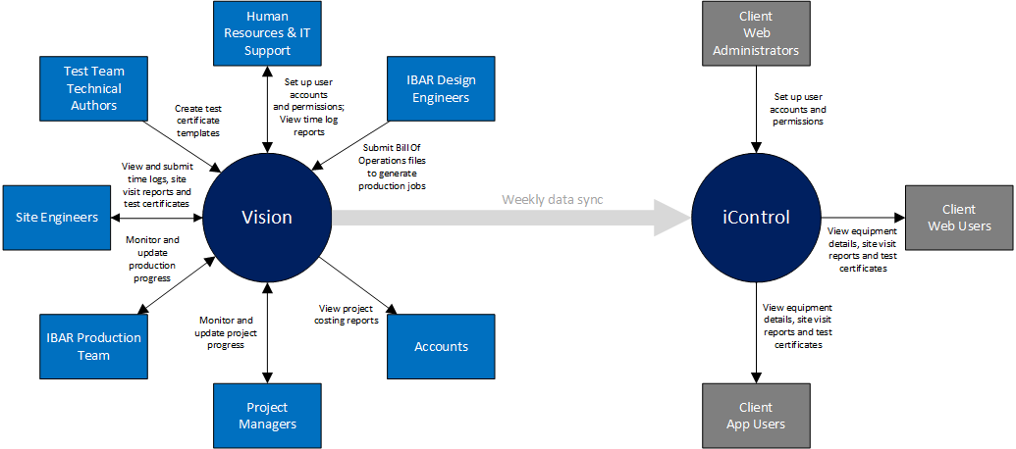

## **Users**

The modules in **Vision** relevant to Project XXXX are utilised by the following users.

* **IT Support** can create user accounts if required (this function can also be performed by the Software Development Team); they will also be able to control the works orders assigned to users with Engineer App ‘Subcontractor’ authorisation level
* **Human Resources** will use the time log reports to track engineer work history; it is anticipated that they will also be able to control the works orders assigned to users with Engineer App ‘Subcontractor’ authorisation level
* The **IBAR Design Engineers** produce the Bill Of Operations Excel files that are used to auto-generate IBAR production batches via the IBAR Importer Windows service
* The **Technical Authors** in the **Test Team** create and upload the test document templates used by the site engineers
* The **Site Engineers** will use the Engineer App to log time, equipment/component details, site visit reports, and test certificates
* The **IBAR Production Team** monitor production batches of IBAR components, ensure labels are printed and attached, and facilitate delivery to site
* The **Project Managers** monitor and update production schedule information
* **Accounts** will use the project costing reports to track project finance

The **iControl** system is utilised by the following users.

* **Administrators** can create user accounts
* **iControl Web Users** will use the web-based iControl system to track the client equipment inventory and service information, and to review site-based activities and testing
* **iControl App Users** will use the iControl iOS app to track the client equipment inventory and service information, and to review site-based activities and testing

## **Process Flow**

The following flow diagrams cover the individual processes affected as part of the Project modifications.

Where a new step has been introduced into the process, the entire step will be highlighted with a light red background.

Where relevant, notes relating to ‘potential workarounds’ have been included; these are alternative short-term solutions that could be expedited more quickly if required, while still delivering the required functionality; it is anticipated that in the event of a workaround being implemented for initial go-live, the additional functionality would still be implemented shortly afterwards.

Note the level of detail of each process diagram will vary from process to process, depending on how specific the area covered by each process is.

### **Permissions**

#### **Vision | User Account Administration**

***Potential workarounds:*** *Use existing Employees screen to create users; use database script to set subcontractor role and works order permissions*

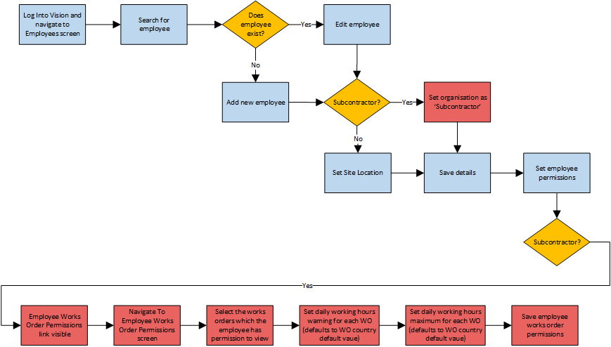

#### **Vision | Subcontractor Login**

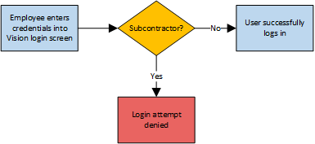

#### **Engineer App | Search | Site Visit Report**

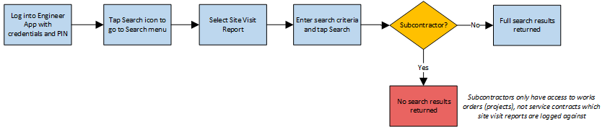

#### **Engineer App | Search | Service Contract**

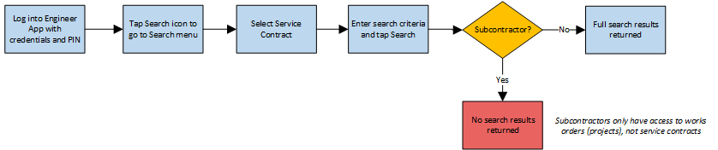

#### **Engineer App | Search | Works Order**

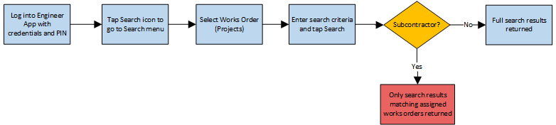

#### **Engineer App | Search | Service Tag Number**

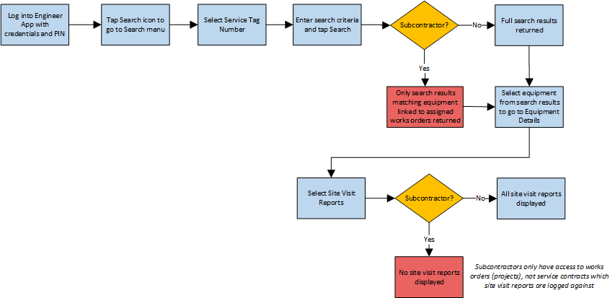

#### **Engineer App | Search | Branch**

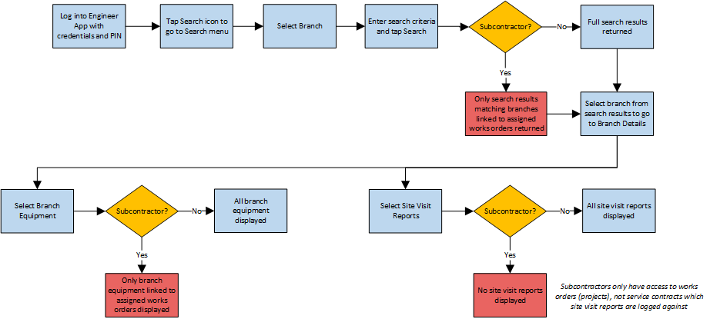

#### **Engineer App | Scan**

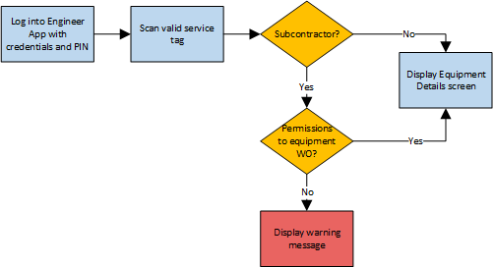

#### **Engineer App | Scan History**

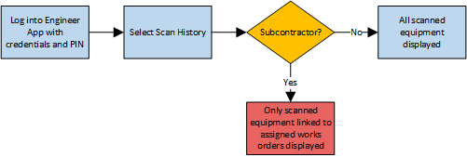

### **IBAR Design**

### **IBAR Production**

#### **Vision | In Production Screen**

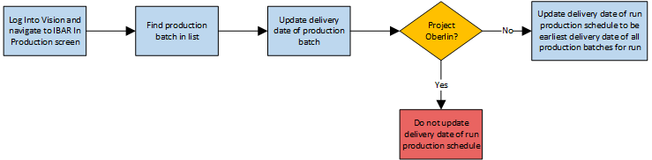

#### **IBAR Manufacturing App | Scanning Components**

*All steps performed using the IBAR Manufacturing App*

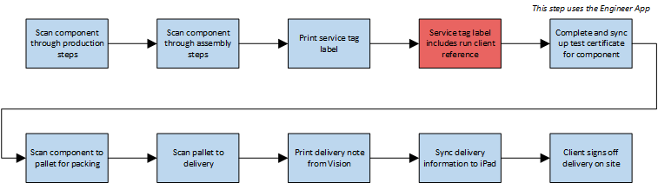

### **Pallet Note**

#### **Vision | Set Works Order Information**



#### **Generate Pallet Note**

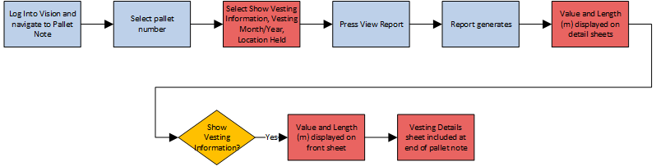

### **Time Logging**

#### **Vision | Set Country Working Hour Limits**

***Potential workarounds:*** *Use database script to set country working hour limits*

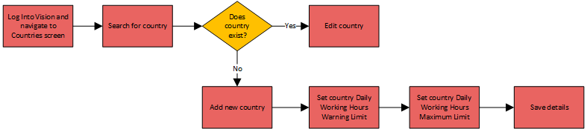

#### **Vision | Site Time Log Administration**

***Potential workarounds:*** *Use database script to administer time logs*



#### **Engineer App | Working Hours Warning Limit**

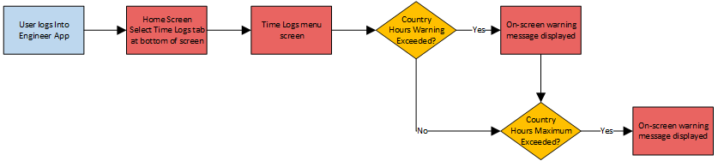

#### **Engineer App | Arrive In New Country**

#### **Engineer App | Arrive In / Leave Country**

#### **Engineer App | Arrive At / Leave Site**

*Note the captured Site links to a Works Order, which in turn links to a Country*

#### **Engineer App | Start / Finish Work**

#### **Engineer App | Log Additional Project Time**

*Note the captured Site links to a Works Order, which in turn links to a Country*

#### **Engineer App | Log Non-Project Time**

### **Site Works**

#### **Engineer App | Language Support**



#### **Engineer App | Scan Master Run Service Tag**

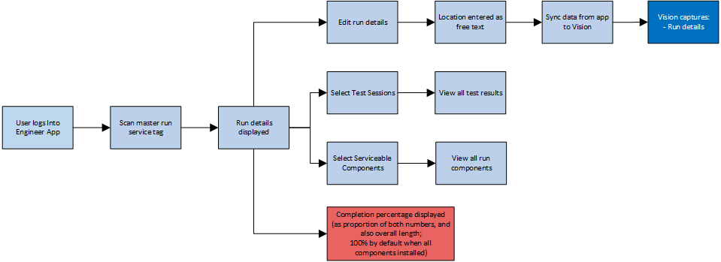

#### **Engineer App | Scan Component Service Tag**

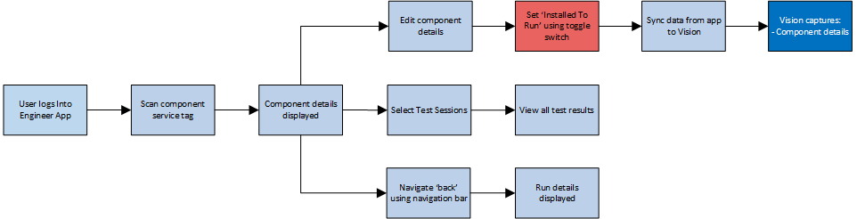

### **Test Certificates**

#### **Vision | Create Test Document Template | Prerequisite Modifications**

*Note this process is a one-time operation to modify existing test certificate templates*

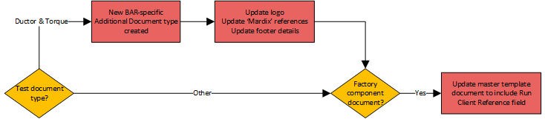

#### **Vision | Create Test Document Template**



#### **Engineer App | Complete Test Certificate**

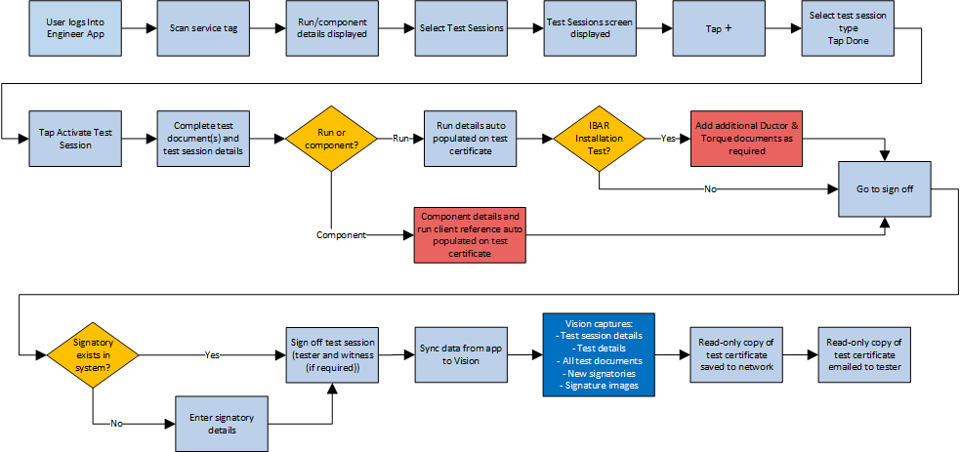

### **iControl**

#### **iDataTransmogrifier**

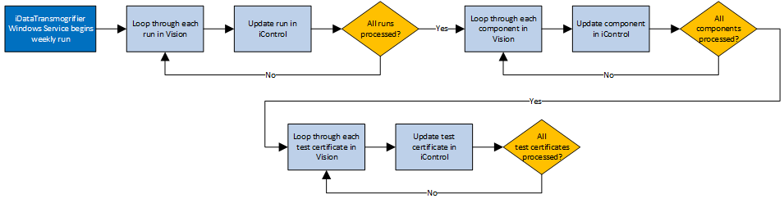

#### **iControl Web | Search for Equipment**

#### **iControl Web | Search for Component**

***Potential workarounds:*** *New features possibly not needed for initial go-live deadline*

#### **iControl App | Scan Master Run Service Tag**

***Potential workarounds:*** *New features possibly not needed for initial go-live deadline*

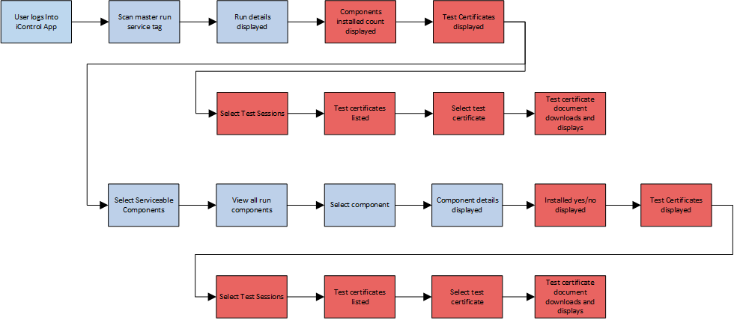

#### **iControl App | Scan Component Service Tag**

***Potential workarounds:*** *New features possibly not needed for initial go-live deadline*

### **Vision Reports**

#### **Site Time Sheet Report**

***Potential workarounds:*** *Possibly not needed for initial go-live deadline*

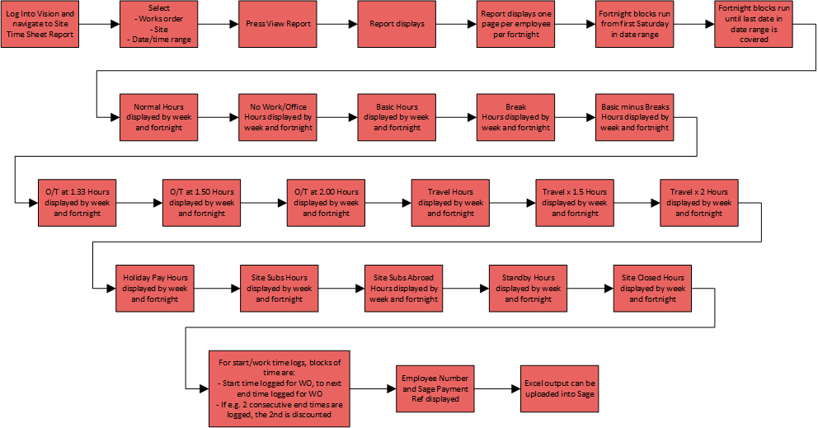

#### **Component Progress Report**

***Potential workarounds:*** *Possibly not needed for initial go-live deadline*

#### **Hours Work Per Country Report**

***Potential workarounds:*** *Possibly not needed for initial go-live deadline*



#### **Hours Work Per Works Order**

***Potential workarounds:*** *Possibly not needed for initial go-live deadline*



#### **Site Time Log Exceptions Report**

***Potential workarounds:*** *New features possibly not needed for initial go-live deadline*

#### **Project Costing Report**

***Potential workarounds:*** *New features possibly not needed for initial go-live deadline*



## **Functional Requirements**

### **Vision**

#### **Login | Subcontractor**

***URL:*** *https://vision.xxxx.co.uk/*

The Vision login screen will accept Email and Password input to login, as per current operation.

**New Functionality**

* If a user whose Organisation is set to ‘Subcontractor’ attempts to login, they will receive the warning message.
  + *You do not currently have permissions to access Vision*

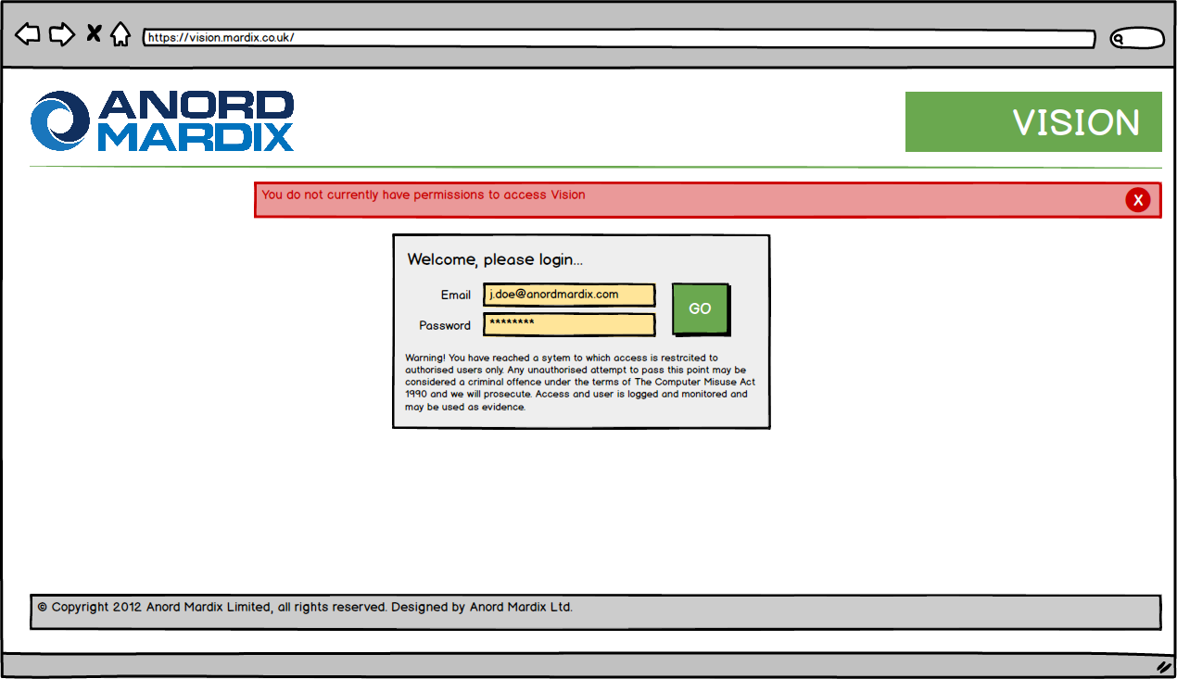

#### **Employees | Grid**

***URL:*** *https://vision.xxxx.co.uk/employees/employees.asp*

***Navigation:*** *Directories > Employees List*

The Vision Employees screen will list all employee and allow navigation to action screens, as per current operation.

**New Functionality**

* For only those users whose Organisation is set to ‘Subcontractor’, the following new link will be displayed in the Actions column.
  + **WO**: Navigates to the Employees Works Order Permissions screen (**7.4.1.4**)

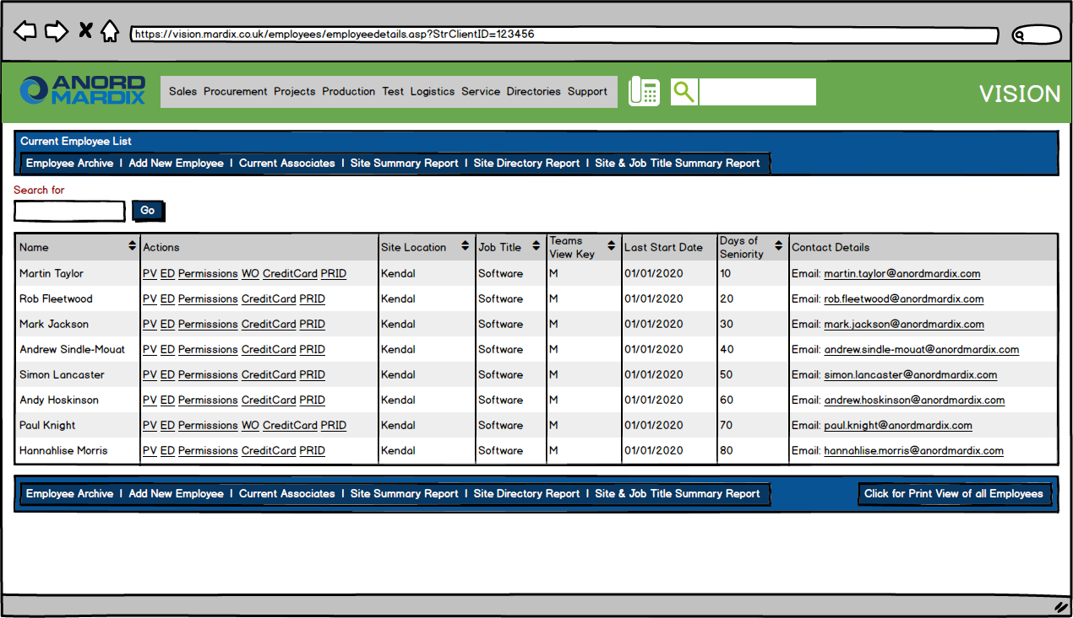

#### **Employees | Add/Edit**

***URL (Add):*** *https://vision.xxxx.co.uk/employees/addemployee.asp*

***URL (Edit):*** *https://vision.xxxx.co.uk/employees/editemployee.asp?strClientID={Employee Id}*

***Navigation (Add):*** *Directories > Employees List; Add New Employee*

***Navigation (Edit):*** *Directories > Employees List; ED*

The Vision Add/Edit Employee screen allow an employee to be created or edited, as per current operation.

**New Functionality**

* The following new fields will be displayed.
  + **Organisation:** The organisation to which the employee belongs; Drop down list; Mandatory; Defaults to ‘XXXX’
    - The following options will be available.
      * XXXX
      * Subcontractor
  + **Current Location:** The current country in which the employee is known to be, used by the Engineer App to detect when a user arrives in a new country; Drop down list; Mandatory; Defaults to ‘United Kingdom’, but changes to ‘Ireland’ when the Site Location is changed to an Ireland-based location
    - All countries will be available as options.

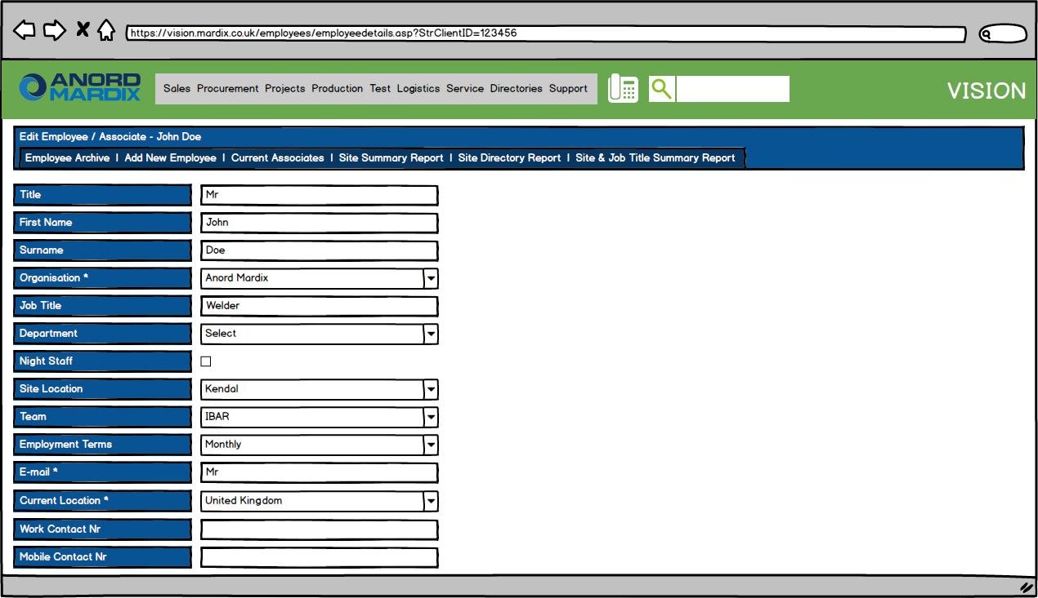

#### **Employees | Works Order Permissions | Grid**

***URL:*** *https://vision.xxxx.co.uk/employees*/*workorderpermissions.asp?employeeid={Employee Id}*

***Navigation:*** *Directories > Employees List > WO*

**New Functionality**

The Vision Employee Works Order Permissions screen is a new screen to allow employee whose organisation is specifically set to ‘Subcontractor’ to be allocated permissions to specific works orders, and to set the daily working hours warning and maximum limits for those works orders.

* Each record denotes a single works order, the data for which the employee will be permitted to access when using the Engineer App.
* The grid can be paged using standard paging controls.
* New records can be added by pressing Add New Record.
* Existing records can be edited by pressing the Edit icon.
* Existing records can be deleted by pressing the Delete icon. This will follow the standard pattern of a single confirmation prompt.

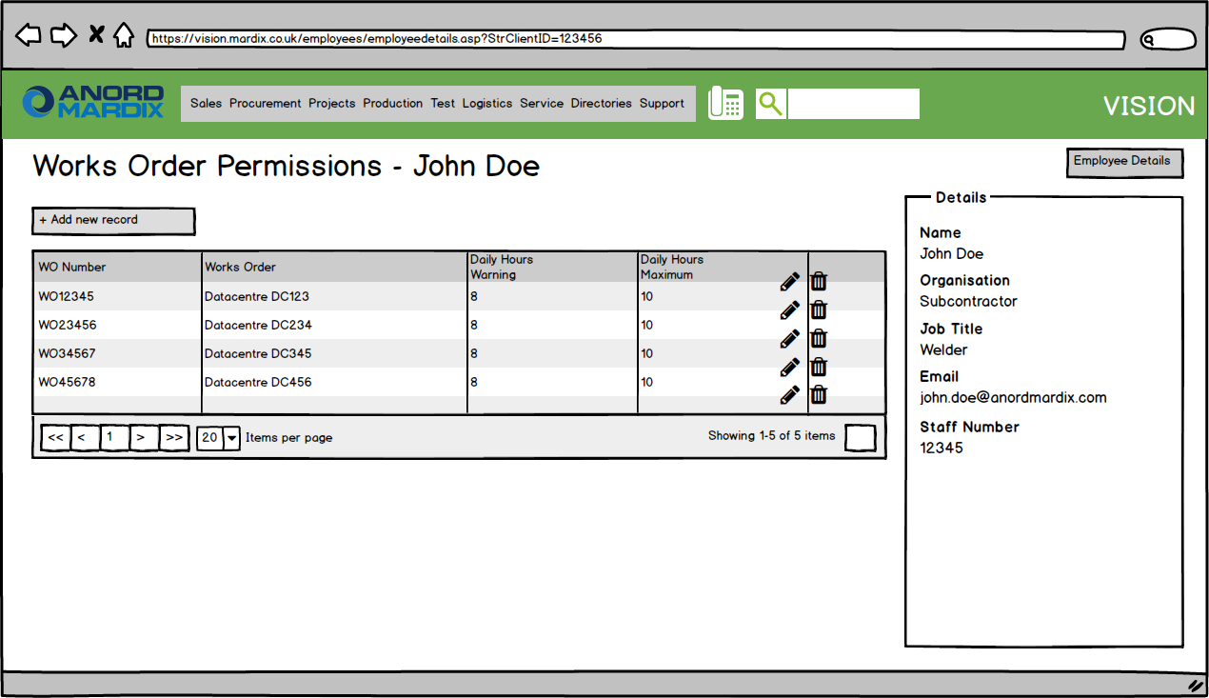

#### **Employees | Works Order Permissions | Add/Edit**

***URL:*** *https://vision.xxxx.co.uk/employees*/*workorderpermissions.asp?employeeid={Employee Id}*

***Navigation (Add):*** *Directories > Employees List > WO > Add New Record*

***Navigation (Edit):*** *Directories > Employees List > WO > Edit*

**New Functionality**

The Vision Employee Works Order Permissions screen is a new screen to allow employee whose organisation is specifically set to ‘Subcontractor’ to be allocated permissions to specific works orders, and to set the daily working hours warning and maximum limits for those works orders.

* Records consist of the following fields.
  + **Works Order:** The works order for which the employee is allowed to view data in the Engineer App; Lookup data, searchable; Mandatory
  + **Daily Working Hours Warning:** The number of daily hours the employee can work before a warning is triggered; Text entry, numeric only; Mandatory; Defaults to the corresponding field on the Works Order’s associated Country record
  + **Daily Working Hours Maximum:** The maximum number of daily hours the employee is allowed to work; Text entry, numeric only; Mandatory; Defaults to the corresponding field on the Works Order’s associated Country record

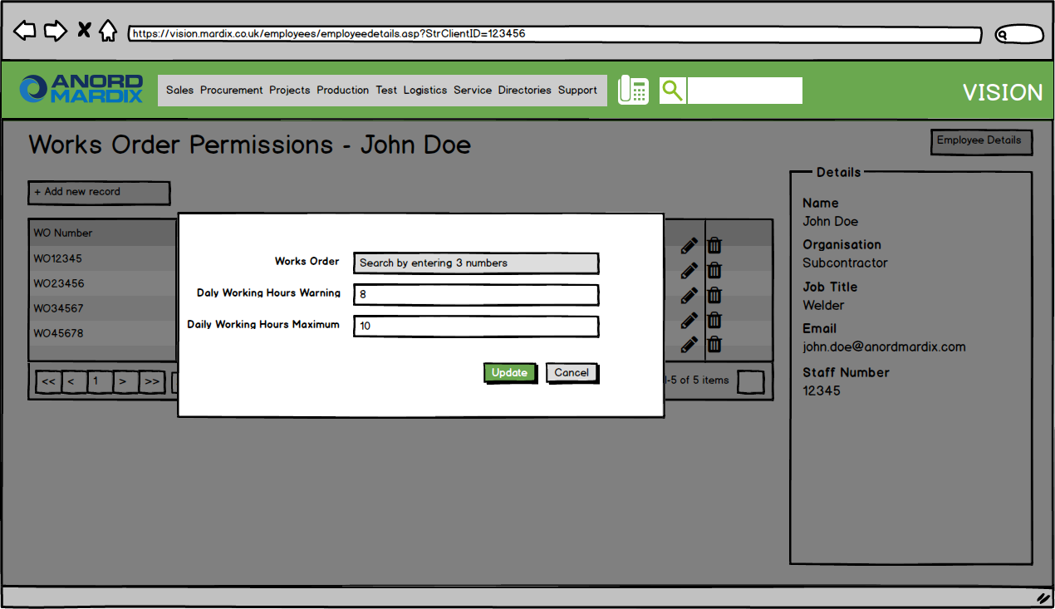

#### **Site Time Logs | Grid**

***URL:*** *https://vision.xxxx.co.uk/timelogs/sitetimelogs*

***Navigation:*** *Directories > Site Time Logs*

**New Functionality**

The Site Time Logs screen is a new screen to allow time log activities logged on site via the Engineer App to be administered and corrected if required.

* Each record denotes a single log entry entered via the Engineer App and synced to Vision.
* The grid can be paged using standard paging controls.
* The grid can be ordered on the following fields.
  + First Name
  + Surname
  + Employee No
  + Country
  + WO Number
  + Service Tag
  + Time Log Type
  + Start Date
  + Finish Date
* All time log types are to be displayed on the grid; this includes
  + Standard time log types
    - Arrive in country
    - Leave country
    - Arrive at site
    - Leave site
  + Project time log types
    - Start work
    - Finish work
    - Travel time
    - Paid rest day
    - Paid hours for no work
    - Site subs (UK)
    - Site subs (Outside UK)
    - Site closed
  + Non-project time log types
    - Public holidays for the country
    - Training
    - College
    - Annual leave
    - Sickness
    - Standby
* For records where a single ‘start’ action is logged via the app (e.g. Enter Country, Start Work) the record will only have a Start time; this is because the corresponding ‘finish’ action will be logged separately at a later date or time, possibly on a different device, and the other device may not have been synced to become aware of the corresponding ‘start’ action.
* For records where a single ‘finish’ action is logged via the app (e.g. Leave Country, Finish Work) the record will only have a Finish time; this is because the corresponding ‘start’ action will have been logged separately at an earlier date or time, possibly on a different device, and the current device may not have been synced to become aware of the corresponding ‘start’ action.
* For records where both the ‘start’ and ‘finish’ times are known (e.g. Training, Annual Leave) the record will have both a Start and Finish time.
* New records can be added by pressing Add New Record.
* Existing records can be edited by pressing the Edit icon.
* Existing records can be deleted by pressing the Delete icon. This will follow the standard pattern of a single confirmation prompt.

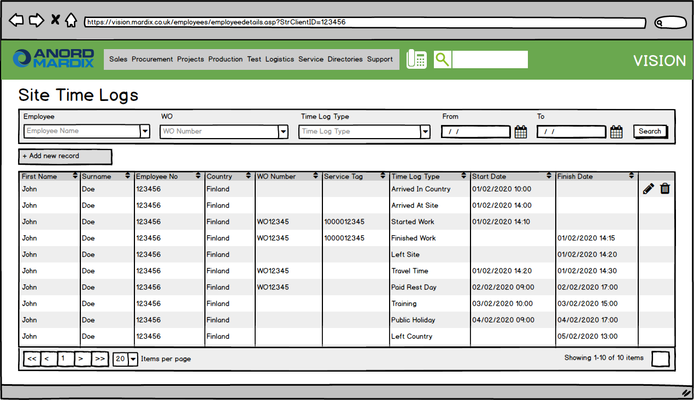

#### **Site Time Logs | Add/Edit**

***URL:*** *https://vision.xxxx.co.uk/timelogs/sitetimelogs*

***Navigation (Add):*** *Directories > Site Time Logs > Add New Record*

***Navigation (Edit):*** *Directories > Site Time Logs > WO > Edit*

**New Functionality**

The Site Time Logs screen is a new screen to allow time log activities logged on site via the Engineer App to be administered and corrected if required.

* Records consist of the following fields.
  + **Employee:** The employee name and number; Lookup data, searchable; Mandatory
  + **Country:** The country the time log entry relates to; Drop down list; Mandatory
  + **Site:** The client site the time log entry relates to; Lookup data, searchable
  + **Works Order:** The works order the time log entry relates to; Lookup data, searchable
  + **Service Tag:** The service tag the time log entry relates to; Text entry, numeric only, exactly 10 digits required
  + **Time Log Type:** The type of time log entry; Drop down list; Mandatory
  + **Start Date:** The start date of the time log; Date selector; Mandatory for the following time log types
    - Arrive in country
    - Arrive at site
    - Start work
    - Travel time
    - Paid rest day
    - Paid hours for no work
    - Site subs (UK)
    - Site subs (Outside UK)
    - Site closed
    - Public holidays for the country
    - Training
    - College
    - Annual leave
    - Sickness
    - Standby
  + **Finish Date:** The finish date of the time log; Date selector; Mandatory for the following time log types
    - Leave country
    - Leave site
    - Finish work
    - Travel time
    - Paid rest day
    - Paid hours for no work
    - Site subs (UK)
    - Site subs (Outside UK)
    - Site closed
    - Public holidays for the country
    - Training
    - College
    - Annual leave
    - Sickness
    - Standby

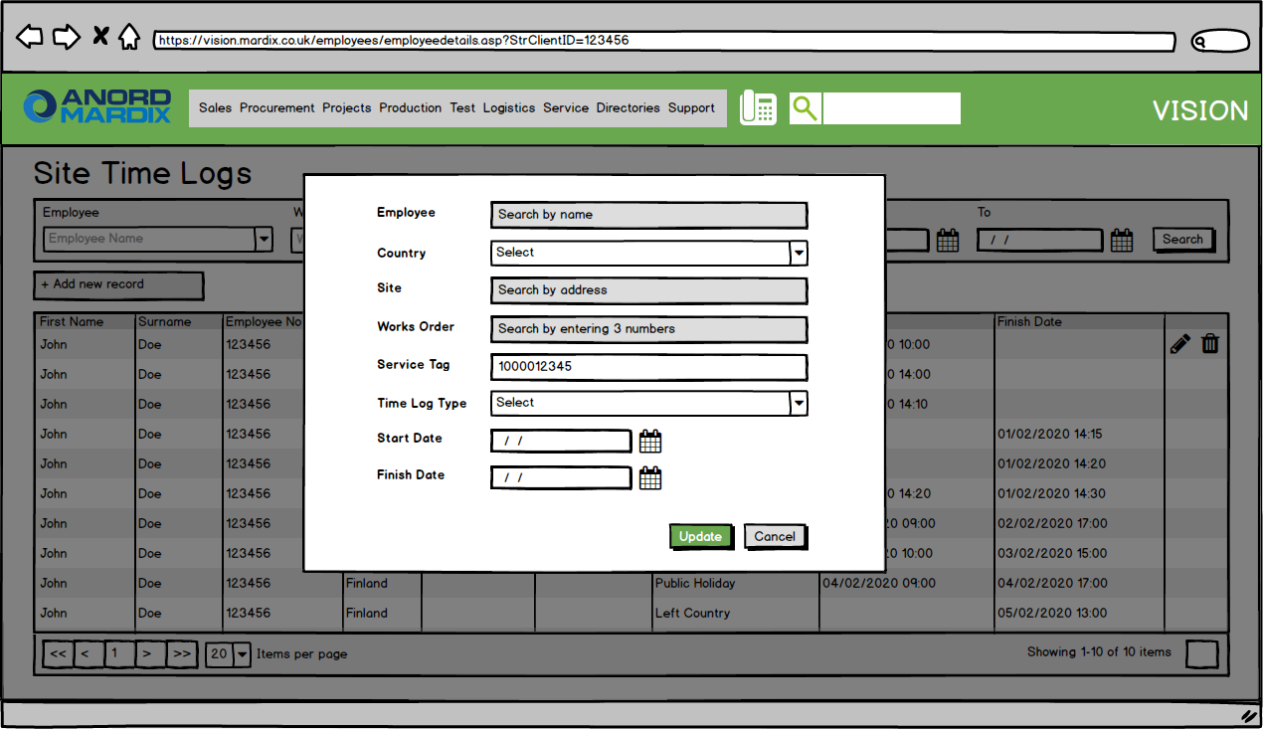

#### **Production Time Logs**

***URL:*** *https://vision.xxxx.co.uk/timelogs/timelogs*

***Navigation (Edit):*** *Directories > Production Time Logs*

**New Functionality**

The existing Vision menu entry

* **Directories** > **Employee Time Logs**

will be renamed in the menu to the following

* **Directories** > **Production Time Logs**

This is to distinguish from the new Site Time Logs screen which, although similar in nature, represents an entirely different dataset.

#### **Countries | Grid**

***URL:*** *https://vision.xxxx.co.uk/countries.asp*

***Navigation:*** *Directories > Countries*

**New Functionality**

The Vision Countries screen is a new screen to allow country reference data to be administered.

* Each record denotes a single country.
* The grid can be paged using standard paging controls.
* New records can be added by pressing Add New Record.
* Existing records can be edited by pressing the Edit icon.
* No records can be deleted.

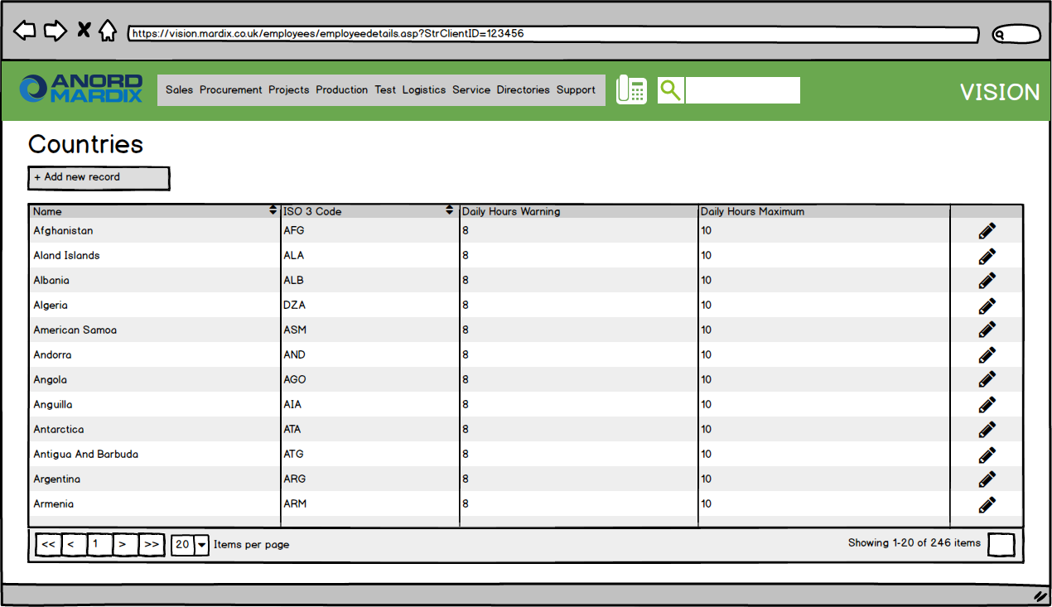

#### **Countries | Edit**

***URL:*** *https://vision.xxxx.co.uk/countries.asp*

***Navigation (Add):*** *Directories > Countries > Add New Record*

***Navigation (Edit):*** *Directories > Countries > WO > Edit*

**New Functionality**

The Vision Countries screen is a new screen to allow country reference data to be administered.

* Records consist of the following fields.
  + **Name:** The name of the country; Text entry; Mandatory; Validation: No duplicates
  + **ISO 2 Code:** The 2 letter country code defined in ISO 3166-1; Text entry; Mandatory; Validation: No duplicates
  + **ISO 3 Code:** The 3 letter country code defined in ISO 3166-1; Text entry; Mandatory; Validation: No duplicates
  + **ISO Numeric:** The 3 digit numeric country code defined in ISO 3166-1; Text entry, numeric; Mandatory; Validation: No duplicates
  + **Currency:** The official currency of the country; Drop down list
  + **Daily Working Hours Warning:** The number of daily hours an employee can work before a warning is triggered; Text entry, numeric only
  + **Daily Working Hours Maximum:** The maximum number of daily hours an employee is allowed to work; Text entry, numeric only

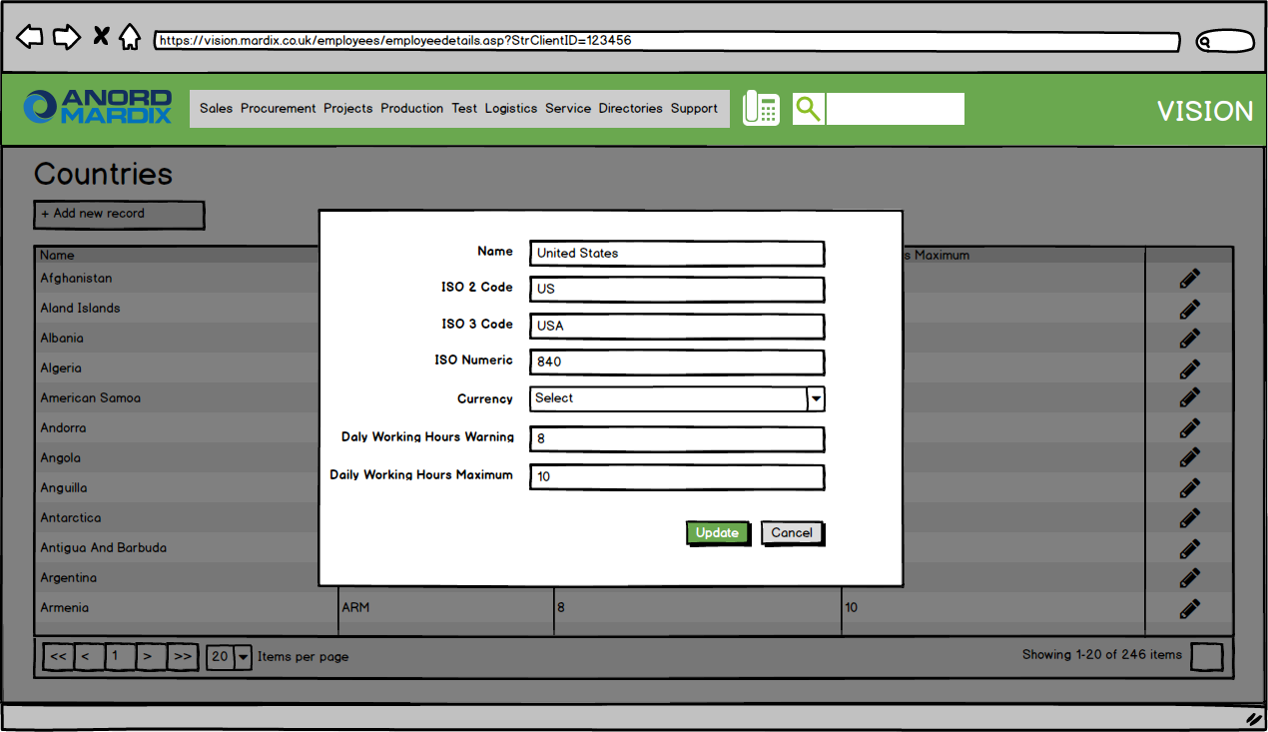

#### **Works Orders | Edit**

***URL:*** *https://vision.xxxx.co.uk/worksbook/estimate_edit.asp?StrEID={Works Order Id}*

***Navigation:*** *Projects > Works Order List > ED*

The Vision Works Order Edit screen will allow existing works orders to be modified, as per current operation.

**New Functionality**

* Records include the following new fields.
  + **Held To Order Text:** The text to display for the ‘Held to order’ field on the Vesting Information sheet of the pallet note (**7.4.5**); Text entry

*Functionality already live and included retrospectively; Live screenshot used*

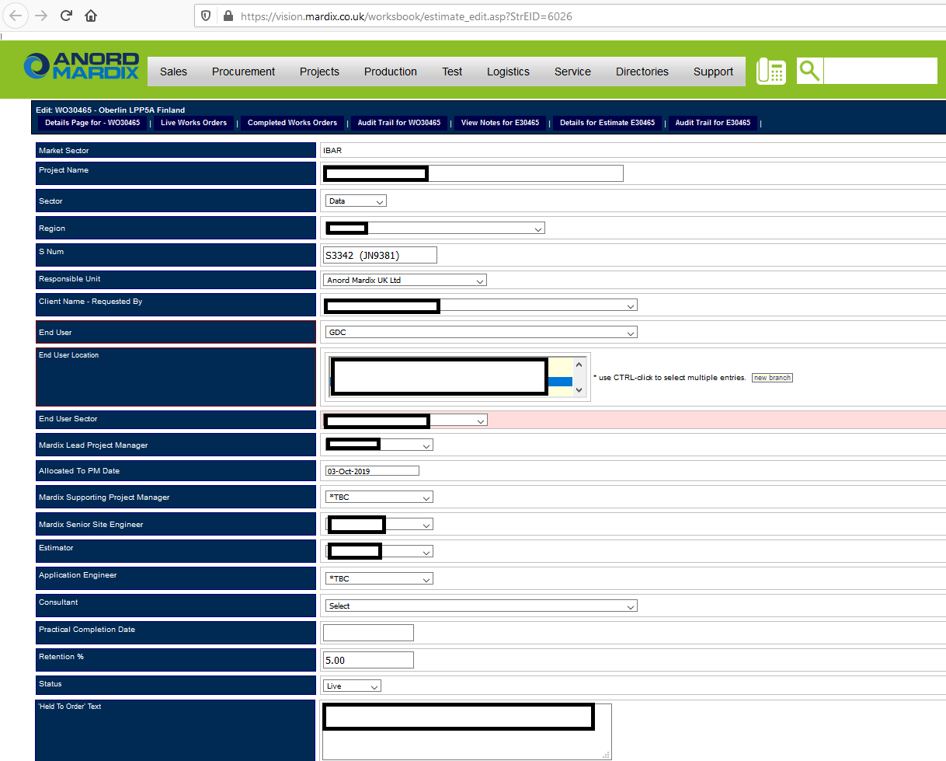

#### **Production Schedule**

***URL:*** *https://vision.xxxx.co.uk/ps_qmf_list.asp?p1a=789a*

***Navigation:*** *Production > Production Schedule*

The Vision Production Schedule screen allows all production lines to be monitored and administered, as per current operation.

* When pressing ‘Equip’ to view the details of a run, the following information is displayed.
  + **Client Reference:** The client’s own reference for the run
  + **Location On-Site:** The location on site where the run is located

**New Functionality**

* When pressing ‘Equip’ to view the details of an IBAR run, the following information is displayed.
  + **Installed:** The number of components installed to the run on site, vs the total components making up the run, in the format x/y

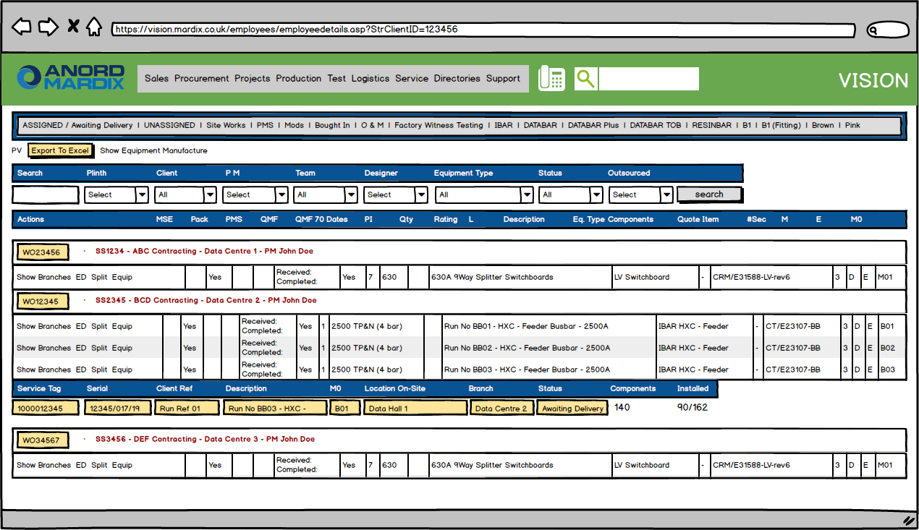

#### **In Production**

***URL:*** *https://vision.xxxx.co.uk/production/in-production.asp?marketsectorids=7*

***Navigation:*** *Production > IBAR In Production*

The Vision In Production screen allows all IBAR production batches to be monitored and administered, as per current operation.

**New Functionality**

* The number of components installed to the run on site, vs the total components in the batch, is displayed at the end of each row in the format x/y
* When pressing the Delivery cell and setting the delivery date of the batch, for Project XXXX only, the related production schedule line’s delivery date is not updated (for other IBAR projects the default behaviour is that the production schedule delivery date is set to the earliest production batch)

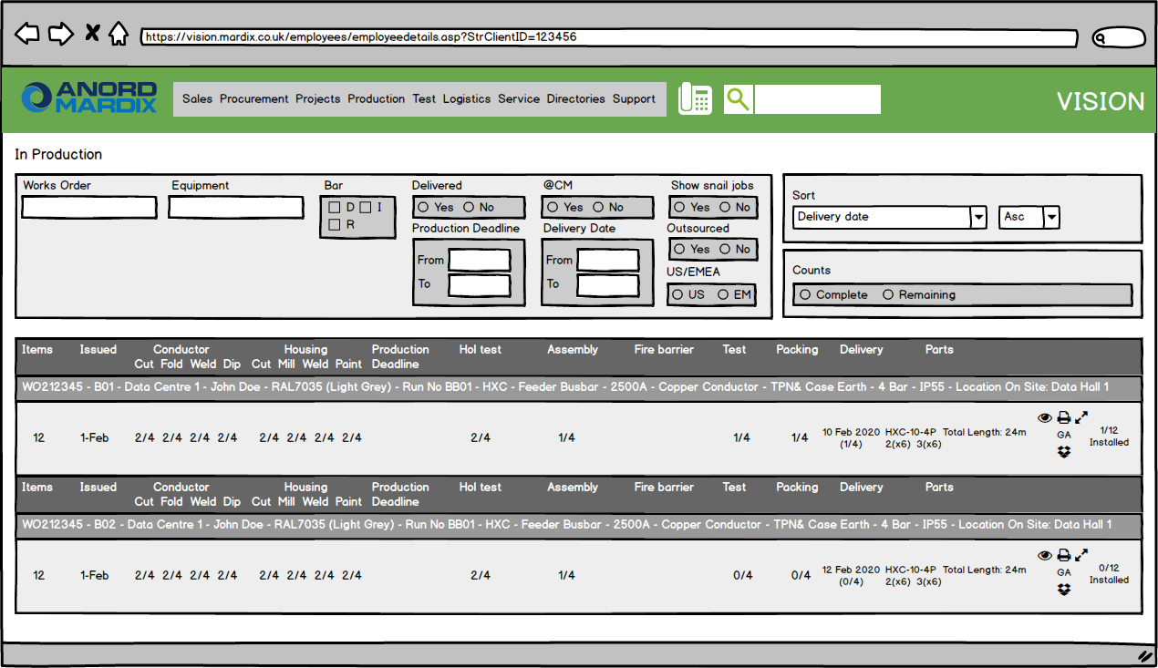

#### **Emails | Site Visit Reports**

Automated emails will be generated upon sign off of site visit reports, as per current operation.

**New Functionality**

* The emails will be updated to use Company branding

#### **Emails | Test Sessions**

Automated emails will be generated upon sign off of test sessions, as per current operation.

**New Functionality**

* The emails will be updated to use Company branding

### **Engineer App**

#### **Home**

***Navigation:*** *Default screen*

**New Functionality**

* A new option is available in the tab bar at the bottom of the screen, ‘Time Logs’; this is used to navigate to the new Time Logs section in the app



#### **Home | Alternative Language**

***Navigation:*** *Default screen*

**New Functionality**

* When the device has its language set to Bulgarian, all in-app navigation, text and instructions will be automatically translated to Bulgarian
  + This applies to all screens in the app; the home screen is shown here for illustration purposes
  + Any data pulled from Vision via the data sync will not be translated; this includes e.g. run descriptions and additional/non-project time log types such as ‘Travel’ and ‘Public Holidays’



#### **Search | Menu**

***Navigation:*** *Home > Search*

The Engineer App search menu lists all data types that can be searched, as per current operation.

**New Functionality**

* When a search has been performed
  + Employees whose organisation is set to ‘Company’ will be able to view all search results
  + Employees whose organisation is set to ‘Subcontractor’ will only be able to view search results relevant to the works orders that they have specifically been given access to (**7.4.1.5**)
* Subsequent sections detail the specific effects of the filtering for each data type.

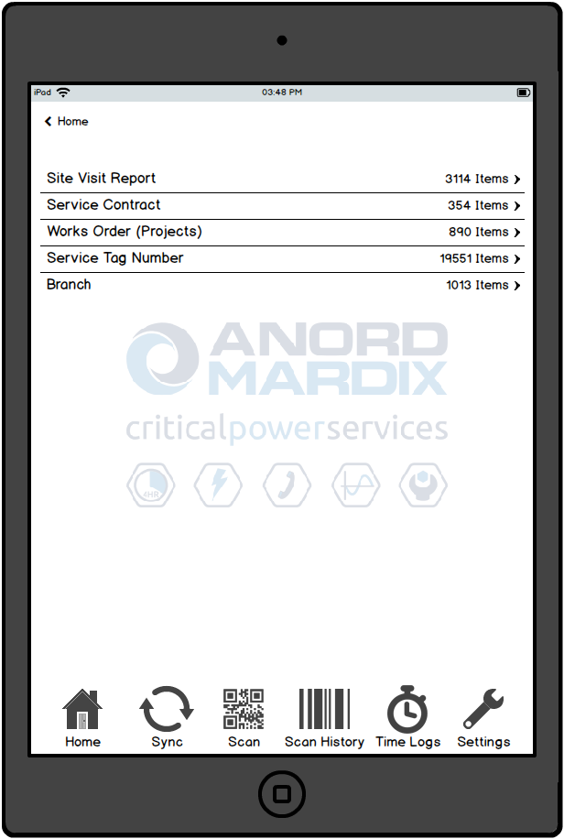

#### **Search | Site Visit Report**

***Navigation:*** *Home > Search*

The Engineer App site visit report search allows site visit reports to be searched by CPS number, engineer and site visit status, as per current operation.

**New Functionality**

* When a search has been performed
  + Employees whose organisation is set to ‘Company’ will be able to view all search results
  + Employees whose organisation is set to ‘Subcontractor’ will not be able to view any search results, as they only have access to works order (project) information, not service-related information

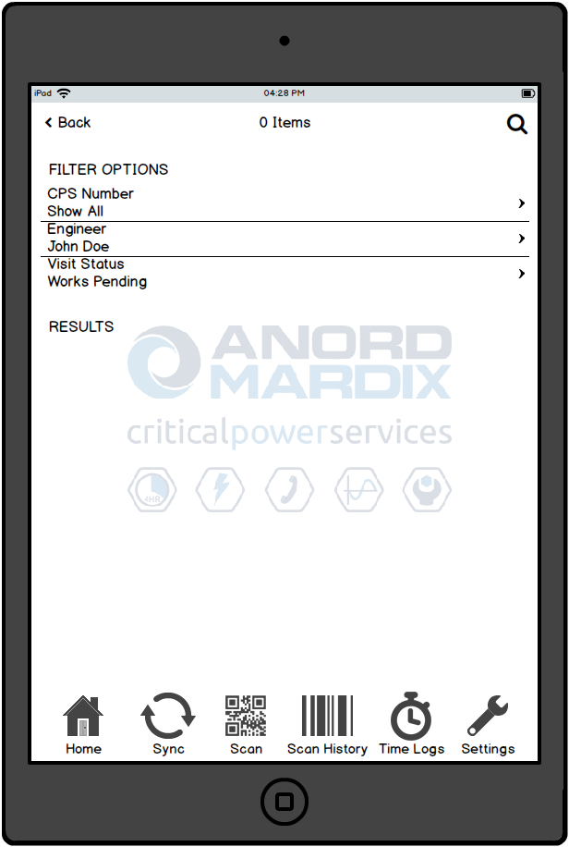

#### **Search | Service Contract**

***Navigation:*** *Home > Search*

The Engineer App service contract search allows service contracts to be searched by CPS number, as per current operation.

**New Functionality**

* When a search has been performed
  + Employees whose organisation is set to ‘Company’ will be able to view all search results
  + Employees whose organisation is set to ‘Subcontractor’ will not be able to view any search results, as they only have access to works order (project) information, not service-related information

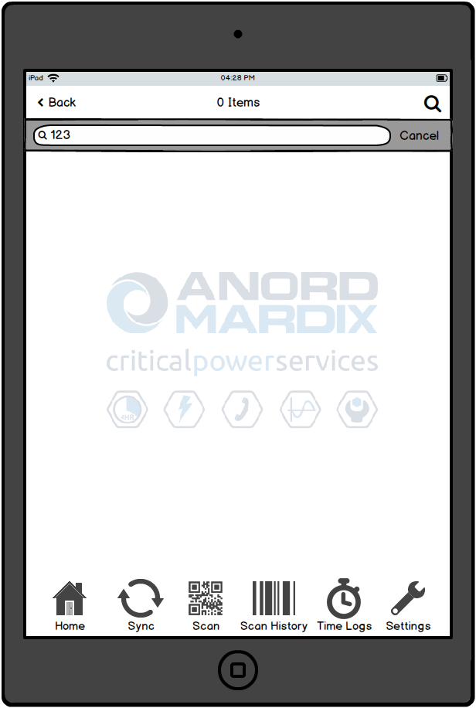

#### **Search | Works Order**

***Navigation:*** *Home > Search*

The Engineer App works order search allows works orders to be searched by works order number, as per current operation.

**New Functionality**

* When a search has been performed
  + Employees whose organisation is set to ‘Company’ will be able to view all search results
  + Employees whose organisation is set to ‘Subcontractor’ will only be able to view search results including works orders that they have specifically been given access to (**7.4.1.5**)

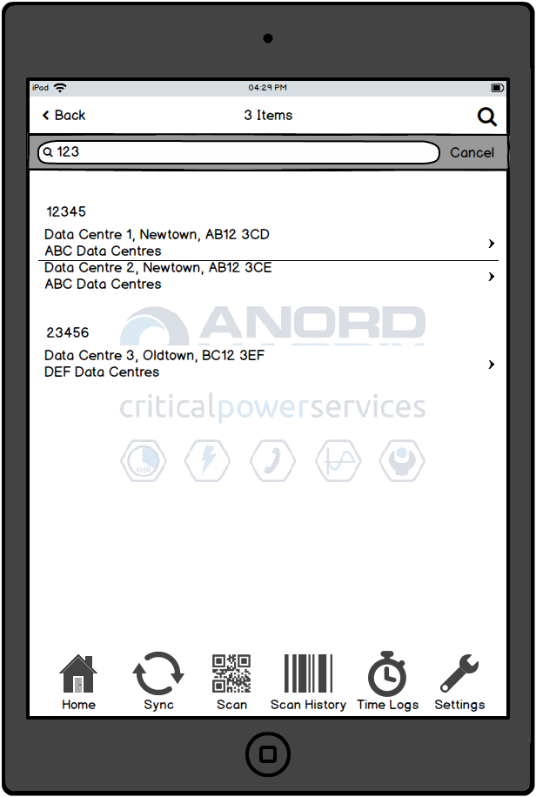

#### **Search | Service Tag Number**

***Navigation:*** *Home > Search*

The Engineer App service tag number search allows equipment and components to be searched by service tag number, as per current operation.

**New Functionality**

* When a search has been performed
  + Employees whose organisation is set to ‘Company’ will be able to view all search results
  + Employees whose organisation is set to ‘Subcontractor’ will only be able to view search results including equipment whose works orders that they have specifically been given access to (**7.4.1.5**)

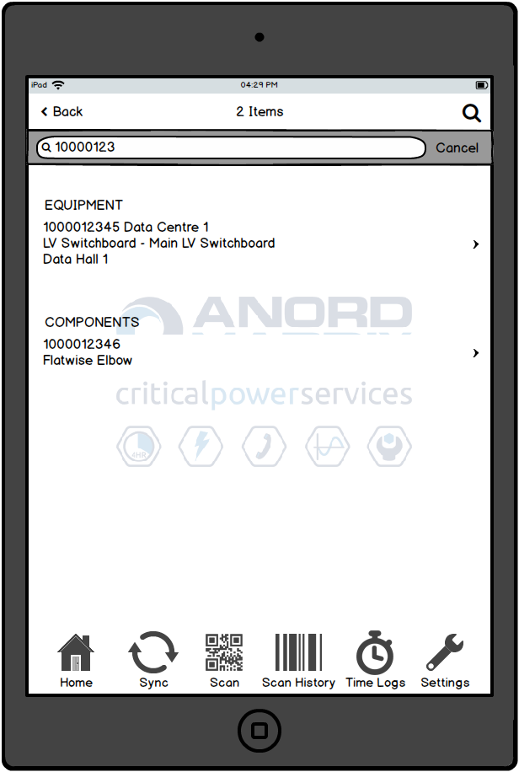

#### **Search | Branch**

***Navigation:*** *Home > Search*

The Engineer App branch search allows client sites to be searched by name and address, as per current operation.

**New Functionality**

* When a search has been performed
  + Employees whose organisation is set to ‘Company’ will be able to view all search results
  + Employees whose organisation is set to ‘Subcontractor’ will only be able to view search results including branches linked to works orders that they have specifically been given access to (**7.4.1.5**)

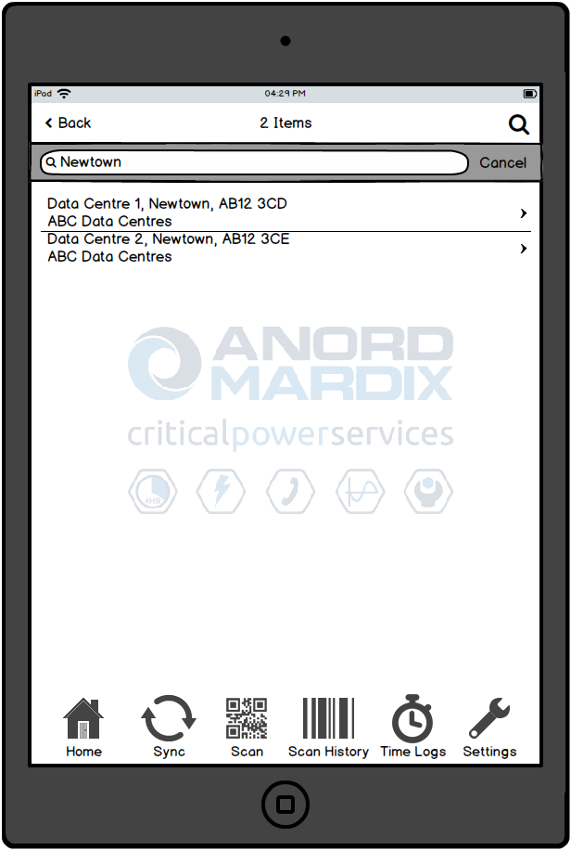

#### **Scan | Permission Denied**

***Navigation:*** *Scan*

The Engineer App scan functionality allows equipment and component service tag numbers to be scanned in order to display their details, as per current operation.

**New Functionality**

* When a scan has been performed
  + Employees whose organisation is set to ‘Company’ will be able to view all search results
  + Employees whose organisation is set to ‘Subcontractor’ will only be able to scan equipment whose works orders that they have specifically been given access to (**7.4.1.5**)
  + Scanning the service tag of an equipment item for a works order the user does not have permission to, will receive the following error message

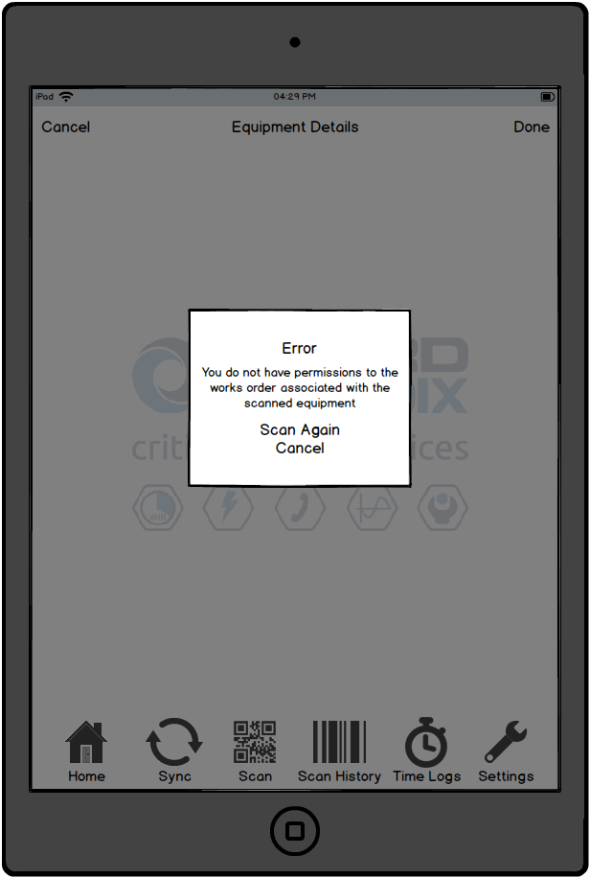

#### **Scan History**

***Navigation:*** *Scan History*

The Engineer App scan history allows the details of previously scanned equipment and components to be displayed, as per current operation.

**New Functionality**

* When viewing the Scan History screen
  + Employees whose organisation is set to ‘Company’ will be able to view all scanned equipment
  + Employees whose organisation is set to ‘Subcontractor’ will only be able to view scanned equipment whose works orders that they have specifically been given access to (**7.4.1.5**)

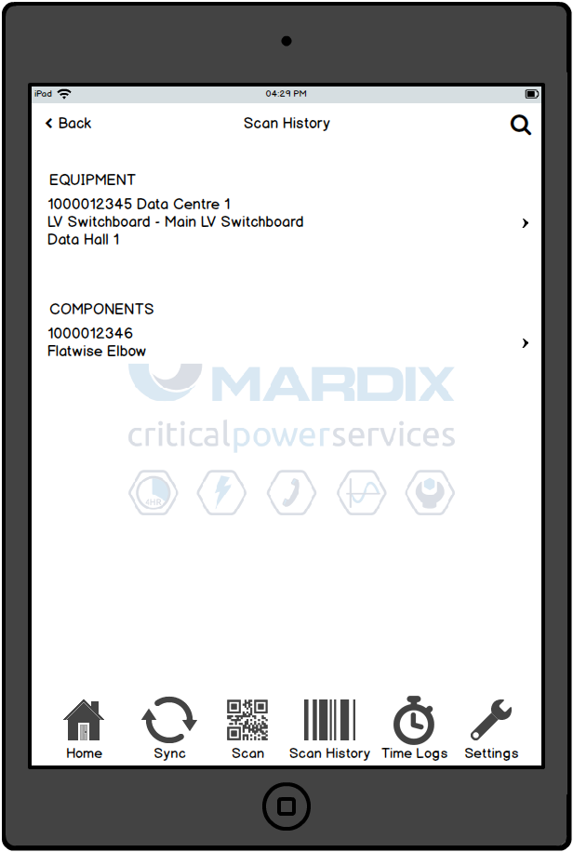

#### **Country Change Prompt**

***Navigation:*** *Default screen*

**New Functionality**

* When the app is launched, and the app detects that the user is now in a different country, a prompt will be displayed forcing the user to go to the Arrive In/Leave Country screen (**7.4.2.14**)
* The user will be determined to be in a different country if the synced data in the app’s local database has either
  + a different country logged as the user’s last known location
  + no country logged as the user’s last known location (e.g. first run of the device following installation of the app)
* The user will only have a single option available via the prompt, ‘Log Arrival’, which will force them to the Arrive In/Leave Country screen (**7.4.2.14**)
* When taken to the Arrive In/Leave Country screen (**7.4.2.14**), the current detected country will be auto-populated as the device’s new location
* Upon initial release, all users will have their country location backfilled by default to the United Kingdom or Ireland by script; this will avoid the prompt unnecessarily flagging up for all app users, while still ensuring that any users arriving in a different country will still receive the prompt as expected
* For cellular iPads, the GPS will allow the country change to be detected as soon as the app is launched in the new country, regardless of whether the app is connected to wi-fi
* For wi-fi only iPads, the country change will be detected the first time the app is launched when connected to wi-fi in the new country; in this case, the arrival date can be modified to reflect the actual arrival time

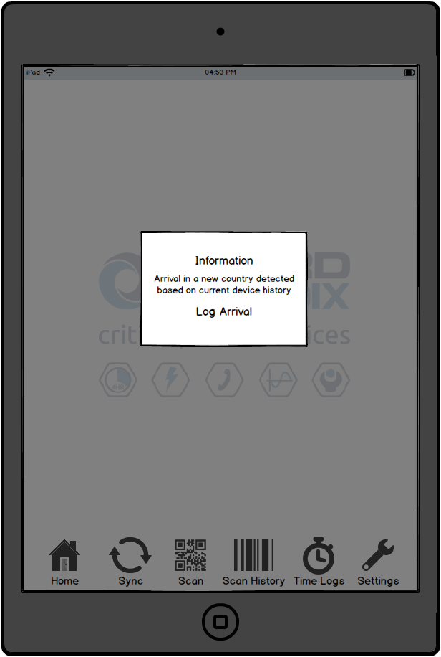

#### **Time Logs | Menu**

***Navigation:*** *Time Logs*

**New Functionality**

* A new section ‘Time Logs’ will now be available within the app
* The section can be accessed by pressing the ‘Time Logs’ tab on the tab bar at the bottom of the screen
* The initial screen in the new section will list any previously logged time logs for the user
* Selecting a previous time log will allow the time log to be edited via the Add/Edit screen (the relevant screen from **7.4.2.14** onwards, depending on the type of time log being edited)
* Pressing ‘+’ in the navigation bar at the top of the screen will allow a new time log to be created via the Add screen (**7.4.2.13**)
* Any time logs created, but not yet synced up, can be deleted by swiping right-to-left to reveal a hidden delete icon

#### **Time Logs | Add**

***Navigation:*** *Time Logs > +*

**New Functionality**

* A new option within the ‘Time Logs’ section to allow users to create a new time log
* The initial Add screen will allow the type of time log being created to be selected.
  + Arrive In/Leave Country: Allows the user to log arrival in, or departure from, a country; navigates to Arrive In/Leave Country (**7.4.2.14**)
  + Arrive At/Leave Site: Allows the user to log arrival at, or departure from, a client site
  + Start/Finish Work: Allows the user to log starting or finishing work on a particular equipment item or works order
  + Additional Project Time: Allows the user to log a block of work related to a project, other than a standard work log
  + Non-Project Time: Allows the user to log a block of work not related to a project

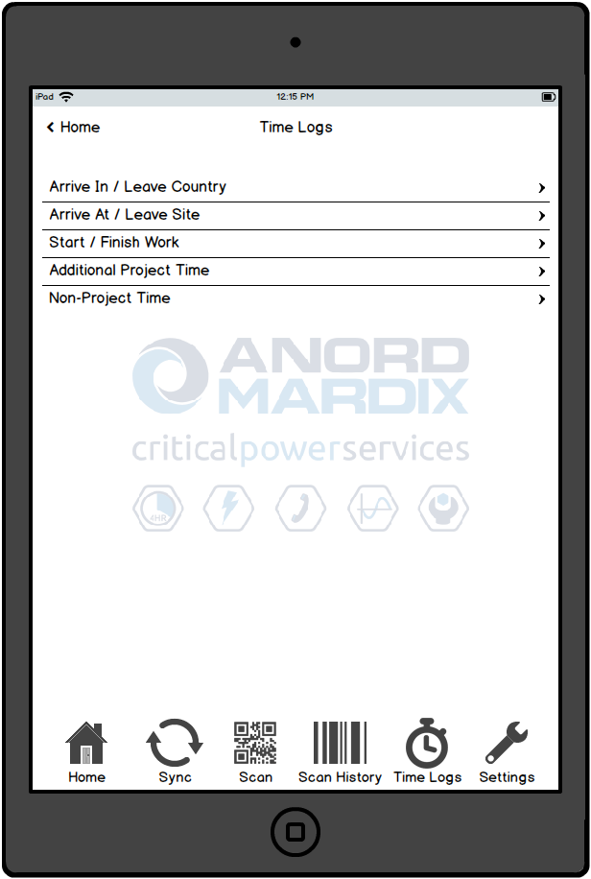

#### **Time Logs | Arrive In/Leave Country**

***Navigation (Add):*** *Time Logs > + > Arrive In/Leave Country*

***Navigation (Edit):*** *Time Logs > Edit existing Arrive In/Leave Country record*

**New Functionality**

* A new option within the ‘Time Logs’ section to allow users to log arrival in, or departure from, a country
* Used to create a new record when adding, or modify an existing one when editing
* The user will select the following details to be included in the log.
  + **Country:** The country the user is arriving in or leaving; Selection list; Mandatory; When Arrive In/Leave Country has been arrived at from the Country Change Prompt screen (**7.4.2.11**) the new country will be automatically selected
  + **Arrive/Leave** The action being logged; Selection list; Mandatory; When Arrive In/Leave Country has been arrived at from the Country Change Prompt screen ‘Arrive’ will be automatically selected
    - The following options will be available.
      * Arrive
      * Leave
  + **Date/Time:** The date and time of arrival or departure; Date/time picker; Mandatory
* The time log type will be set to ‘Country Change’ under the ‘Non-Project’ category
* The Done button will be used to commit the log (for new time logs only)
* The Done button will be disabled until all mandatory fields are completed
* When editing an existing time log, no Done button is displayed, and changes are instead saved as they are made
* If the user has arrived directly from the Country Change Prompt screen (**7.4.2.11**), the Back button and tab bar at the bottom of the screen will be disabled until the arrival has been logged
* If the user has arrived directly from the Country Change Prompt screen (**7.4.2.11**), and the last time log on the device (prior to the Arrival just logged) is ***not*** a departure from the last known location, then following submission of the time log, all navigation options will be re-enabled and the user will be taken to a new instance of this screen, with the last known country (if any) and ‘Leaving’ both automatically selected; a prompt will ask the user to log their departure from the previous country if they have not already done so
  + Unlike the ‘Arrival’ screen, the user will be able to navigate away from this screen, as their departure may have been logged on a separate device

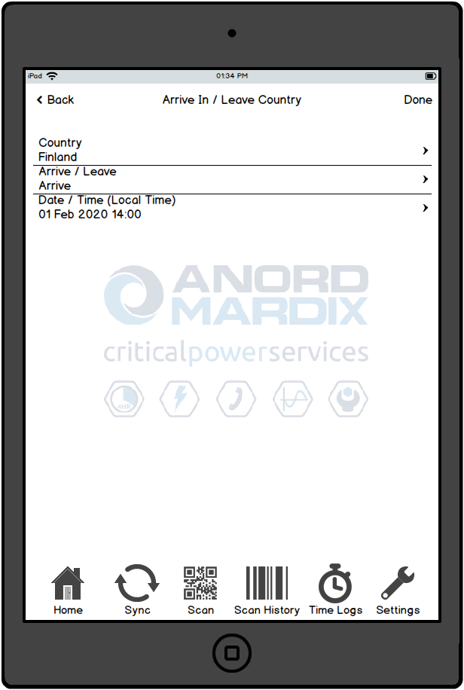

#### **Time Logs | Arrive In/Leave Country | Select Country**

***Navigation (Add):*** *Time Logs > + > Arrive In/Leave Country > Country*

***Navigation (Edit):*** *Time Logs > Edit existing Arrive In/Leave Country record > Country*

**New Functionality**

* When adding or editing an Arrive In/Leave Country time log, the user will select the country from a selection list
* Selecting a country will set that country for the time log, and immediately navigate back to the time log details screen
* When a country has previously been selected, when navigating back to this screen by pressing ‘Country’ again, the selected country will be highlighted with a grey background and the list will automatically scroll to display that country in the middle of the list

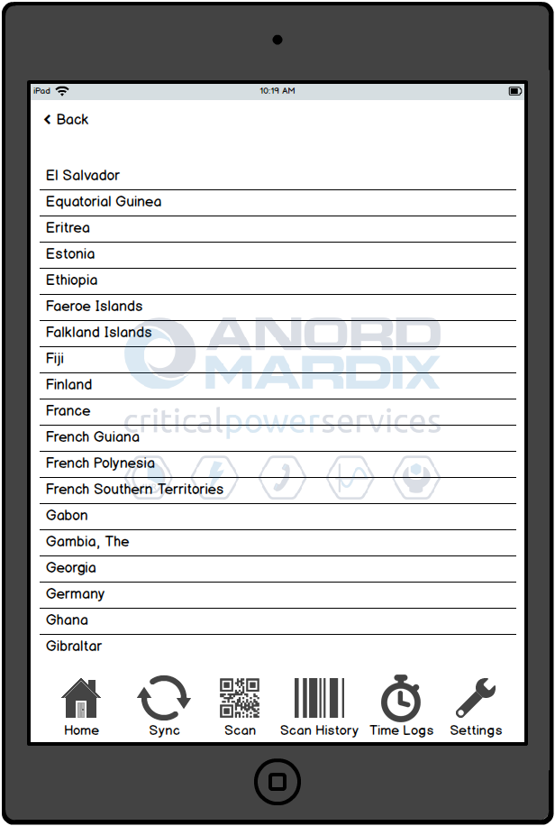

#### **Time Logs | Arrive In/Leave Country | Select Arrive / Leave**

***Navigation (Add):*** *Time Logs > + > Arrive In/Leave Country > Arrive/Leave*

***Navigation (Edit):*** *Time Logs > Edit existing Arrive In/Leave Country record > Arrive/Leave*

**New Functionality**

* When adding or editing an Arrive In/Leave Country time log, the user will select the action from a selection list
  + The following options will be available.
    - Arrive
    - Leave
* Selecting an action will set that action for the time log, and immediately navigate back to the time log details screen
* When an action has previously been selected, when navigating back to this screen by pressing ‘Arrive/Leave’ again, the selected action will be highlighted with a grey background and the list will automatically scroll to display that action in the middle of the list

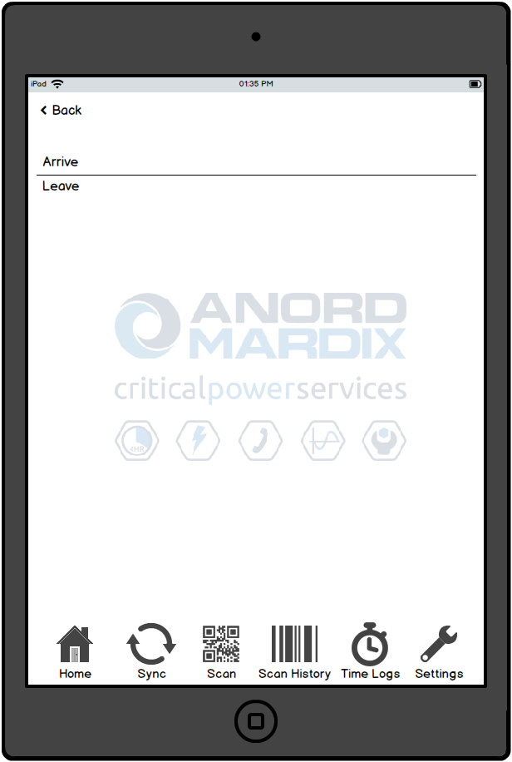

#### **Time Logs | Arrive In/Leave Country | Select Date / Time**

***Navigation (Add):*** *Time Logs > + > Arrive In/Leave Country > Date/Time*

***Navigation (Edit):*** *Time Logs > Edit existing Arrive In/Leave Country record > Date/Time*

**New Functionality**

* When adding or editing an Arrive In/Leave Country time log, the user will select the date/time from a date/time picker
* The selected date is also displayed in the ‘Selected Date’ section
* After setting the date and time, navigating back to the time log details screen via the ‘< Back’ button will set the date/time for the time log
* When a date/time has previously been selected, when navigating back to this screen by pressing ‘Date/Time’ again, the date/time picker and ‘Selected Date’ will both display the selected date/time
* Pressing the Clear button will clear the selected date

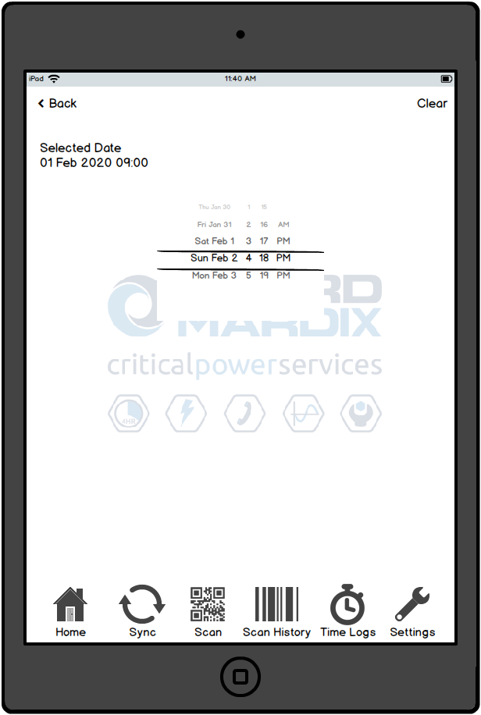

#### **Time Logs | Arrive At/Leave Site**

***Navigation (Add):*** *Time Logs > + > Arrive At/Leave Site*

***Navigation (Edit):*** *Time Logs > Edit existing Arrive At/Leave Site record*

**New Functionality**

* A new option within the ‘Time Logs’ section to allow users to log arrival at, or departure from, a site
* Used to create a new record when adding, or modify an existing one when editing
* The user will select the following details to be included in the log.
  + **Site:** The site the user is arriving at or leaving; Search lookup; Mandatory
  + **Works Order:** Read-only field, set automatically when the Site is selected
  + **Arrive/Leave:** The action being logged; Selection list; Mandatory
    - The following options will be available.
      * Arrive
      * Leave
  + **Date/Time:** The date and time of arrival or departure; Date/time picker; Mandatory
* The time log type will be set to ‘Site Attendance’ under the ‘Project’ category
* The Done button will be used to commit the log (for new time logs only)
* The Done button will be disabled until all mandatory fields are completed
* When editing an existing time log, no Done button is displayed, and changes are instead saved as they are made

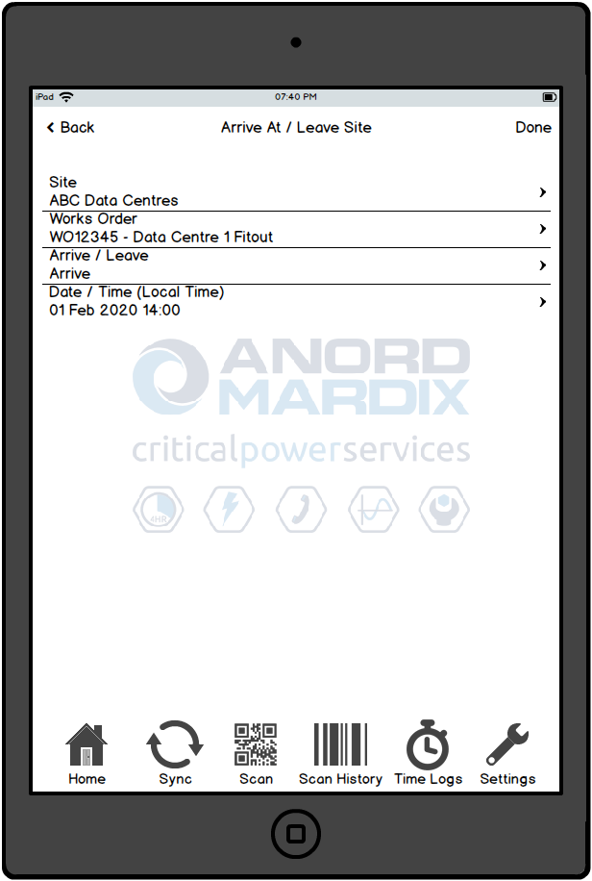

#### **Time Logs | Arrive At/Leave Site | Select Site**

***Navigation (Add):*** *Time Logs > + > Arrive At/Leave Site > Site*

***Navigation (Edit):*** *Time Logs > Edit existing Arrive At/Leave Site record > Site*

**New Functionality**

* When adding or editing an Arrive At/Leave Site time log, the user will select the site using a search lookup
* Similar to the functionality of the Works Order Search screen (**7.4.2.6**), the user will search for the works order number then select the site under the relevant works order in the results
* Selecting a site will set that site for the time log, and immediately navigate back to the time log details screen

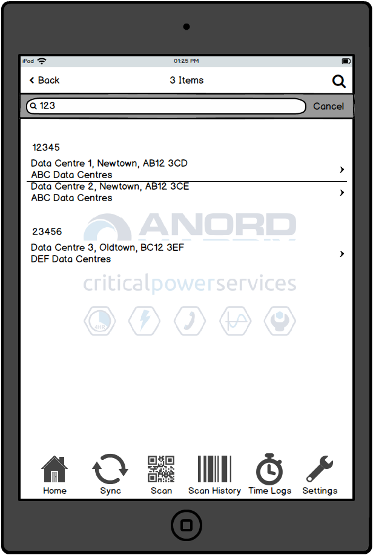

#### **Time Logs | Arrive At/Leave Site | Select Arrive / Leave**

***Navigation (Add):*** *Time Logs > + > Arrive At/Leave Site > Arrive/Leave*

***Navigation (Edit):*** *Time Logs > Edit existing Arrive At/Leave Site record > Arrive/Leave*

**New Functionality**

* When adding or editing an Arrive At/Leave Site time log, the user will select the action from a selection list
  + The following options will be available.
    - Arrive
    - Leave
* Selecting an action will set that action for the time log, and immediately navigate back to the time log details screen
* When an action has previously been selected, when navigating back to this screen by pressing ‘Arrive/Leave’ again, the selected action will be highlighted with a grey background and the list will automatically scroll to display that action in the middle of the list

*The screen display will be the same as in (****7.4.2.16 Time Logs | Arrive In/Leave Country | Select Arrive / Leave****)*

#### **Time Logs | Arrive At/Leave Site | Select Date / Time**

***Navigation (Add):*** *Time Logs > + > Arrive At/Leave Site > Date/Time*

***Navigation (Edit):*** *Time Logs > Edit existing Arrive At/Leave Site record > Date/Time*

**New Functionality**

* When adding or editing an Arrive At/Leave Site time log, the user will select the date/time from a date/time picker
* The selected date is also displayed in the ‘Selected Date’ section
* After setting the date and time, navigating back to the time log details screen via the ‘< Back’ button will set the date/time for the time log
* When a date/time has previously been selected, when navigating back to this screen by pressing ‘Date/Time’ again, the date/time picker and ‘Selected Date’ will both display the selected date/time
* Pressing the Clear button will clear the selected date

*The screen display will be the same as in (****7.4.2.17 Time Logs | Arrive In/Leave Country | Select Date / Time****)*

#### **Time Logs |** **Start/Finish Work**

***Navigation (Add):*** *Time Logs > + > Start/Finish Work*

***Navigation (Edit):*** *Time Logs > Edit existing Start/Finish Work record*

**New Functionality**

* A new option within the ‘Time Logs’ section to allow users to log starting or finishing a standard block of work
* Used to create a new record when adding, or modify an existing one when editing
* The user will select the following details to be included in the log.
  + **Service Tag:** The service tag of the equipment the user is working on if relevant; Scanned data; Mandatory unless site selected
    - If set via scanning, then a Site is subsequently selected via the search lookup, the Service Tag selection is cleared
  + **Site:** The site the user is working at; Search lookup *or* set automatically when the Service Tag or Site is selected; Mandatory unless service tag scanned
    - If set via the search lookup, then a Service Tag is subsequently scanned, the Site is updated to the Site where the service tag is located
  + **Works Order:** Read-only field, set automatically when the Service Tag or Site is selected
  + **Start/Finish:** The action being logged; Selection list; Mandatory
    - The following options will be available.
      * Start
      * Finish
  + **Date/Time:** The date and time of starting or finishing; Date/time picker; Mandatory
* The time log type will be set to ‘Service’ under the ‘Project’ category
* The Done button will be used to commit the log (for new time logs only)
* The Done button will be disabled until all mandatory fields are completed
* When editing an existing time log, no Done button is displayed, and changes are instead saved as they are made
* If any work time logs have been started, and are now (based on the current date/time) in breach of either the daily warning or maximum hours limits (based on those thresholds set for the user against the works order in question), a warning message will be displayed on the screen.
  + Time logs breaching the maximum limit will be displayed first, in descending order of start date/time; followed by those breaching warning limits, also in descending order of start date/time

#### **Time Logs | Start/Finish Work | Service Tag**

***Navigation (Add):*** *Time Logs > + > Start/Finish Work > Service Tag*

***Navigation (Edit):*** *Time Logs > Edit existing Start/Finish Work record > Service Tag*

**New Functionality**

* When adding or editing a Start/Finish Work time log, the user will scan the service tag of the equipment they are working on (if relevant)
* Pressing the QR code icon on the Service Tag will bring up a scan window, which will display ‘Scan service tag’
* Scanning an invalid QR code will display a warning to the user that no matching equipment item has been found
* Scanning a valid service tag will automatically set both the Service Tag and Works Order fields

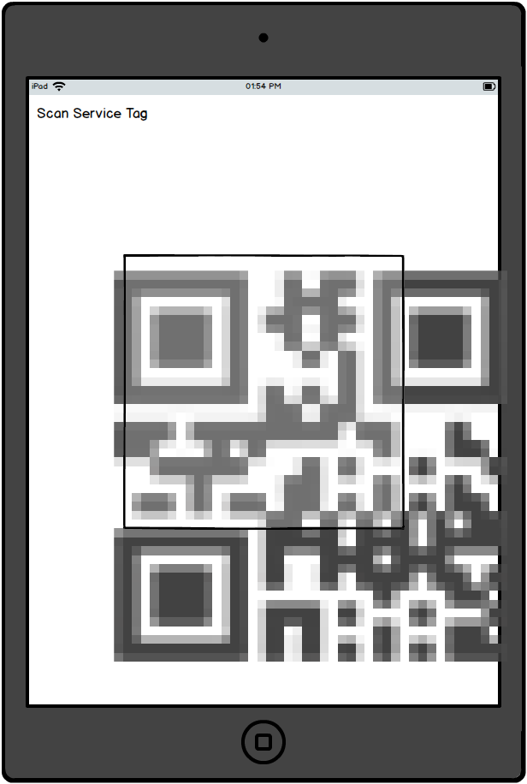

#### **Time Logs | Start/Finish Work | Select Site**

***Navigation (Add):*** *Time Logs > + > Start/Finish Work > Site*

***Navigation (Edit):*** *Time Logs > Edit existing Start/Finish Work record > Site*

* When adding or editing a Start/Finish Work time log, the user will select the site using a search lookup
* Similar to the functionality of the Works Order Search screen (**7.4.2.6**), the user will search for the works order number then select the site under the relevant works order in the results
* Selecting a site will set that site for the time log, and immediately navigate back to the time log details screen

*The screen display will be the same as in (****7.4.2.19 Time Logs | Arrive At/Leave Site | Select Site****)*

#### **Time Logs | Start/Finish Work | Select Start / Finish**

***Navigation (Add):*** *Time Logs > + > Start/Finish Work > Start/Finish*

***Navigation (Edit):*** *Time Logs > Edit existing Start/Finish Work record > Start/Finish*

**New Functionality**

* When adding or editing a Start/Finish Work time log, the user will select the action from a selection list
  + The following options will be available.
    - Start
    - Finish
* Selecting an action will set that action for the time log, and immediately navigate back to the time log details screen
* When an action has previously been selected, when navigating back to this screen by pressing ‘Start/Finish’ again, the selected action will be highlighted with a grey background and the list will automatically scroll to display that action in the middle of the list

*The screen display will be the same as in (****7.4.2.16 Time Logs | Arrive In/Leave Country | Select Arrive / Leave****), but with options of ‘Start’ and ‘Finish’*

#### **Time Logs | Start/Finish Work | Select Date / Time**

***Navigation (Add):*** *Time Logs > + > Start/Finish Work > Date/Time*

***Navigation (Edit):*** *Time Logs > Edit existing Start/Finish Work record > Date/Time*

**New Functionality**

* When adding or editing a Start/Finish Work time log, the user will select the date/time from a date/time picker
* The selected date is also displayed in the ‘Selected Date’ section
* After setting the date and time, navigating back to the time log details screen via the ‘< Back’ button will set the date/time for the time log
* When a date/time has previously been selected, when navigating back to this screen by pressing ‘Date/Time’ again, the date/time picker and ‘Selected Date’ will both display the selected date/time
* Pressing the Clear button will clear the selected date

*The screen display will be the same as in (****7.4.2.17 Time Logs | Arrive In/Leave Country | Select Date / Time****)*

#### **Time Logs | Additional Project Time**

***Navigation (Add):*** *Time Logs > + > Additional Project Time*

***Navigation (Edit):*** *Time Logs > Edit existing Additional Project Time record*

**New Functionality**

* A new option within the ‘Time Logs’ section to allow users to log a block of additional project work
* Used to create a new record when adding, or modify an existing one when editing
* The user will select the following details to be included in the log.
  + **Time Log Type:** The type of time log being logged; Mandatory
  + **Site:** The site the user is working at; Search lookup; Mandatory
    - Originally specified as ‘Works Order’ in Business Requirements; however works order selections elsewhere in the app are selectable on the site field; as this still provides us with the required data (works order), and to maintain consistency with the rest of the app, it is suggested the Site search option is also used here
    - In this instance, the user will simply select the main site they are currently working at
  + **Works Order:** Read-only field, set automatically when the Site is selected
  + **Start Date/Time:** The date and time the block of work started; Date/time picker; Mandatory
  + **Finish Date/Time:** The date and time the block of work finished; Date/time picker; Mandatory
* The Done button will be used to commit the log (for new time logs only)
* The Done button will be disabled until all mandatory fields are completed
* When editing an existing time log, no Done button is displayed, and changes are instead saved as they are made

#### **Time Logs | Additional Project Time | Time Log Type**

***Navigation (Add):*** *Time Logs > + > Additional Project Time > Time Log Type*

***Navigation (Edit):*** *Time Logs > Edit existing Additional Project Time record > Time Log Type*

**New Functionality**

* When adding or editing an Additional Project Time time log, the user will select the time log type from a selection list
  + The following options will be available.
    - Travel time
    - Paid rest day
    - Paid hours for no work
    - Site subs (UK)
    - Site subs (Outside UK)
    - Site closed
* Selecting a time log type will set that time log type for the time log, and immediately navigate back to the time log details screen
* When a time log type has previously been selected, when navigating back to this screen by pressing ‘Time Log Type’ again, the selected time log type will be highlighted with a grey background and the list will automatically scroll to display that time log type in the middle of the list

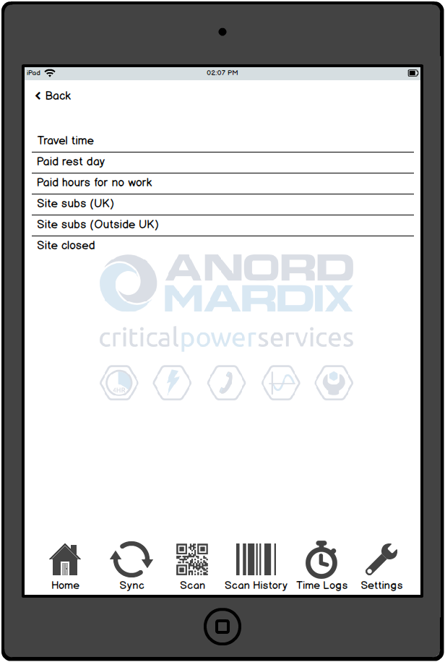

#### **Time Logs | Additional Project Time | Select Site**

***Navigation (Add):*** *Time Logs > + > Additional Project Time > Works Order*

***Navigation (Edit):*** *Time Logs > Edit existing Additional Project Time record > Works Order*

**New Functionality**

* When adding or editing an Additional Project Time time log, the user will select the site using a search lookup
* Similar to the functionality of the Works Order Search screen (**7.4.2.6**), the user will search for the works order number then select the site under the relevant works order in the results
* Selecting a site will set that site for the time log, and immediately navigate back to the time log details screen

*The screen display will be the same as in (****7.4.2.19 Time Logs | Arrive At/Leave Site | Select Site****)*

#### **Time Logs | Additional Project Time | Select Start Date / Time**

***Navigation (Add):*** *Time Logs > + > Additional Project Time > Start Date/Time*

***Navigation (Edit):*** *Time Logs > Edit existing Additional Project Time record > Start Date/Time*

**New Functionality**

* When adding or editing an Additional Project Time time log, the user will select the start date/time from a date/time picker
* The selected date is also displayed in the ‘Selected Date’ section
* After setting the start date and time, navigating back to the time log details screen via the ‘< Back’ button will set the start date/time for the time log
* When a start date/time has previously been selected, when navigating back to this screen by pressing ‘Start Date/Time’ again, the date/time picker and ‘Selected Date’ will both display the selected date/time
* Pressing the Clear button will clear the selected date

*The screen display will be the same as in (****7.4.2.17 Time Logs | Arrive In/Leave Country | Select Date / Time****)*

#### **Time Logs | Additional Project Time | Select Finish Date / Time**

***Navigation (Add):*** *Time Logs > + > Additional Project Time > Finish Date/Time*

***Navigation (Edit):*** *Time Logs > Edit existing Additional Project Time record > Finish Date/Time*

**New Functionality**

* When adding or editing an Additional Project Time time log, the user will select the finish date/time from a date/time picker
* The selected date is also displayed in the ‘Selected Date’ section
* After setting the finish date and time, navigating back to the time log details screen via the ‘< Back’ button will set the finish date/time for the time log
* When a finish date/time has previously been selected, when navigating back to this screen by pressing ‘Finish Date/Time’ again, the date/time picker and ‘Selected Date’ will both display the selected date/time
* Pressing the Clear button will clear the selected date

*The screen display will be the same as in (****7.4.2.17 Time Logs | Arrive In/Leave Country | Select Date / Time****)*

#### **Time Logs | Non-Project Time**

***Navigation (Add):*** *Time Logs > + > Non-Project Time*

***Navigation (Edit):*** *Time Logs > Edit existing Non-Project Time record*

* A new option within the ‘Time Logs’ section to allow users to log a block of non-project work
* Used to create a new record when adding, or modify an existing one when editing
* The user will select the following details to be included in the log.
  + **Time Log Type:** The type of time log being logged; Mandatory
  + **Start Date/Time:** The date and time the block of work started; Date/time picker; Mandatory
  + **Finish Date/Time:** The date and time the block of work finished; Date/time picker; Mandatory
* The Done button will be used to commit the log (for new time logs only)
* The Done button will be disabled until all mandatory fields are completed
* When editing an existing time log, no Done button is displayed, and changes are instead saved as they are made

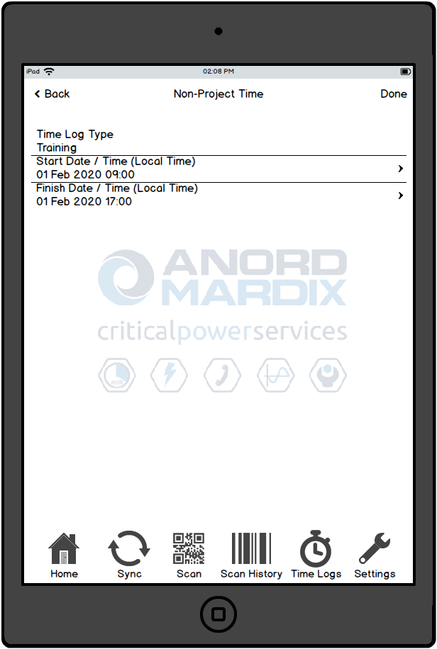

#### **Time Logs | Non-Project Time | Time Log Type**

***Navigation (Add):*** *Time Logs > + > Non-Project Time > Time Log Type*

***Navigation (Edit):*** *Time Logs > Edit existing Non-Project Time record > Time Log Type*

**New Functionality**

* When adding or editing a Non-Project Time time log, the user will select the time log type from a selection list
  + The following options will be available.
    - Public holiday
    - Training
    - College
    - Annual leave
    - Sickness
    - Standby
* Selecting a time log type will set that time log type for the time log, and immediately navigate back to the time log details screen
* When a time log type has previously been selected, when navigating back to this screen by pressing ‘Time Log Type’ again, the selected time log type will be highlighted with a grey background and the list will automatically scroll to display that time log type in the middle of the list

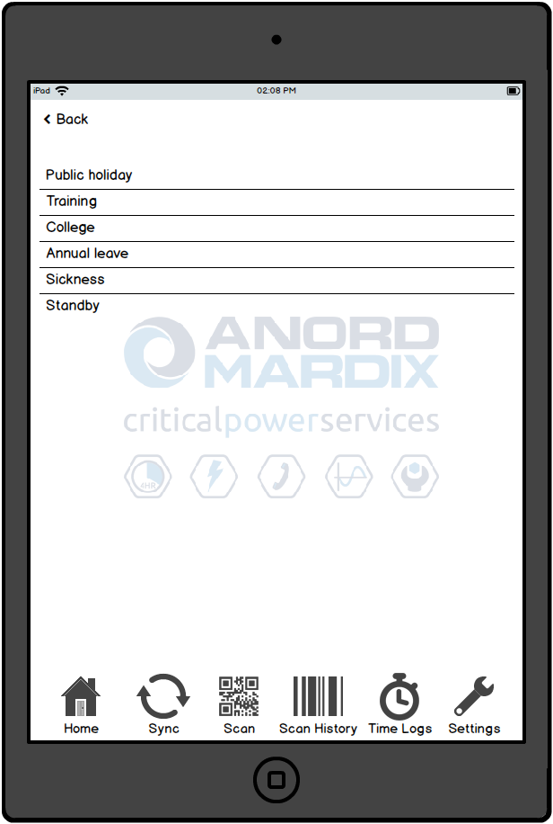

#### **Time Logs | Non-Project Time | Select Start Date / Time**

***Navigation (Add):*** *Time Logs > + > Non-Project Time > Start Date/Time*

***Navigation (Edit):*** *Time Logs > Edit existing Non-Project Time record > Start Date/Time*

**New Functionality**

* When adding or editing a Non-Project Time time log, the user will select the start date/time from a date/time picker
* The selected date is also displayed in the ‘Selected Date’ section
* After setting the start date and time, navigating back to the time log details screen via the ‘< Back’ button will set the start date/time for the time log
* When a start date/time has previously been selected, when navigating back to this screen by pressing ‘Start Date/Time’ again, the date/time picker and ‘Selected Date’ will both display the selected date/time
* Pressing the Clear button will clear the selected date

*The screen display will be the same as in (****7.4.2.17 Time Logs | Arrive In/Leave Country | Select Date / Time****)*

#### **Time Logs | Non-Project Time | Select Finish Date / Time**

***Navigation (Add):*** *Time Logs > + > Non-Project Time > Finish Date/Time*

***Navigation (Edit):*** *Time Logs > Edit existing Non-Project Time record > Finish Date/Time*

**New Functionality**

* When adding or editing a Non-Project Time time log, the user will select the finish date/time from a date/time picker
* The selected date is also displayed in the ‘Selected Date’ section
* After setting the finish date and time, navigating back to the time log details screen via the ‘< Back’ button will set the finish date/time for the time log
* When a finish date/time has previously been selected, when navigating back to this screen by pressing ‘Finish Date/Time’ again, the date/time picker and ‘Selected Date’ will both display the selected date/time
* Pressing the Clear button will clear the selected date

*The screen display will be the same as in (****7.4.2.17 Time Logs | Arrive In/Leave Country | Select Date / Time****)*

#### **Branch Details | Branch Equipment**

***Navigation:*** *Search > Branch > Branch Details > Branch Equipment*

**New Functionality**

* When navigating to the Branch Equipment screen
  + Employees whose organisation is set to ‘Company’ will be able to view all branch equipment
  + Employees whose organisation is set to ‘Subcontractor’ will only be able to view branch equipment whose works orders that they have specifically been given access to (**7.4.1.5**)

#### **Branch Details | Site Visit Reports**

***Navigation:*** *Search > Branch > Branch Details > Site Visit Reports*

**New Functionality**

* When navigating to the Branch Site Visit Reports screen
  + Employees whose organisation is set to ‘Company’ will be able to view all site visit reports
  + Employees whose organisation is set to ‘Subcontractor’ will not be able to view any site visit reports, as they only have access to works order (project) information, not service-related information

#### **Equipment Details | Site Visit Reports**

***Navigation (Scan):*** *Scan > Equipment Details > Site Visit Reports*

***Navigation (Search):*** *Search > Service Tag Number > Equipment Details > Site Visit Reports*

**New Functionality**

* When navigating to the Equipment Site Visit Reports screen
  + Employees whose organisation is set to ‘Company’ will be able to view all site visit reports
  + Employees whose organisation is set to ‘Subcontractor’ will not be able to view any site visit reports, as they only have access to works order (project) information, not service-related information

*The screen display will be the same as in (****7.4.2.37 Branch Details | Site Visit Reports****)*

#### **Equipment Details | Run**

***Navigation (Scan):*** *Scan > Equipment Details*

***Navigation (Search):*** *Search > Service Tag Number > Equipment Details*

The run’s Floor (drop down list), Area (text entry) and Location On Site (text entry) can be modified, as per current operation.

**New Functionality**

* The following new information is displayed.
  + Installed
    - Count (x/y) and percentage of components installed, by number of components
    - Meterage (x/y) and percentage of components installed, by length (m)
      * Calculated as total length (m) of components installed vs total QMF length (m)
      * When all components are installed, the percentage will automatically display as 100 % even if the meterage does not add up to the QMF total

#### **Equipment Details | Component**

***Navigation (Scan):*** *Scan > Equipment Details*

***Navigation (Search):*** *Search > Service Tag Number > Equipment Details*

**New Functionality**

* The following new option is available.
  + Installed To Run
    - A toggle switch that immediately sets the component as ‘Installed’ on its parent run
    - When set, the component will count towards the ‘Installed’ percentage of the run

#### **Test Sessions**

***Navigation (Scan):*** *Scan > Equipment Details > Test Sessions*

***Navigation (Search):*** *Search > Service Tag Number > Equipment Details > Test Sessions*

The run’s Floor (drop down list), Area (text entry) and Location On Site (text entry) can be modified, as per current operation.

#### **Test Sessions | Test Session Details**

***Navigation (Scan):*** *Scan > Equipment Details > Test Sessions > Test Session Details*

***Navigation (Search):*** *Search > Service Tag Number > Equipment Details > Test Sessions > Test Session Details*

Test sessions are logged against equipment and components, as per current operation.

It is expected that

* IBAR test sessions (test certificate QMF 93) will be created against components during factory production
* IBAR Installation test sessions (test certificate QMF 139) will be created against runs during on-site installation

**New Functionality**

* The Additional Documents option (**7.4.2.44**) will be enabled for the IBAR Installation test session type
* ‘Tested to Company general arrangement drawing revision’ to be changed to ‘Tested To Company General Arrangement Drawing revision’
* ‘Tested to Company electrical schematic drawing revision’ to be changed to ‘Tested To Company Electrical Schematic Drawing revision’
* ‘Signed For Company’ to be changed to ‘Signed For Company‘

#### **Test Sessions | Test Certificate**

***Navigation (Scan):*** *Scan > Equipment Details > Test Sessions > Test Session Details > Test*

***Navigation (Search):*** *Search > Service Tag Number > Equipment Details > Test Sessions > Test Session Details > Test*

Test certificate documents are completed by editing the PDF form within the app, as per current operation.

It is expected that

* IBAR test sessions (test certificate QMF 93) will be created against components during factory production
* IBAR Installation test sessions (test certificate QMF 139) will be created against runs during on-site installation

**New Functionality**

* The run client reference is displayed on the document (see **7.4.6.3** for details of the test certificate)

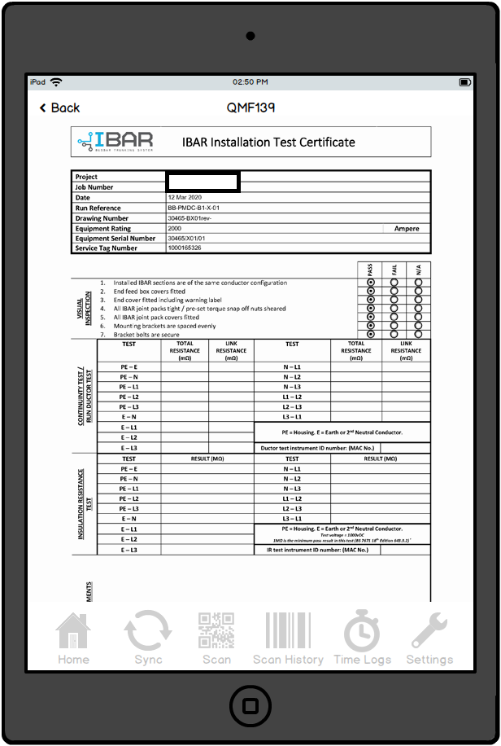

#### **Test Sessions | Additional Documents**

***Navigation (Scan):*** *Scan > Equipment Details > Test Sessions > Test Session Details > Test*

***Navigation (Search):*** *Search > Service Tag Number > Equipment Details > Test Sessions > Test Session Details > Test*

**New Functionality**

* The Additional Documents option will be enabled for the IBAR Installation test session type
  + this will allow the engineers to complete as many sheets of the new combined IBAR Installation Test Certificate (Ductor/Torque Test) document (**7.4.6.4**) as required for the run
  + all additional documents added will be appended to the main IBAR Installation test certificate that is emailed to the tester and saved to the network upon sign-off and sync

#### **Test Sessions | Additional Document**

***Navigation (Scan):*** *Scan > Equipment Details > Test Sessions > Test Session Details > Test*

***Navigation (Search):*** *Search > Service Tag Number > Equipment Details > Test Sessions > Test Session Details > Test*

Additional test documents are completed by editing the PDF form within the app, as per current operation.

**New Functionality**

* The new combined IBAR Installation Test Certificate (Ductor/Torque Test) document allows doctor and torque testing to be completed for each joint on the run (see **7.4.6.4** for details of the test certificate)

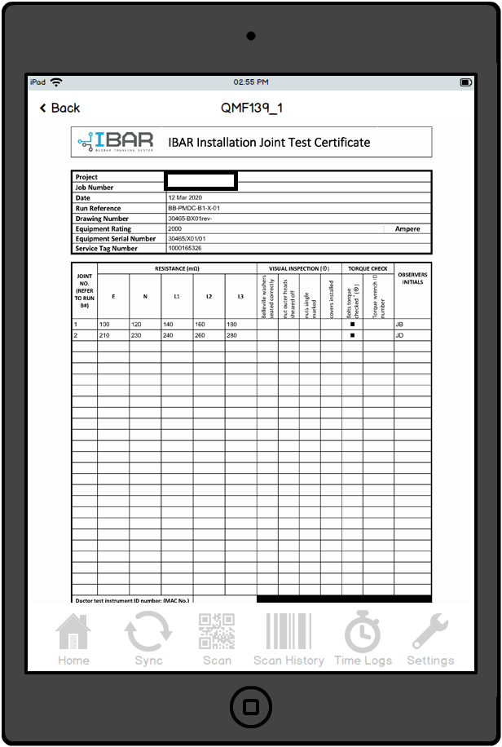

#### **Test Sessions | Select Witness Type**

***Navigation (Scan):*** *Scan > Equipment Details > Test Sessions > Test Session Details > Signed For Witness*

***Navigation (Search):*** *Search > Service Tag Number > Equipment Details > Test Sessions > Test Session Details > Signed For Witness*

Witness type selection screen displayed when signing off a test certificate as a witness, as per current operation.

**New Functionality**

* ‘Company’ to be changed to ‘Company‘

#### **Site Visit Reports | Site Visit Report Details**

***Navigation (Search):*** *Home > Search > Site Visit Report > Site Visit Report*

***Navigation (Equipment/Scan):*** *Scan > Equipment Details > Site Visit Reports > Site Visit Report*

***Navigation (Equipment/Search):*** *Search > Service Tag Number > Equipment Details > Site Visit Reports > Site Visit Report*

***Navigation (Branch):*** *Search > Branch > Branch Details > Site Visit Reports > Site Visit Report*

Site visit reports are logged against equipment and branches, as per current operation.

**New Functionality**

* ‘Signed For Company’ to be changed to ‘Signed For Company‘

#### **Sync**

***Navigation:*** *Sync*

The upload and/or download sync operation can be used to synchronise data between the app and Vision, as per current operation.

**New Functionality**

* Time Logs data will be included in the Uploads section
* All new data as required by the app will be included in the Downloads section

### **IBAR Importer**

#### **Bill Of Operations File**

***Navigation:*** *\\MXCOLOSSUS\IBARItemProcessor.Storage*

The Bill Of Operations file will be used to automate the creation of IBAR components in Vision, as per current operation.

**New Functionality**

* The run reference can now be set during the import, by including it as a as a third segment in the filename enclosed by square brackets, for example 30465-B35-[**Run Reference**]-GA.xls
  + A configurable option is now available to make this mandatory for specific works orders; this has been set for Project XXXX
  + The run reference will not be updated if the filename segment is empty
* The total component count for the run will be captured by the import

*Functionality already live and included retrospectively; Live screenshot used*

#### **Email | Confirmation**

A success notification email will be generated to the IBAR designers in the event of a successful IBAR Bill Of Operations file import, as per current operation.

**New Functionality**

* If the run reference has been updated using the new functionality (**7.4.3.1**), this will be included in the email notification

*Functionality already live and included retrospectively; Live screenshot used*

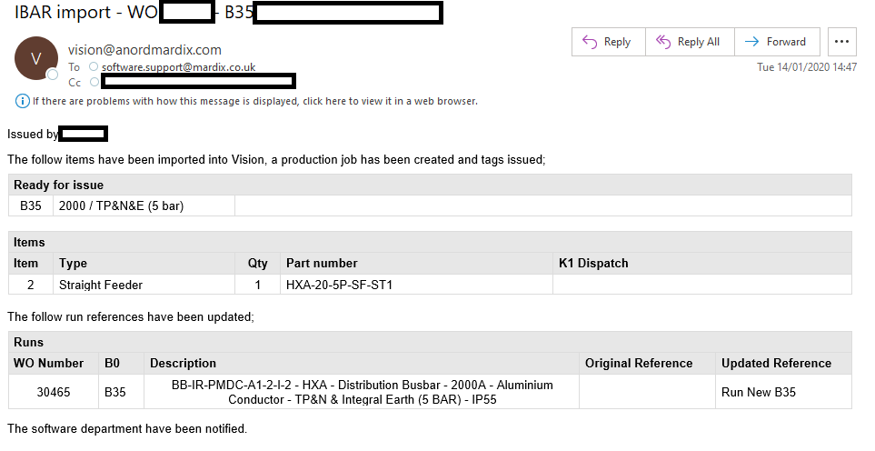

#### **Email | Rejection**

A failure notification email will be generated to the IBAR designers in the event of an unsuccessful IBAR Bill Of Operations file import, as per current operation.

**New Functionality**

* If the run reference has not been included using the new functionality (**7.4.3.1**) for a run for whose works order this requirement is mandatory, this will be included in the email notification

*Functionality already live and included retrospectively; Live screenshot used*

### **Zebra Labels**

#### **IBAR Master Run Service Tag**

***URL:*** *https://vision.xxxx.co.uk/ps_qmf_list.asp?p1a=789a*

***Navigation:*** *Production > Production Schedule > Pr Tag*

IBAR master run service tags will be printed to the Zebra label printers from the Production Schedule screen, as per current operation.

**New Functionality**

* The Run Reference will be displayed on the label

*Functionality already live and included retrospectively; Live screenshot used*

#### **IBAR Bar Service Tag**

***URL:*** *https://vision.xxxx.co.uk/production/in-production.asp?marketsectorids=7*

***Navigation:*** *Production > IBAR In Production > Print icon*

IBAR bar service tags will be printed to the Zebra label printers from the In Production screen, as per current operation.

* Relevant component types:
  + Adapter - Company HX
  + Adapter - Other Busbar Manufacturer
  + Combination
  + Combination with Fire Barrier
  + Edgewise Elbow
  + Edgewise Elbow with Fire Barrier
  + Edgewise Offset
  + Edgewise Offset with Fire Barrier
  + Expansion Unit
  + Flange
  + Flange Elbow Edgewise
  + Flange Elbow Flatwise
  + Flange Offset Flatwise
  + Flatwise Elbow
  + Flatwise Elbow with Fire Barrier
  + Flatwise Offset
  + Flatwise Offset with Fire Barrier
  + Flatwise Tee
  + Flatwise Tee with Fire Barrier
  + Flatwise Transformer Flange
  + Straight Distribution
  + Straight Distribution with Fire Barrier
  + Straight Feeder
  + Straight Feeder with Fire Barrier
  + Transition Box

**New Functionality**

* The Run Reference will be displayed on the label
* Complies With will display the default value of BS EN 61439-6, unless the works order has a value entered into the BSIBarStandardIBARBar field in the database WorksBook table, in which case that value will be displayed instead

*Functionality already live and included retrospectively; Live screenshot used*

#### **IBAR Joint Pack Service Tag**

***URL:*** *https://vision.xxxx.co.uk/production/in-production.asp?marketsectorids=7*

***Navigation:*** *Production > IBAR In Production > Print icon*

IBAR joint pack service tags will be printed to the Zebra label printers from the In Production screen, as per current operation.

* Relevant component types:
  + Joint Pack

**New Functionality**

* The Run Reference will be displayed on the label

*Functionality already live and included retrospectively; Live screenshot used*

#### **IBAR Accessory Service Tag**

***URL:*** *https://vision.xxxx.co.uk/production/in-production.asp?marketsectorids=7*

***Navigation:*** *Production > IBAR In Production > Print icon*

IBAR accessory service tags will be printed to the Zebra label printers from the In Production screen, as per current operation.

* Relevant component types:
  + End Cap
  + End Feed Box
  + End Feed Box - Switched
  + Spring Bracket

**New Functionality**

* The Run Reference will be displayed on the label

*Functionality already live and included retrospectively; Live screenshot used*

### **Pallet Note**

***URL:*** *http://194.73.171.164:8043/ReportServer/Pages/ReportViewer.aspx?%2fVision%2fIBAR%2fPallet+Note*

***Navigation:*** *Logistics > IBAR Pallet Note*

The IBAR pallet note will be printed to A4 from Vision by selecting a pallet number, as per current operation.

**New Functionality**

* The following new parameters will be selectable on the report.
  + **Show Vesting Information (No/Production/Accounts):** Choose which version of the pallet note to display; each of the options displays slightly different vesting options.
  + **Vesting Month/Vesting Year:** Allows the Vesting month and year to be set; Defaults to the current month and year
  + **Location Held:** Allows the Company site to be selected where the equipment is being held; Defaults to N/A
    - Note the Vesting Month/Year and Location Held fields are not mandatory; this is because, if Vesting Information is not required, they will not be relevant; as such there will be a requirement here on the user generating the note to ensure these fields are correctly selected, if required
* The following information will be displayed on the pallet note.
  + **Front Sheet**
    - New graphics and figures for Value and Length (m) are now displayed on the front sheet of the pallet note
      * the Value will only be displayed if ‘Accounts’ has been selected for Show Vesting Information
      * the graphic for Value, and the figure itself, will display the actual local currency for the works order
      * the Value will be pro rata by length, based on the proportion of the QMF value for the total bar length vs QMF overall length (for bar components), or simply the value “as is” (for e.g. tap off boxes); values will be after discount in all cases
  + **Details Sheet**
    - New columns for Value and Length (m) are now displayed on the detail sheets
      * the Value column will only be displayed if ‘Accounts’ has been selected for Show Vesting Information
      * the Value will display in the actual local currency for the works order
      * the Value will be pro rata by length, based on the proportion of the QMF value for the total bar length vs QMF overall length (for bar components), or simply the value “as is” (for e.g. tap off boxes); values will be after discount in all cases
  + **Run Summary Sheet**
    - New run summary sheet
      * the run summary sheet will only be displayed if ‘Accounts’ has been selected for Show Vesting Information
      * each run which contains components that are on the pallet, will be listed by M0 number
      * the Total Run Value will be the QMF value of the run
      * the Total Run Length (m) will be the length of the run, as quoted in the QMF
      * the Pallet Value will be the QMF value of all the components for the run that are present on the pallet, and will be pro rata by length, based on the proportion of the QMF value for the total bar length vs QMF overall length
      * the Pallet Length (m) will be the combined length of the run’s components that are present on the pallet
      * the % complete will be the percentage of the run’s total length represented by the combined length of the components for the run that are present on the pallet
  + **Vesting Details Sheet**
    - New vesting details sheet
      * the vesting details sheet will only be displayed if ‘Production’ has been selected for Show Vesting Information
      * Held To Order is the new Held To Order Text field on the works order
      * Project is the WO Number and WO Project Name from Vision
      * Location Held is the selected ‘Location Held’ parameter
      * Listed Item Reference is the Production Schedule Description, M0, and total component lengths
      * Pallet No is the selected Pallet
      * Vesting Month is the selected ‘Vesting Month’ and ‘Year’ parameters

*Functionality already live and included retrospectively; Live screenshot used*

*Report parameters*

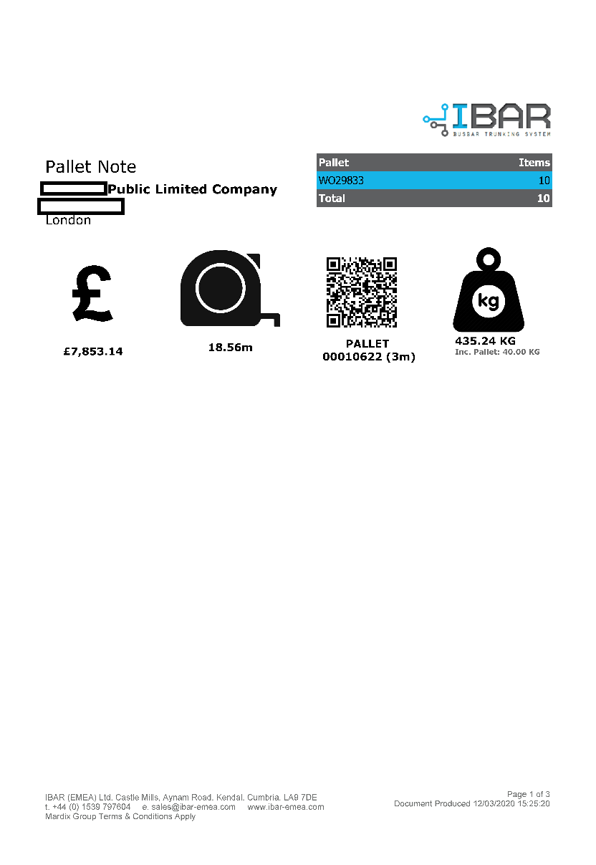

*Front sheet*

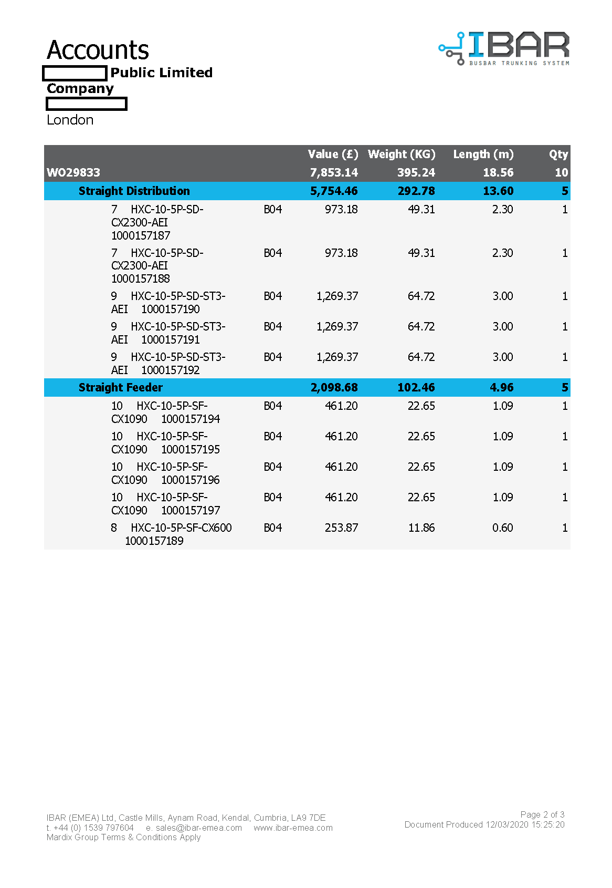

*Details sheet*

*Run Summary Sheet*

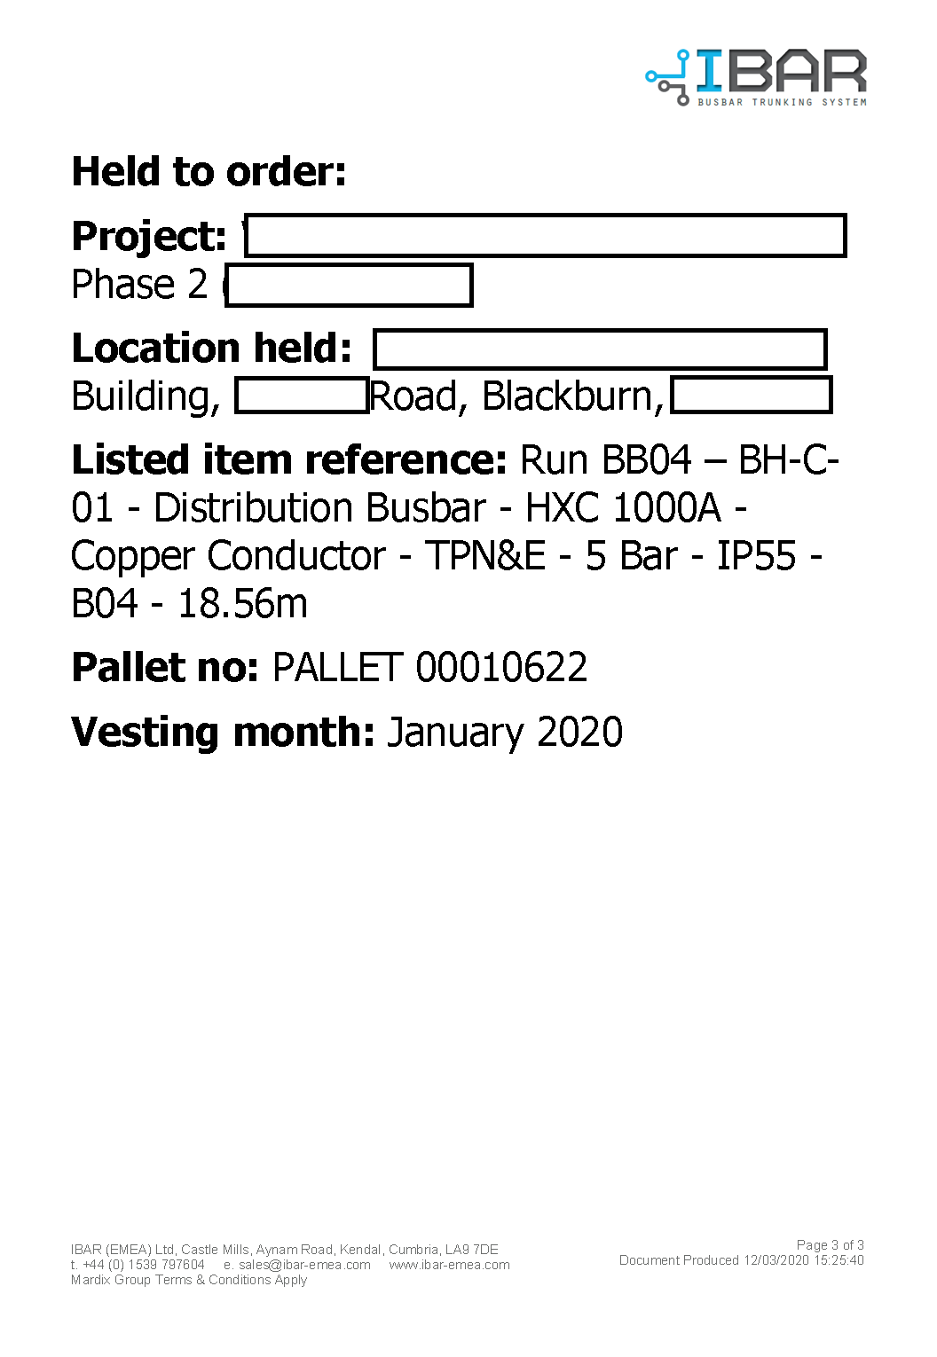

*Vesting Details Sheet*

### **Test Certificates**

#### **QMF 93 IBAR Test Certificate**

***URL:*** *https://vision.xxxx.co.uk/testdocumenttemplates.asp*

***Navigation:*** *Test > Test Document Templates*

The QMF 93 IBAR Test Certificate will be uploaded to Vision and used by the engineers when completing factory-based IBAR Test Sessions using the Engineer App, as per current operation.

**New Functionality**

* The Run Reference will be displayed on the test certificate in the header section (‘Run Ref’)

*Functionality already live and included retrospectively; Live screenshot used*

#### **QMF 88 IBAR Tap Off Box Test Certificate**

***URL:*** *https://vision.xxxx.co.uk/testdocumenttemplates.asp*

***Navigation:*** *Test > Test Document Templates*

The QMF 88 IBAR Test Certificate will be uploaded to Vision and used by the engineers when completing factory-based IBAR Tap Off Box Test Sessions using the Engineer App, as per current operation.

No changes will be required as the run reference does not relate to individual tap off boxes, which can be moved around as required.

*Functionality already live and included retrospectively; Live screenshot used*

#### **QMF 139 IBAR Installation Test Certificate**

***URL:*** *https://vision.xxxx.co.uk/testdocumenttemplates.asp*

***Navigation:*** *Test > Test Document Templates*

The QMF 139 IBAR Installation Test Certificate will be uploaded to Vision and used by the engineers when completing site-based IBAR Test Sessions using the Engineer App, as per current operation.

**New Functionality**

* The Run Reference will be displayed on the test certificate in the header section (‘Run Reference’)
* The Drawing Number will be the mechanical drawing number only, and include the revision in the format e.g. 12345-B01revA
* The document will be modified to remove references to Ductor Testing on the main sheet, as this will now be covered by a new dedicated additional document (**7.4.6.4**)
* The document will be generic and cover 3, 4 and 5 pole run designs
* Upon completion of the document, all fields will be captured as data items (and synced up to Vision as part of the Test Session Document sync)

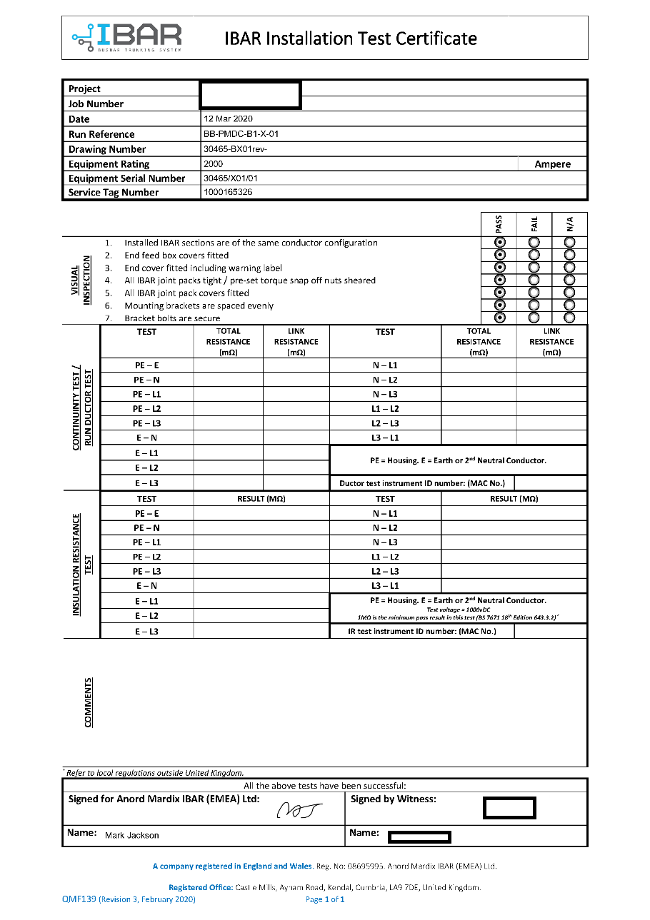

#### **QMF 139_1 IBAR Installation Test Certificate (Ductor/Torque Test)**

***URL:*** *https://vision.xxxx.co.uk/testdocumenttemplates.asp*

***Navigation:*** *Test > Test Document Templates*

**New Functionality**

* A new combined IBAR Installation Test Certificate (Ductor/Torque Test) document allows doctor and torque testing to be completed for each joint on the run
* The Run Reference will be displayed on the test certificate in the header section (‘Run Reference’)
* The Drawing Number will be the mechanical drawing number only, and include the revision in the format e.g. 12345-B01revA
* Each row on the document will represent a single joint on the run, and will be used to record both doctor and torque testing
* The joint numbers will be entered manually in the first column by the testers
* The document will be generic and cover 3, 4 and 5 pole run designs
* As many sheets as are required to cover all joints in the run can be added
* Upon completion of one of the documents, all fields will be captured as data items (and synced up to Vision as part of the Test Session Document sync), with each one representing a completed row on the document and containing the following fields; these will be captured as the data types indicated.
  + Row identification fields
    - Joint number *(text)*
  + Ductor fields, all joint resistance in µΩ
    - E *(text)*
    - N *(text)*
    - L1 *(text)*
    - L2 *(text)*
    - L3 *(text)*
  + Visual inspection fields
    - Belleville washers seated correctly *(boolean)*
    - Nut outer heads sheared off *(boolean)*
    - Nuts single marked *(boolean)*
    - Covers installed *(boolean)*
  + Torque fields
    - Bolts torque checked *(boolean)*
    - Torque wrench ID number *(text)*
  + Sign off fields
    - Observer initials *(text)*
* Presentation details on document required as follows
  + References to ‘Company’ instead of ‘Company’
  + Company logo used instead of Company logo

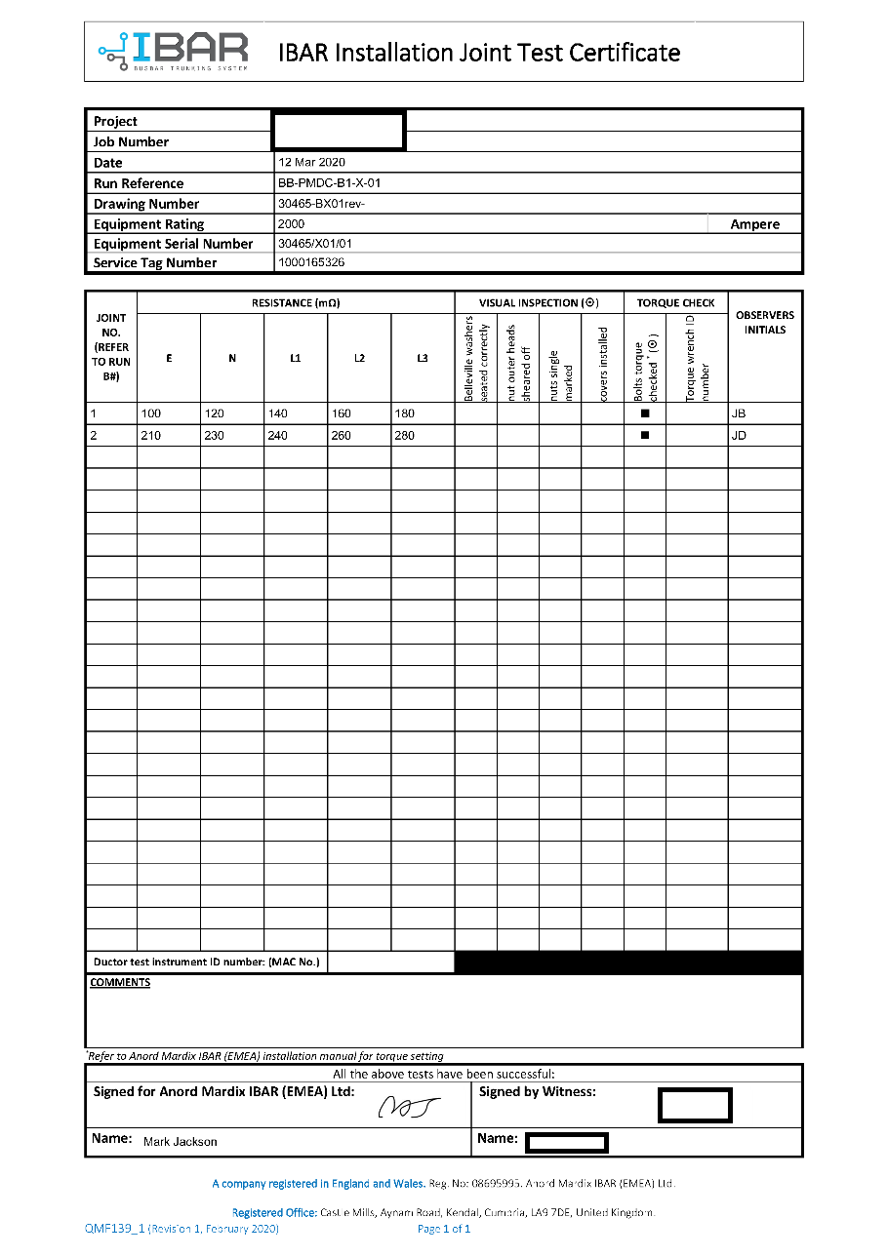

### **iControl Web**

#### **Equipment Details | Run**

***URL:*** *https://ui.icontrol-cloud.com/profile/{Equipment Id}*

***Navigation (Menu):*** *Equipment > Service tag*

***Navigation (Search):*** *Search > Service tag*

Equipment (including runs) details will be updated weekly from Vision and viewed via the iControl website, as per current operation.

**New Functionality**

* The Components section will display the number installed vs the total number for the run in the format x/y
* Each individual component listed will indicate if it has been installed to the run

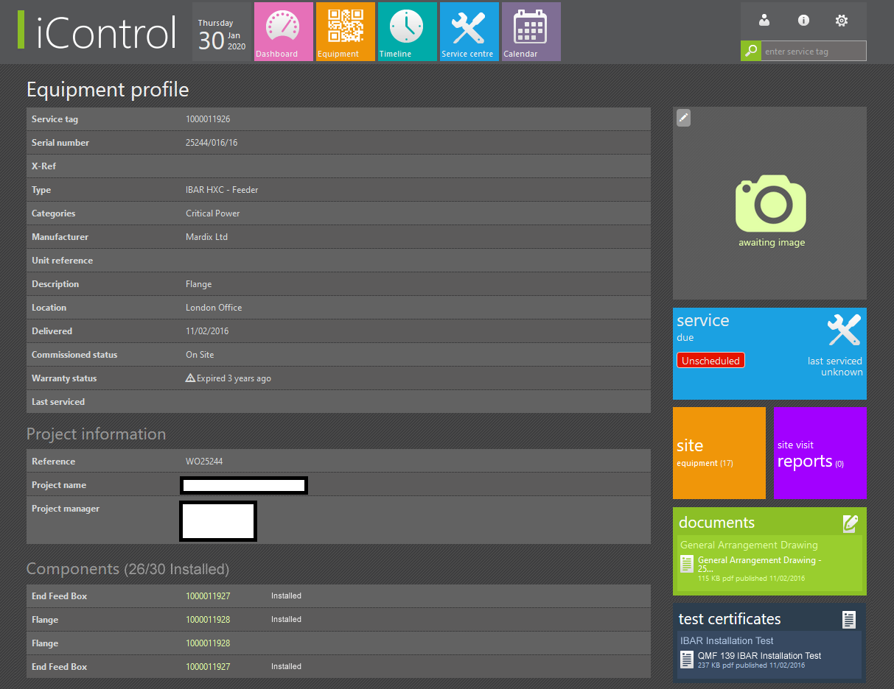

#### **Equipment Details | Component**

***URL:*** *https://ui.icontrol-cloud.com/profile/{Equipment Id}*

***Navigation (Menu):*** *Equipment > Service tag*

***Navigation (Search):*** *Search > Service tag*

Component details will be updated weekly from Vision and viewed via the iControl website, as per current operation.

**New Functionality**

* Component service tags can now be searched for, as equipment service tag numbers currently are
* The component will indicate if the it has been installed to the run

#### **Test Certificate**

***URL:*** *https://ui.icontrol-cloud.com/document/{Document Id}*

***Navigation (Menu):*** *Equipment > Service tag > Test certificate*

***Navigation (Search):*** *Search > Service tag > Test certificate*

Test certificates for both equipment (including runs) and components will be updated weekly from Vision and viewed via the iControl website, as per current operation.

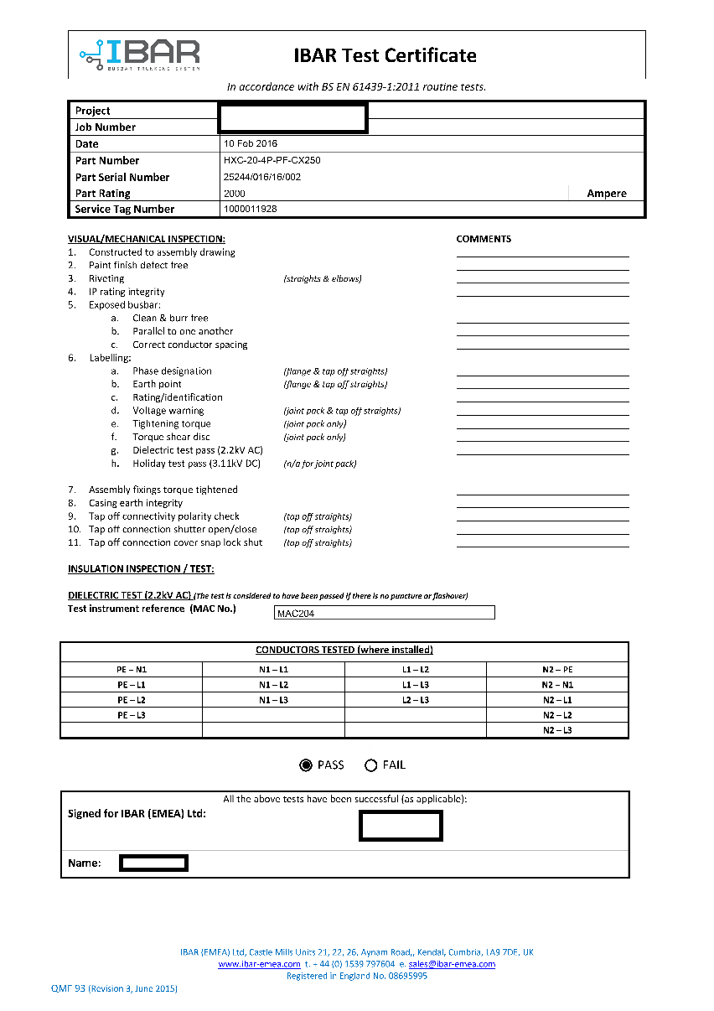

### **iControl Client App**

#### **Equipment Details | Run**

***Navigation (Scan):*** *Scan > Equipment Details*

***Navigation (Search):*** *Search > Service Tag Number > Equipment Details*

The run’s details can be viewed, as per current operation.

**New Functionality**

* The following new information is displayed.
  + **Installed:** Count (x/y) and percentage of components installed, by number of components
  + **Test Certificates:** Allows test certificates completed against the run to be viewed (**7.4.8.3**)

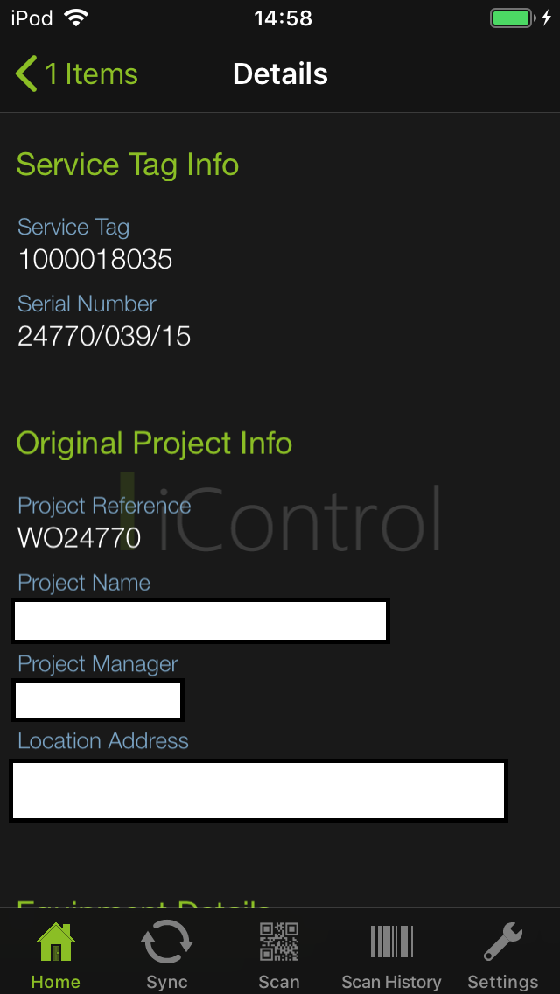

#### **Equipment Details | Component**

***Navigation (Scan):*** *Scan > Component Details*

***Navigation (Search):*** *Search > Service Tag Number > Component Details*

The component’s details can be viewed, as per current operation.

**New Functionality**

* The following new information is displayed.
  + **Installed:** Indicates whether the component is installed to the run
  + **Test Certificates:** Allows test certificates completed against the run to be viewed (**7.4.8.3**)

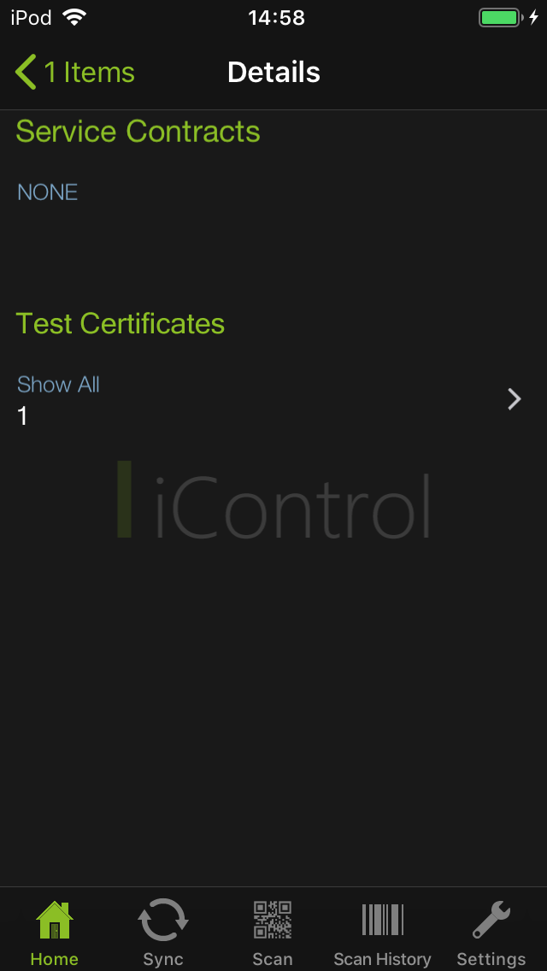

#### **Test Sessions**

***Navigation (Scan):*** *Scan > Equipment/Component Details > Test Certificates*

***Navigation (Search):*** *Search > Service Tag Number > Equipment/Component Details > Test Certificates*

**New Functionality**

* Test certificates completed against runs and components can now be viewed
* Selecting Test Certificates from either the Equipment Details or Component Details screen will bring up a list of completed test certificates
* Selecting a test certificate will download it and display within the app

### **Vision Reports**

#### **Site Time Sheet Report**

***URL:*** *http://194.73.171.164:8043/ReportServer/Pages/ReportViewer.aspx?%2fVision%2fHR%2fSite+Time+Sheet*

***Navigation:*** *SSRS (Live Site) > Vision > HR > Site Time Sheet*

**New Functionality**

* A fortnightly report generated for each user using a date range from and to (of site’s local date and time); this will show:
  + **For Weeks 1 and 2**:
    - **Week Commencing**: 1st day of the Week (Saturday)
    - **Normal Hours**: Display ‘**On Site’** Time logged Monday to Friday 6am to 4pm (local time)
    - **No Work / Office**: This will include hours logged for
      * **Paid Hours for No Work** (Monday to Friday local time)
      * **Days of Training** (Monday to Friday local time)
      * **Paid Rest Days** (Any Day)
      * **College** (Any Day)
    - **Basic**: This will include a total of all hours under Normal Hours & No Work / Office
    - **Breaks**: Any time logged Monday to Friday then 0.5 hours per day is added here
    - **Basic Total**: Basic hours minus Breaks hours
    - **O/T at 1.33**: This will include hours logged if Basic Total time & Travel Time for a day is over 9.5 hours and logged Mon-Friday between 4pm and 12am (local time) for:
      * **On Site**
      * **Days of Training**
    - **O/T at 1.50**: This will include hours logged on Saturday’s between 6am to midnight (local time) for:
      * **On Site**
      * **Paid Hours for Now Work**
      * **Days of Training**
    - **O/T at 2.00**: This will include hours logged on Sunday (local time) for:
      * On Site
      * Paid Hours for No Work
      * Days of Training
      * And will also include hours logged any day of the week between 12am to 6am (local time) for:
        + On Site
        + Paid Hours for No Work
        + Days of Training
    - **Travel**: This will include hours logged as **Travel Time** logged Monday to Friday (local time)
    - **Travel x1.5**: This will include hours logged as **Travel Time** logged on Saturday (local time)
    - **Travel x2**: This will include hours logged as **Travel Time** logged on Sunday (local time)
    - **Holiday Pay**: This will include hours logged as **Annual Leave** logged
    - **Site Subs**: This will include hours logged as **Site Subs (UK)**
    - **Site Subs (Abroad)**: This will include hours logged as **Site Subs (Outside UK)**
    - **Standby**: This will include hours logged as **Standby**
    - **Site Closed**: This will include hours logged as **Site Closed**
    - **Fortnightly Totals:** Shows 1st and 2nd Week total hours
    - **Employee No:** Displays the employee number
    - **Payment Ref:** Displays the Sage payment reference
* The report will be set to run on a schedule and automatically email HR personnel
* The report is exportable to Excel
* As start/finish work logs will be submitted separately, possibly via different devices, and possibly synced at different times, the report logic will need to ‘piece together’ valid blocks of work; this will be achieved as follows
  + For Country Visit or Site Attendance ‘Start’ time logs, a matching ‘Finish’ time log will be any of the following
    - The next chronological 'Finish-only' log for that country or site
    - The next chronological 'Start-only' log for that country or site (the start date of the new log will be used as the terminator of the current one)
  + For Service (start/finish work) ‘Start’ time logs, a matching ‘Finish’ time log will be any of the following
    - The next chronological 'Finish-only' log for that site, or for any equipment item at that site
    - The next chronological 'Start-only' log for that site, or for any equipment item at that site (the start date of the new log will be used as the terminator of the current one)
    - The next chronological 'Leave Site' log for that site
  + Any unmatched time logs (Start with no Finish or vice versa) will be highlighted in the Site Time Log Exceptions Report (**7.4.9.5**)

#### **Complete Site Time Logs Report**

***URL:*** *http://194.73.171.164:8043/Reports/Pages/Report.aspx?ItemPath=%2fVision%2fHR%2fComplete+Site+Time+Logs*

***Navigation:*** *SSRS (Live Site) > Vision > HR > Complete Site Time Logs*

**New Functionality**

* A report to be run on-demand by engineer, time log type, country, site and/or works order; this will show:
  + Complete time logs only, constructed on-the-fly from synced start and finish logs
  + The time log’s start and end date/time (displayed as date, hours and minutes), in the local time of the country to which the log relates
  + The time log duration in minutes
  + The country the time log relates to
    - For non-project time logs, this will be derived as the country of the last immediate previous time log that has an associated country, or the engineer’s current location if none has been logged
  + The works order the time log relates to (if any)
  + The site the time log relates to (if any)
  + The M0 and service tag the time log relates to (if any)
* The report will be run as and when required
* The report is exportable to Excel

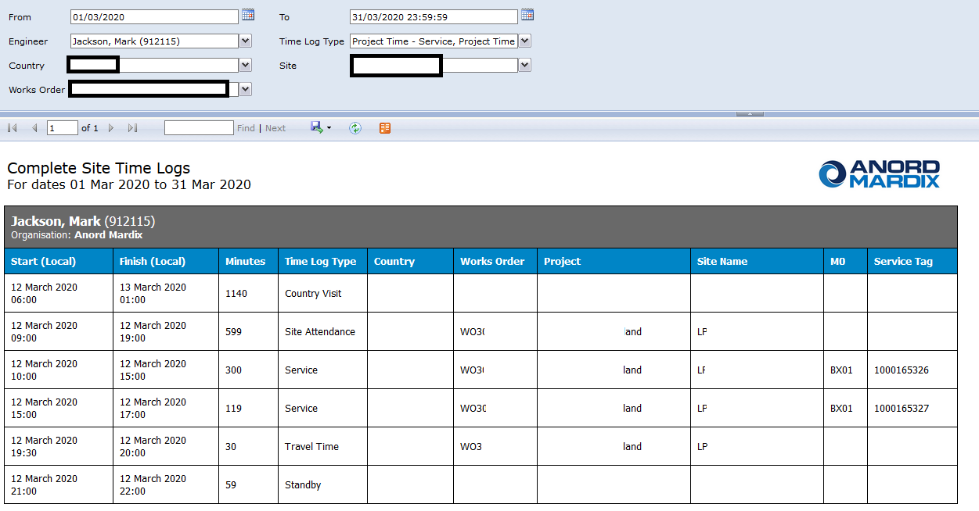

#### **Run Component Progress Report**

***URL:*** *http://194.73.171.164:8043/Reports/Pages/Report.aspx?ItemPath=%2fVision%2fIBAR%2fRun+Component+Progress*

***Navigation:*** *SSRS (Live Site) > Vision > IBAR > Run Component Progress*

**New Functionality**

* A report to be run on-demand by country, site and/or works order; this will show:
  + Each Run's details
  + The Run's total site hours recorded to date
  + The Run's components installed count to date
  + The Run's planned total components count
  + The Run's percentage complete to date by count
  + The Run's components installed total length to date
  + The Run's planned total length
  + The Run's percentage complete to date by length
* The report will be run as and when required
* The report is exportable to Excel

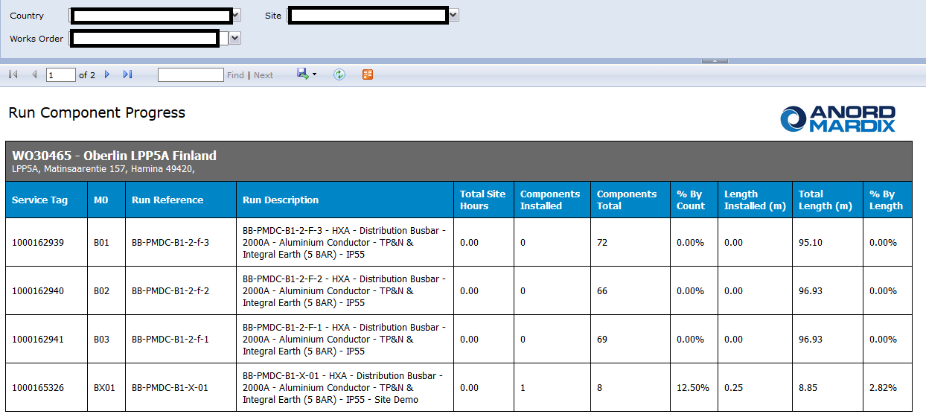

#### **Hours Work Per Country Report**

***URL:*** *http://194.73.171.164:8043/ReportServer/Pages/ReportViewer.aspx?%2fVision%2fHR%2fHours+Work+Per+Country*

***Navigation:*** *SSRS (Live Site) > Vision > HR > Hours Work Per Country*

**New Functionality**

* A report to be run on-demand by country and date range; this will show:
  + Employee details
  + Country
  + Works Order
  + Date
  + Hours worked
  + Vision warning limit for the country hit
  + Vision maximum limit for the country hit
* Additional filters will allow the report to only display entries where the user has hit either the Vision warning limit for the country hit or the Vision maximum limit for the country hit
* The report will be set to run on a schedule and automatically email HR personnel
* The report is exportable to Excel

#### **Hours Work Per Works Order Report**

***URL:*** *http://194.73.171.164:8043/ReportServer/Pages/ReportViewer.aspx?%2fVision%2fHR%2fHours+Work+Per+Works+Order*

***Navigation:*** *SSRS (Live Site) > Vision > HR > Hours Work Per Works Order*

**New Functionality**

* A report to be run on-demand by works order and date range; this will show:
  + Employee details
  + Country
  + Works Order
  + Date
  + Hours worked
  + Vision warning limit for the country hit
  + Vision maximum limit for the country hit
* Additional filters will allow the report to only display entries where the user has hit either the Vision warning limit for the country hit or the Vision maximum limit for the country hit
* The report will be set to run on a schedule and automatically email HR personnel
* The report is exportable to Excel

#### **Site Time Log Exceptions Report**

***URL:*** *http://194.73.171.164:8043/ReportServer/Pages/ReportViewer.aspx?%2fVision%2fHR%2fSite+Time+Log+Exceptions*

***Navigation:*** *SSRS (Live Site) > Vision > HR > Site Time Log Exceptions*

**New Functionality**

* A report to be run on-demand by works order, date range, and type of exception; this will show:
  + Employee details
  + Country
  + Site
  + Works Order
  + Date
  + Type of exception; this will be one of the following
    - Leave Country With No Matching Previous Arrival
    - Arrive In Country Does Not Match Previous Departure
    - Leave Site With No Matching Previous Arrival
    - Arrive At Site Still Open After 24 Hours
    - Finish Work With No Matching Previous Start
    - Start Work Still Open After 24 Hours
  + The logic used to determine whether a Start/Finish work time log has a matching Finish/Start will be the same as that specified in the Site Time Sheet Report (**7.4.9.1**)
* The report will be set to run on a schedule and automatically email HR personnel
* The report is exportable to Excel

#### **Project Costing Report**

***URL:*** *http://* *http://194.73.171.164:8043/Reports/Pages/Report.aspx?ItemPath=%2fVision%2fManagement%2fProject+Costing*

***Navigation:*** *SSRS (Live Site) > Vision > Management > Project Costing*

The Project Costing Report will be used to details all costs associated with each project, as per current operation.

**New Functionality**

* Include site time logs in labour cost calculations, if appropriate

## **Non-Functional Requirements**

### **Performance Requirements**

* All systems should respond in a timely manner at all times
* For iOS apps, the only acknowledged performance issues will be related to factor outside the control of the software, such as unexpected wi-fi issues

### **Safety Requirements**

* In the event of any issues during the sync process, the Engineer App will retain all data until a successful sync can be performed

### **Security Requirements**

* All data transfer will be performed using a secure HTTPS connection
* All data operations will require a secure authentication using registered credentials via the OAUTH 1.0 protocol

## **Requirements Priority**

The requirements in this document are prioritised as follows:

|  |  |
| --- | --- |
| **Rating** | **Description** |
| Critical | The requirement is critical to the success of the project. The project will not be possible without this requirement |
| High | The requirement is a high priority, but the project can be implemented at a bare minimum without this requirement |
| Medium | Requirement is important |
| Low | This is a low priority requirement, a nice to have feature if time and cost allow it |
| Future | This requirement is out of scope for this project and has been included here for a possible future release |

## **Requirements List**

1. Below shows each requirement identified within this document. Each requirement should be independent, clear, unambiguous & testable (in UAT) and be covered within the System Requirements documentation.

|  |  |  |  |  |  |
| --- | --- | --- | --- | --- | --- |
| **ID** | **ID (BR)** | **Area** | **Requirement Details** | **Priority** | **Impacted Stakeholders** |
| SR-1 | BR-1 | Time Logging | User will be able to log when they entered the site of a Works Order | Critical | HR |
| SR-2 | BR-2 | Time Logging | User will be able to log when they leave the site of a Works Order | Critical | HR |
| SR-3 | BR-3 | Time Logging | User will be able to log when they are working on components to track the hours worked per run | Critical | Project Manager |
| SR-4 | BR-4 | Time Logging | User will be able to log when they have finished working on components | Critical | Project Manager |
| SR-5 | BR-5 | Time Logging | User will be able to log date & time and country of arrival based on GPRS of the device | Critical | HR |
| SR-6 | BR-6 | Time Logging | User able to confirm or amend the Country returned (based on the GPRS of the device) | Critical | HR |
| SR-7 | BR-7 | Time Logging | User will be able to log date & time and country when leaving based on GPRS of the device | Critical | HR |
| SR-8 | BR-8 | Time Logging | Able to track the working hours and overtime based on the employee’s working time per day | Critical | HR |
| SR-9 | BR-9 | Time Logging | Display a warning when a user has exceeded the Daily Working Hours Warning Limit when logging a new time log entry | Critical | HR |
| SR-10 | BR-10 | Time Logging | Each user able to log project time for Travel time | Critical | HR |
| SR-11 | BR-11 | Time Logging | Each user able to log project time for a Paid rest day | Critical | HR |
| SR-12 | BR-12 | Time Logging | Each user able to log project time for Paid hours for no work | Critical | HR |
| SR-13 | BR-13 | Time Logging | Each user able to log project time for Site Subs (UK) | Critical | HR |
| SR-14 | BR-14 | Time Logging | Each user able to log project time for Site Subs (Outside UK) | Critical | HR |
| SR-15 | BR-15 | Time Logging | Each user able to log project time for Site Closed | Critical | HR |
| SR-16 | BR-16 | Time Logging | Each user able to log non-project time for Public holidays for the country | Critical | HR |
| SR-17 | BR-17 | Time Logging | Each user able to log non-project time for Days of training | Critical | HR |
| SR-18 | BR-18 | Time Logging | Each user able to log non-project time for College | Critical | HR |
| SR-19 | BR-19 | Time Logging | Each user able to log non-project time for Annual Leave | Critical | HR |
| SR-20 | BR-20 | Time Logging | Each user able to log non-project time for Sickness | Critical | HR |
| SR-21 | BR-21 | Time Logging | Each user able to log non-project time for Standby | Critical | HR |
| SR-22 | BR-22 | Time Logging | Time displayed within the Engineer app is the local time | Critical | HR |
| SR-23 | - | Engineer App | Fully iOS 13 compatible | Critical | Engineers |
| SR-24 | BR-23 | Engineer App | Access allowed for authorised Company Employees | Critical | Engineers |
| SR-25 | BR-24 | Engineer App | Access allowed for authorised Subcontractor | Critical | Engineers |
| SR-26 | - | Engineer App | Users log onto the Engineer App by entering their Vision credentials, with an additional security layer of PIN number specific to the user and device | Critical | Engineers |
| SR-27 | BR-25 | Engineer App | Able to operate outside Company premises and sync to Vision via a manual push/pull request | Critical | Engineers |
| SR-28 | BR-26 | Engineer App | User access will be controlled by permission groups managed within Vision to specific Works Orders | Critical | Engineers |
| SR-29 | BR-27 | Engineer App | Users will be presented with text if set in English | Critical | Engineers |
| SR-30 | BR-28 | Engineer App | Users will be presented with text if set in Bulgarian | Critical | Engineers |
| SR-31 | BR-29 | Engineer App | User able to component has been installed on its pre-assigned run | Critical | Engineers |
| SR-32 | BR-30 | Engineer App | Able to log the area on-site where they have tested by scanning the Service Tag label which is linked to the equipment / the run of the Works Order | Critical | Engineers |
| SR-33 | BR-31 | Engineer App | Scanning the IBAR Master Run label on the end of each run will display a summary of all components of the equipment (the run) | Critical | Engineers |
| SR-34 | BR-32 | Engineer App | Scanning the IBAR Master Run label on the end of each run will display the completion percentage progress of the run defined by the number of components which are fitted to the run via scanning or a toggle of the list of components | Critical | Engineers |
| SR-35 | BR-33 | Engineer App | Scanning the IBAR Master Run label on the end of each run will display the results recorded for each component of the run | Critical | Engineers |
| SR-36 | BR-34 | Engineer App | The Engineer App will be used to capture test results | Critical | Engineers |
| SR-37 | BR-35 | Engineer App | Ductor Testing - Users will scan the run and perform multiple Ductor Tests | Critical | Engineers |
| SR-38 | BR-36 | Engineer App | Ductor Testing - importing results from a BlueTooth test device | Low | Engineers |
| SR-39 | BR-37 | Engineer App | Ductor Testing - Users will scan the run and perform multiple Torque Tests | Critical | Engineers |
| SR-40 | BR-38 | iControl App | The app which will be able to scan a component or the equipment / the run and view all components installed on the run (equipment) | Critical | Customer |
| SR-41 | BR-39 | iControl App | The app which will be able to scan a component or the equipment / the run and view all test results (including Ductor & Torque tests) | Critical | Customer |
| SR-42 | BR-40 | Vision System | Additional Subcontractor users to be added to Vision to allow them to access the Engineer App only | Critical | Engineers |
| SR-43 | BR-41 | Vision System | Additional Subcontractor users to be added to Vision and have them defined under their Organisation, which would distinguish them from Company employees | Critical | Engineers |
| SR-44 | BR-42 | Vision System | Permissions groups by Works Order with assignable users | Critical | Engineers |
| SR-45 | - | Vision System | New screen to select authorised works orders for any users with the Subcontractor Organisation set | Critical | HR |
| SR-46 | - | Vision System | Users with the Subcontractor Organisation set will only be permitted access to Engineer App; logging into the Vision web interface will be prevented | Critical | Engineers |
| SR-47 | BR-43 | Vision System | Date & time of arrival in a country – Able to hold data captured from time logging which is stored in UTC (however will be displayed in the local time of the country the work log was entered in) | Critical | HR |
| SR-48 | BR-44 | Vision System | Date & time when leaves country – Able to hold data captured from time logging which is stored in UTC (however will be displayed in the local time of the country the work log was entered in) | Critical | HR |
| SR-49 | BR-45 | Vision System | Date & time of arrival on site – Able to hold data captured from time logging which is stored in UTC (however will be displayed in the local time of the country the work log was entered in) | Critical | HR |
| SR-50 | BR-46 | Vision System | Date & time when starting work on a component / run – Able to hold data captured from time logging which is stored in UTC (however will be displayed in the local time of the country the work log was entered in) | Critical | HR |
| SR-51 | BR-47 | Vision System | Date & time when finished work on a component / run – Able to hold data captured from time logging which is stored in UTC (however will be displayed in the local time of the country the work log was entered in) | Critical | HR |
| SR-52 | BR-48 | Vision System | Date & time when they left the site – Able to hold data captured from time logging which is stored in UTC (however will be displayed in the local time of the country the work log was entered in) | Critical | HR |
| SR-53 | BR-49 | Vision System | Able to set a Country’s Working hours Warning Limit | Critical | HR |
| SR-54 | BR-50 | Vision System | Able to set a Country’s Working hours Maximum Limit | Critical | HR |
| SR-55 | BR-51 | Vision System | Default working hour limits will be derived from the country of the Works Order with the values being editable | Critical | HR |
| SR-56 | BR-52 | Vision System | Able to set the Daily Working Hours Warning Limit per Works Order within Vision per user | Critical | HR |
| SR-57 | BR-53 | Vision System | Daily Working Hours Warning Limit - If a user exceeds the warning limit an email is sent to distribution group and Works Order Project Manager | Critical | HR |
| SR-58 | BR-54 | Vision System | Daily Working Hours Warning Limit - If a user exceeds warning limit the user is notified through the Engineer App when logging a new time log entry | Critical | HR |
| SR-59 | BR-55 | Vision System | Able to set the Daily Working Hours Maximum Limit per Works Order within Vision | Critical | HR |
| SR-60 | BR-56 | Vision System | Daily Working Hours Maximum Limit - If a user exceeds limit an email is sent to configured users (HR & Project Manager) | Critical | HR |
| SR-156 | - | Vision System | HR personnel can view all time log entries entered by employee, log type (all project and non-project time logs, enter/leave site entries, and enter/leave country entries), and/or works order | Medium | HR |
| SR-157 | - | Vision System | HR personnel can edit all Time log entries (all project and non-project time logs, enter/leave site entries, and enter/leave country entries) | Medium | HR |
| SR-158 | - | Vision System | HR personnel can delete Time log entries (all project and non-project time logs, enter/leave site entries, and enter/leave country entries) | Medium | HR |
| SR-160 | - | Vision System | Existing Employee Time Logs Vision menu item to be renamed to Production Time Logs to distinguish from the new menu item for Site Time Logs | Medium | HR |
| SR-64 | BR-60 | Vision System | Able to hold On-Site Location for Equipment | Critical | Engineers |
| SR-65 | - | Vision System | Works Order updated to include new free text field ‘Held To Order Text’, containing information to display in corresponding new field on Pallet Note | Critical | Project Manager |
| SR-66 | - | Pallet Note | Pallet Note updated to include all the following changes | Critical | Production Supervisor |
| SR-67 | - | Pallet Note | New Pallet Note parameter: Show Vesting Information (No/Production/Accounts): Choose whether or not to display the new information on the report | Critical | Production Supervisor |
| SR-68 | - | Pallet Note | New Pallet Note parameter: Vesting Month/Vesting Year: Allows the Vesting month and year to be set; defaults to the current month and year | Critical | Production Supervisor |
| SR-69 | - | Pallet Note | New Pallet Note parameter: Location Held: Allows the Company site to be selected where the equipment is being held; defaults to N/A | Critical | Production Supervisor |
| SR-70 | - | Pallet Note | New graphics and figures for Value and Length (m) displayed on front sheet of Pallet Note | Critical | Production Supervisor |
| SR-71 | - | Pallet Note | Only display Value if ‘Show Vesting Information’ has been set to ‘Accounts’ | Critical | Production Supervisor |
| SR-72 | - | Pallet Note | The graphic for Value, and the figure itself, will display the actual local currency for the works order | Critical | Production Supervisor |
| SR-73 | - | Pallet Note | The Value will be pro rata by length, based on the proportion of the QMF value for the total bar length vs QMF overall length (for bar components) | Critical | Production Supervisor |
| SR-74 | - | Pallet Note | The value will be the straightforward item value (for e.g. tap off boxes/non-components) | Critical | Production Supervisor |
| SR-75 | - | Pallet Note | Values will be after discount in all cases | Critical | Production Supervisor |
| SR-76 | - | Pallet Note | The Length will be the lengths of components only (not e.g. tap-off boxes) | Critical | Production Supervisor |
| SR-77 | - | Pallet Note | New columns for Value and Length (m) displayed on the detail sheets | Critical | Production Supervisor |
| SR-78 | - | Pallet Note | The Value will display in the actual local currency for the works order | Critical | Production Supervisor |
| SR-79 | - | Pallet Note | The Value will be pro rata by length, based on the proportion of the QMF value for the total bar length vs QMF overall length (for bar components) | Critical | Production Supervisor |
| SR-80 | - | Pallet Note | The value will be the straightforward item value (for e.g. tap off boxes/non-components) | Critical | Production Supervisor |
| SR-81 | - | Pallet Note | Values will be after discount in all cases | Critical | Production Supervisor |
| SR-82 | - | Pallet Note | A new Vesting Details sheet included at the end of the pallet note | Critical | Production Supervisor |
| SR-83 | - | Pallet Note | Only display Vesting Details sheet if ‘Show Vesting Information’ has been set to ‘Production’ | Critical | Production Supervisor |
| SR-84 | - | Pallet Note | Held To Order - data pulled from the new Held To Order Text field on the works order | Critical | Production Supervisor |
| SR-85 | - | Pallet Note | Project - data pulled from the WO Number and WO Project Name from Vision | Critical | Production Supervisor |
| SR-86 | - | Pallet Note | Location Held - data pulled from the selected ‘Location Held’ parameter | Critical | Production Supervisor |
| SR-87 | - | Pallet Note | Listed Item Reference - data pulled from the Production Schedule Description, M0, and total component lengths | Critical | Production Supervisor |
| SR-88 | - | Pallet Note | Pallet No - data pulled from the selected Pallet parameter | Critical | Production Supervisor |
| SR-89 | - | Pallet Note | Vesting Month - data pulled from the selected ‘Vesting Month’ and ‘Year’ parameters | Critical | Production Supervisor |
| SR-90 | - | Vision System | When the delivery date is updated for a delivery batch on the In Production screen, the Delivery Date on the production schedule to not be automatically updated for Project XXXX lines (as is currently the default behaviour for all works orders) | Critical | Production Supervisor |
| SR-61 | BR-57 | Vision System | IBAR importer to set the parent run’s Client Reference | Critical | IBAR Designer Engineers |
| SR-62 | - | Vision System | IBAR importer to email error when attempting to import components without run reference in filename, for works order only | Critical | IBAR Designer Engineers |
| SR-155 | BR-114 | IBAR Importer | Capture the total quantity of components from the Import document within Vision for a run | Critical | HR |
| SR-63 | BR-58 | Vision System | Client Reference to be added to the IBAR Zebra labels for components | Critical | Engineers |
| SR-91 | BR-59 | Test Certificates | Client Reference to be added to the IBAR Test Certs | Critical | Engineers |
| SR-92 | - | Test Certificates | Client Reference to be added to the Ductor and Torque Test Certificates | Critical | Engineers |
| SR-93 | - | Test Certificates | Torque Test Certificate to be available as a full Test Session type, rather than as an ‘additional document’ added by users to other types of Test Session | Critical | Engineers |
| SR-94 | - | Test Certificates | Torque/Ductor test certificates: References to ‘Old Company’ updated to ‘Company’ | Critical | Engineers |
| SR-95 | - | Test Certificates | Torque/Ductor test certificates: Logo updated to Company logo | Critical | Engineers |
| SR-96 | - | Test Certificates | Torque/Ductor test certificates: Footer changed to the specified text | Critical | Engineers |
| SR-97 | BR-61 | Vision Reports | Site Timesheet Report - A report can be generated for each user using a date range from and to (sites local time) | Critical | HR |
| SR-98 | BR-62 | Vision Reports | Site Timesheet Report – ‘Week Commencing’ displays 1st day of the week (Saturday) – 1st and 2nd week | Critical | HR |
| SR-99 | BR-63 | Vision Reports | Site Timesheet Report - Normal Hours: Includes ‘On Site’ Time hours logged Monday to Friday 6am to 4pm (local time) | Critical | HR |
| SR-100 | BR-64 | Vision Reports | Site Timesheet Report - No Work/ Office: Includes ‘Paid Hours for No Work’ logged Monday to Friday (local time) | Critical | HR |
| SR-101 | BR-65 | Vision Reports | Site Timesheet Report - No Work/ Office: Includes ‘Days of Training’ logged Monday to Friday (local time) | Critical | HR |
| SR-102 | BR-66 | Vision Reports | Site Timesheet Report - No Work/ Office: Includes ‘Paid Rest Days’ logged any day of the week | Critical | HR |
| SR-103 | BR-67 | Vision Reports | Site Timesheet Report - No Work/ Office: Includes ‘College’ logged any day of the week | Critical | HR |
| SR-104 | BR-68 | Vision Reports | Site Timesheet Report - Basic: Is a total of ‘Normal Hours’ and ‘No Work/ Office’ | Critical | HR |
| SR-105 | BR-69 | Vision Reports | Site Timesheet Report - Breaks: Any time logged under Basic between Monday to Friday then 0.5 hours per day is displayed | Critical | HR |
| SR-106 | BR-70 | Vision Reports | Site Timesheet Report - Basic Total: Is ‘Basic Hours’ minus ‘Breaks’ | Critical | HR |
| SR-107 | BR-71 | Vision Reports | Site Timesheet Report - O/T at 1.33: Include hours logged ‘On Site’ if Basic Total plus Travel Time logged for a day is over 9.5 hours, and logged Monday to Friday between 4pm and 12am (local time) | Critical | HR |
| SR-108 | BR-72 | Vision Reports | Site Timesheet Report - O/T at 1.33: Include hours logged ‘Days of Training’ if Basic Total plus Travel Time logged for a day is over 9.5 hours, and logged Monday to Friday between 4pm and 12am (local time) | Critical | HR |
| SR-109 | BR-73 | Vision Reports | Site Timesheet Report - O/T at 1.50: Include hours logged ‘On Site’ if logged on Saturday between 6am to midnight (local time) | Critical | HR |
| SR-110 | BR-74 | Vision Reports | Site Timesheet Report - O/T at 1.50: Include hours logged ‘Paid Hours for No Work’ if logged on Saturday between 6am to midnight (local time) | Critical | HR |
| SR-111 | BR-75 | Vision Reports | Site Timesheet Report - O/T at 1.50: Include hours logged ‘Days of Training’ if logged on Saturday between 6am to midnight (local time) | Critical | HR |
| SR-112 | BR-76 | Vision Reports | Site Timesheet Report - O/T at 2.00: Include hours logged ‘On Site’ if logged on Sunday (local time) | Critical | HR |
| SR-113 | BR-77 | Vision Reports | Site Timesheet Report - O/T at 2.00: Include hours logged ‘Paid Hours for Now Work’ if logged on Sunday (local time) | Critical | HR |
| SR-114 | BR-78 | Vision Reports | Site Timesheet Report - O/T at 2.00: Include hours logged ‘Days of Training’ if logged on Sunday (local time) | Critical | HR |
| SR-115 | BR-79 | Vision Reports | Site Timesheet Report - O/T at 2.00: Include hours logged ‘On Site’ if logged any day of the week 12am to 6am (local time) | Critical | HR |
| SR-116 | BR-80 | Vision Reports | Site Timesheet Report - O/T at 2.00: Include hours logged ‘Paid Hours for No Work’ if logged any day of the week 12am to 6am (local time) | Critical | HR |
| SR-117 | BR-81 | Vision Reports | Site Timesheet Report - O/T at 2.00: Include hours logged ‘Days of Training’ if logged any day of the week 12am to 6am (local time) | Critical | HR |
| SR-118 | BR-82 | Vision Reports | Site Timesheet Report - Travel: Include hours logged ‘Travel Time’ logged Monday to Friday (local time) | Critical | HR |
| SR-119 | BR-83 | Vision Reports | Site Timesheet Report - Travel x1.5: Include hours logged ‘Travel Time’ logged on Saturday (local time) | Critical | HR |
| SR-120 | BR-84 | Vision Reports | Site Timesheet Report - Travel x2.0: Include hours logged ‘Travel Time’ logged on Sunday (local time) | Critical | HR |
| SR-121 | BR-85 | Vision Reports | Site Timesheet Report - Holiday Pay: Include hours logged under ‘Annual Leave’ | Critical | HR |
| SR-122 | BR-86 | Vision Reports | Site Timesheet Report - Site Subs: Include hours logged under ‘Site Subs (UK)’ | Critical | HR |
| SR-123 | BR-87 | Vision Reports | Site Timesheet Report - Site Subs (Abroad): Include hours logged under ‘Site Subs (Outside UK)’ | Critical | HR |
| SR-124 | BR-88 | Vision Reports | Site Timesheet Report - Standby: Include hours logged under ‘Standby’ | Critical | HR |
| SR-125 | BR-89 | Vision Reports | Site Timesheet Report - Site Closed: Include hours logged under ‘Site Closed’ | Critical | HR |
| SR-126 | BR-90 | Vision Reports | Site Timesheet Report – Fortnightly Total: Each total shows the total for the 1st & 2nd week of the report | Critical | HR |
| SR-127 | BR-91 | Vision Reports | Site Timesheet Report - Employee No: Each field displays the employee number | Critical | HR |
| SR-128 | BR-92 | Vision Reports | Site Timesheet Report - Payment Ref: Displays the Sage payment reference | Critical | HR |
| SR-129 | BR-93 | Vision Reports | Site Timesheet Report - The report is exportable to Excel | Critical | HR |
| SR-130 | BR-94 | Vision Reports | Component Progress Report - A report generated for a Works Order | Critical | Project Manager |
| SR-131 | BR-95 | Vision Reports | Component Progress Report - Each Run | Critical | Project Manager |
| SR-132 | BR-96 | Vision Reports | Component Progress Report - Will show the Run’s planned total components count | Critical | Project Manager |
| SR-133 | BR-97 | Vision Reports | Component Progress Report - Will show the Run’s planned total length | Critical | Project Manager |
| SR-134 | BR-98 | Vision Reports | Component Progress Report - Will show the Run’s components installed count to date | Critical | Project Manager |
| SR-135 | BR-99 | Vision Reports | Components Progress Report – Will show the Run’s components installed total length to date | Critical | Project Manager |
| SR-136 | BR-100 | Vision Reports | Component Progress Report - Will show the Run’s percentage complete to date | Critical | Project Manager |
| SR-137 | BR-101 | Vision Reports | Component Progress Report - Will show the Run’s total site hours recorded to date | Critical | Project Manager |
| SR-138 | BR-102 | Vision Reports | Hours Worked Per Country Report - A report generated for all users with a selectable date range (of site’s local date and time) | Critical | HR |
| SR-139 | BR-103 | Vision Reports | Hours Worked Per Country Report – Will show Country of Work | Critical | HR |
| SR-140 | BR-104 | Vision Reports | Hours Worked Per Country Report - Will show user’s name | Critical | HR |
| SR-141 | BR-105 | Vision Reports | Hours Worked Per Country Report - Will show hours worked in a country | Critical | HR |
| SR-142 | BR-106 | Vision Reports | Hours Worked Per Country Report - Will highlight those user’s that have hit the Vision set warning limit for the country | Critical | HR |
| SR-143 | BR-107 | Vision Reports | Hours Worked Per Country Report - Will highlight those user’s that have hit the Vision set maximum limit for the country | Critical | HR |
| SR-144 | BR-108 | Vision Reports | Hours Worked Per Works Order Report - A report generated for all users with a selectable date range (of site’s local date and time) | Critical | HR |
| SR-145 | BR-109 | Vision Reports | Hours Worked Per Works Order Report - Will show Works Order | Critical | HR |
| SR-146 | BR-110 | Vision Reports | Hours Worked Per Works Order Report - Will show user’s name | Critical | HR |
| SR-147 | BR-111 | Vision Reports | Hours Worked Per Works Order Report - Hours worked on Works Order | Critical | HR |
| SR-148 | BR-112 | Vision Reports | Hours Worked Per Works Order Report - Will highlight those user’s nearing the Vision set maximum limit for the Works Order | Critical | HR |
| SR-149 | BR-113 | Vision Reports | Hours Worked Per Works Order Report - Will highlight those user’s that have hit the Vision set maximum limit for the Works Order | Critical | HR |
| SR-150 | - | Vision Reports | Site Time Log Exceptions Report - Will highlight any Leave Country entry, where there is no matching Enter Country entry | Medium | HR |
| SR-151 | - | Vision Reports | Site Time Log Exceptions Report - Will highlight any Enter Site entry, 24 hours or older, where there is no matching Leave Site entry | Medium | HR |
| SR-152 | - | Vision Reports | Site Time Log Exceptions Report - Will highlight any Leave Site entry, where there is no matching Enter Site entry | Medium | HR |
| SR-153 | - | Vision Reports | Site Time Log Exceptions Report - Will highlight any Start Work time log entries for a works order, 24 hours or older, where there is no matching End Work time log entry | Medium | HR |
| SR-154 | - | Vision Reports | Site Time Log Exceptions Report - Will highlight any End Work time log entries for a works order, where there is no matching Start Work time log entry | Medium | HR |
| SR-159 | - | Vision Reports | Project Costing Report - Report includes site time logs in labour cost calculations | Critical | Accounts |
| SR-160 | - | Time Logging | For Arrive/Leave Site time logs, setting the Site also sets the Country of the time log (can be verified in Complete Site Time Logs report) | Critical | HR |
| SR-161 | - | Time Logging | For Start/Finish Work time logs, setting the Site also sets the Country of the time log (can be verified in Complete Site Time Logs report) | Critical | HR |
| SR-162 | - | Time Logging | For Additional Project Work time logs, setting the Site also sets the Country of the time log (can be verified in Complete Site Time Logs report) | Critical | HR |
| SR-163 | - | Time Logging | For Start/Finish Work time logs, setting the Service Tag also sets the Country of the time log (can be verified in Complete Site Time Logs report) | Critical | HR |
| SR-164 | - | Engineer App | On the Test Session Details screen, 'Tested To Company General Arrangement Drawing revision', 'Tested To Company Electrical Schematic Drawing revision' and 'Signed For Company' are displayed | Critical | Engineers |
| SR-165 | - | Engineer App | On the Test Session Select Witness Type screen, 'Company' is displayed | Critical | Engineers |
| SR-166 | - | Engineer App | On the Site Visit Report Details screen, 'Signed For Company' is displayed | Critical | Engineers |
| SR-167 | - | Test Certificates | On the QMF 139 IBAR Installation Test Certificate, the Run Reference will be displayed | Critical | Engineers |
| SR-168 | - | Test Certificates | On the QMF 139 IBAR Installation Test Certificate, the Drawing Number will be the mechanical drawing number only, and include the revision | Critical | Engineers |
| SR-169 | - | Test Certificates | Upon syncing of a QMF 139 IBAR Installation Test Certificate, all form fields are captured and stored in the Vision database against the associated test session | Critical | Engineers |
| SR-170 | - | Test Certificates | On the QMF 139_1 IBAR Installation Test Certificate (Ductor/Torque Test), the Run Reference will be displayed | Critical | Engineers |
| SR-171 | - | Test Certificates | On the QMF 139_1 IBAR Installation Test Certificate (Ductor/Torque Test), the Drawing Number will be the mechanical drawing number only, and include the revision | Critical | Engineers |
| SR-172 | - | Test Certificates | Upon syncing of a QMF 139_1 IBAR Installation Test Certificate (Ductor/Torque Test), all form fields are captured and stored in the Vision database against the associated test session | Critical | Engineers |
| SR-173 | - | Pallet Note | Only display Value column on the Details Sheet if 'Show Vesting Information' has been set to 'Accounts' | Critical | Production Supervisor |
| SR-174 | - | Pallet Note | A new Run Summary sheet included | Critical | Production Supervisor |
| SR-175 | - | Pallet Note | Only display Run Summary Sheet if 'Show Vesting Information' has been set to 'Production' | Critical | Production Supervisor |
| SR-176 | - | Pallet Note | Each run which contains components that are on the pallet, will be listed by M0 number | Critical | Production Supervisor |
| SR-177 | - | Pallet Note | The Total Run Value will be the QMF value of the run | Critical | Production Supervisor |
| SR-178 | - | Pallet Note | The Total Run Length (m) will be the length of the run, as quoted in the QMF | Critical | Production Supervisor |
| SR-179 | - | Pallet Note | The Total Run Length (m) will be the length of the run, as quoted in the QMF | Critical | Production Supervisor |
| SR-180 | - | Pallet Note | The Pallet Value will be the QMF value of all the components for the run that are present on the pallet, and will be pro rata by length, based on the proportion of the QMF value for the total bar length vs QMF overall length | Critical | Production Supervisor |
| SR-181 | - | Pallet Note | The Pallet Length (m) will be the combined length of the run’s components that are present on the pallet | Critical | Production Supervisor |
| SR-182 | - | Pallet Note | The % complete will be the percentage of the run’s total length represented by the combined length of the components for the run that are present on the pallet | Critical | Production Supervisor |
| SR-183 | - | Vision System | Site visit report emails will be updated to use Company branding | Medium | CPS |
| SR-184 | - | Vision System | Test session emails will be updated to use Company branding | Medium | Test Team |
| SR-185 | - | Vision Reports | Complete Site Time Logs Report - Will show the time log's start and end date/time (displayed as date, hours and minutes) | Critical | HR |
| SR-186 | - | Vision Reports | Complete Site Time Logs Report - Will show the time log's start and end date/time in the local time of the country to which the log relates | Critical | HR |
| SR-187 | - | Vision Reports | Complete Site Time Logs Report - Will show the time log duration in minutes | Critical | HR |
| SR-188 | - | Vision Reports | Complete Site Time Logs Report - Will show the country the time log relates to | Critical | HR |
| SR-189 | - | Vision Reports | Complete Site Time Logs Report - Will show the works order the time log relates to (if any) | Critical | HR |
| SR-190 | - | Vision Reports | Complete Site Time Logs Report - Will show the site the time log relates to (if any) | Critical | HR |
| SR-191 | - | Vision Reports | Complete Site Time Logs Report - Will show the M0 and service tag the time log relates to (if any) | Critical | HR |
| SR-192 | - | Vision Reports | Complete Site Time Logs Report - For non-project time logs, the country will be derived as the country of the last immediate previous time log that has an associated country, or the engineer’s current location if none has been logged | Critical | HR |
| SR-193 | - | Vision Reports | Complete Site Time Logs Report - Site Timesheet Report - The report is exportable to Excel | Critical | HR |

# **APPENDICES**

## **Glossary**

|  |  |
| --- | --- |
| **Term** | **Description** |
| BOM | Build of Materials |
| Business Requirement | An individual requirement identified by the business |
| Business Requirements Document | A document which clearly identifies the business requirements required to be met for a project |
| Business Requirements Traceability Matrix | A matrix used which maps a business requirement to a specific test, to ensure it is covered within the UAT test phase |
| Client Reference | A unique reference defined by the customer |
| Component | A part of the run |
| Contractor | A subcontractor i.e. site engineer |
| CPS | Critical Power Systems |
| Ductor Testing | A contact resistance test, which measures the resistance of electrical termination, joints, connectors. |
| Employee | An Company employee |
| Engineer App | An Company iOS app which is used by site engineers to log time, log installed components, log test results. |
| Equipment | An IBAR run which contains multiple components. Also known as Run, Master Run or Equipment |
| GPRS | General Packet Radio Services |
| iControl App | A client-facing app which is an inventory of all equipment and components on-site |
| iOS | A mobile operating system for Apple Inc. hardware |
| Master Run | An IBAR run which contains multiple components. Also known as Run, Master Run or Equipment |
| Run | An IBAR run which contains multiple components. Also known as Run, Master Run or Equipment |
| Sage | Accounting software |
| Schematic Drawings | A picture that represents components of a device |
| Site | Customer’s premises |
| Subcontractor | A contracted company/person hired by Company to do site work on its behalf |
| System Requirements Document | An additional document which details how the system(s) will be built to meet the business requirements (identified initially within this document) |
| Test Certificate | A test document completed by a site engineer which details test results following installation |
| Torque Testing | Measuring the amount of torque being applied to a fastened object |
| UAT | UAT is also known as User Acceptance Testing. Is a software test phase performed by business end-users to determine a new or an amendment to a system /process is acceptable to the user and meets the defined business requirements (set out in this document) |
| Works Order | A job for a customer |
| WIFI | The wireless network used by mobile devices |